BRANDY CLARK’S NEW SELF-TITLED ALBUM OUT TODAY, PRODUCED BY BRANDI CARLILE
NOMINATED FOR Best Original Score at 76th Annual Tony Awards
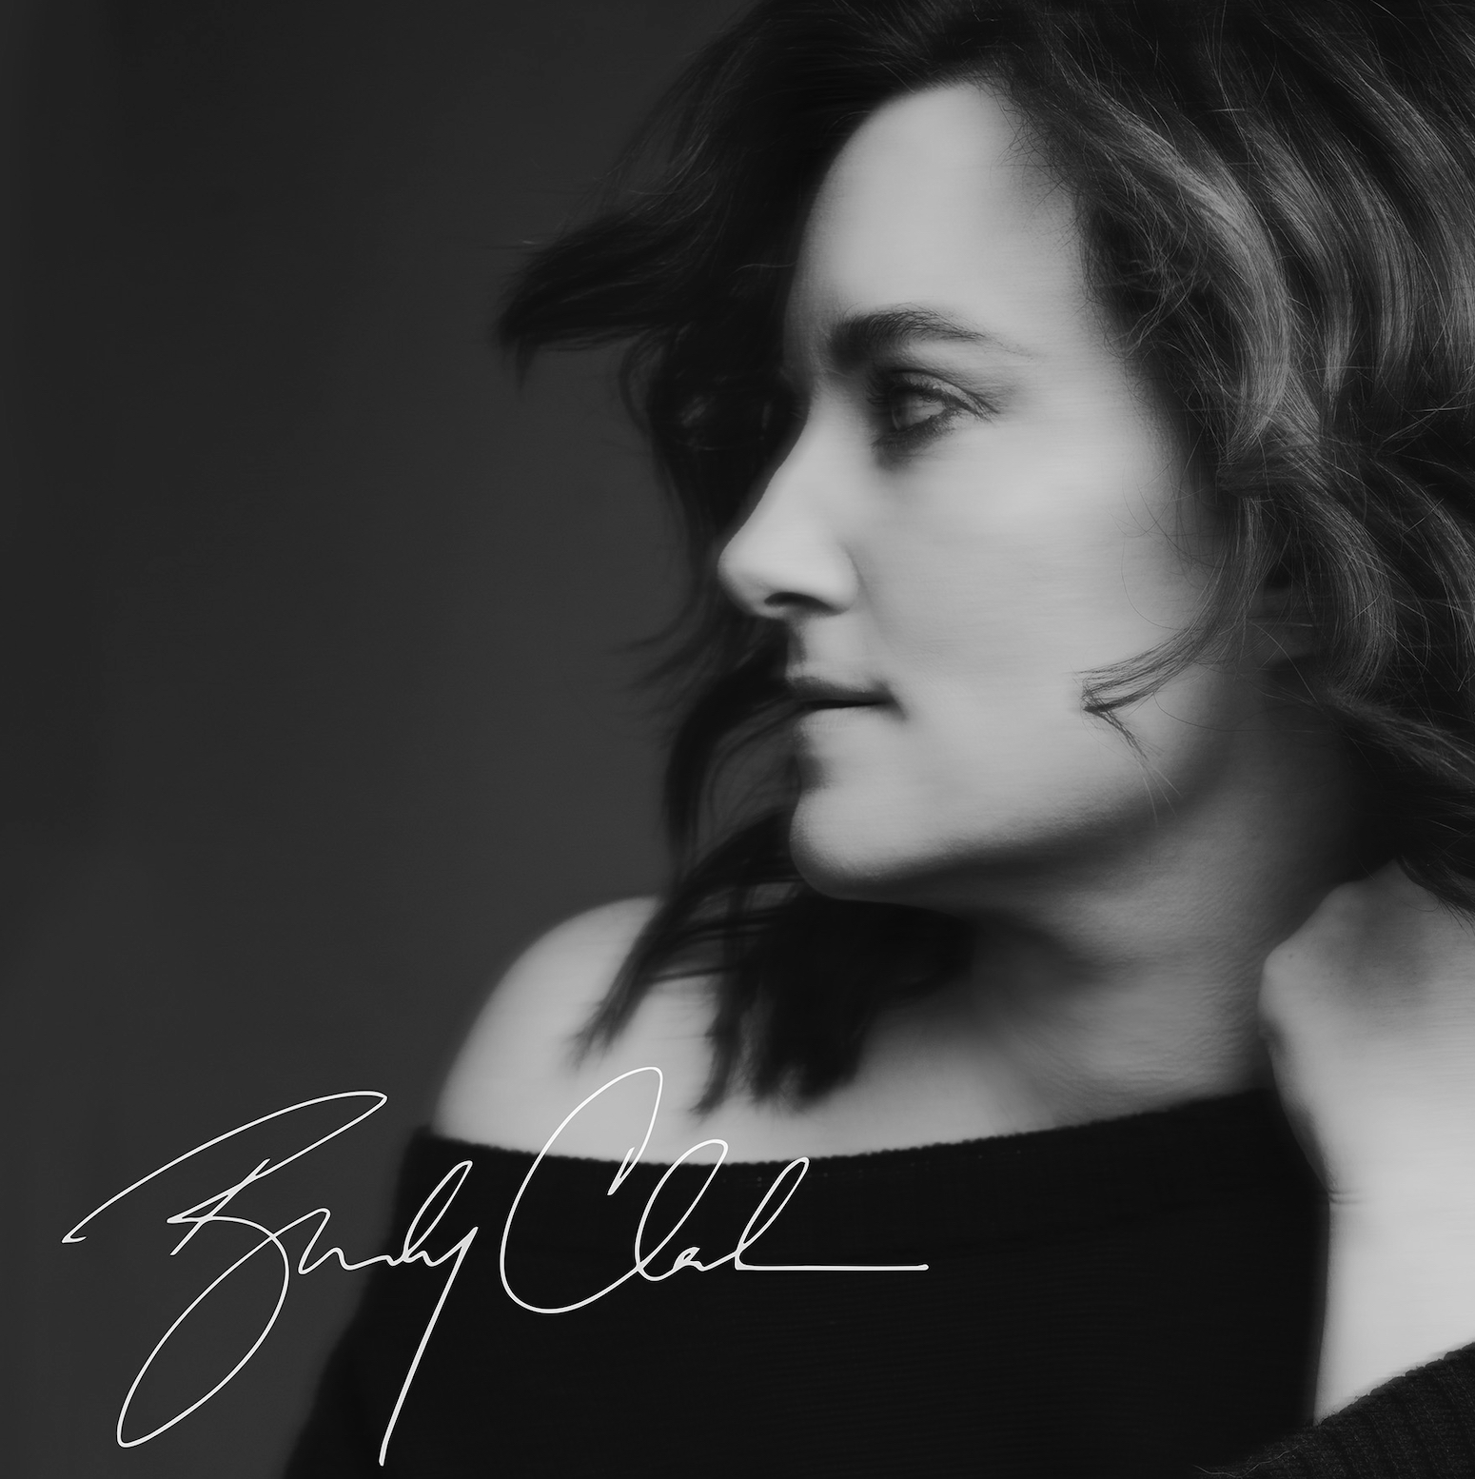
album artwork
May 19, 2023 —11x Grammy-nominated singer, songwriter and musician Brandy Clark’s highly anticipated new self-titled album is out today via Warner Records. Stream/purchase HERE.
Produced by 9x Grammy-winner Brandi Carlile and recorded at the famed Shangri-La studio in Malibu, CA, the album features the most raw and intimate recordings of Clark’s decade-long career, as she showcases her versatility across eleven songs that span the emotional spectrum.
Critical acclaim for Brandy Clark:
“Bucking trends and returning to form, Brandy Clark is a beautiful reminder of the potential that comes with opening up”—NPR Music
“one of Nashville’s craftiest and most meticulous storytellers.”—Los Angeles Times
“Clark continues to convey her inexorable talents as both a song-crafter and vocal
interpreter.”—Billboard
“one of the great singer-songwriters of our day”—Variety
“the album announces the singer as a virtuosa, engaging with country music’s well-worn tropes with both skill and refinement”—Slant
“Brandy Clark is simply an impeccable record, with songs about love, place and identity that cement Clark as a generational talent,” 10/10—Holler
“a label-defying alchemy of sophistication and simplicity…mixing country and singer-songwriter pop in a blazing fire of storytelling”—Nashville Lifestyles
“perfectly unvarnished new album…some of Clark’s rawest, most uninhibited work”
—The Seattle Times
“No one, but no one, writes a song like Brandy Clark”—Music Row
The release adds to yet another landmark year for Clark, who is nominated for Best Original Score at the 76th Annual Tony Awards for Shucked, the new musical comedy she composed alongside longtime collaborator, Shane McAnally. Shucked is nominated for nine awards overall at the 2023 ceremony including Best New Musical.
Reflecting on the project, Clark shares, “This album is a return home to me in many ways. Musically it’s the rawest I’ve been since 12 Stories and maybe even rawer. When Brandi and I sat down and talked about working together, one thing that really intrigued me was her saying ‘I see it as your return to the northwest.’ (Since the two of us are both from Washington state). That comment inspired so much for me. It took me back to where and how I grew up. ‘Northwest’ and ‘She Smoked In The House’ were both a result of that early conversation. Working with another recording artist on this project was such a gift that I didn’t even know I needed and changed the way I want to write songs and make records moving forward. My hope is that anyone who hears this album will feel the heart that I put into every note of it.”
Carlile adds, “Brandy is one of the greatest songwriters I’ve ever known. And I feel like I now know exactly who Brandy Clark is through the portal of this singular brilliantly written album. When I heard the songs for this album, they took me back to the first time I heard Car Wheels on a Gravel Road. I was thinking about Tom Petty, The Pretenders, Kim Richey, Sheryl Crow, Shelby Lynne and the soul of 90s Americana before it had a name. Brandy’s voice is like a friend you’ve had your whole life the second you hear it. I know I’m not alone in feeling this way. This is her moment. This is the one. Sometimes an artist only gets one shot at an album like this in their life. This is the time Brandy has chosen to reveal herself to the world as an artist and a woman and I was blessed beyond measure to be the person she trusted to support and facilitate that swan dive.”
In addition to Clark and Carlile, the album also includes special guests Derek Trucks and Lucius as well as Matt Chamberlain on drums, Sebastian Steinberg on bass, Dave Palmer on piano, Jedd Hughes on guitar, Kyleen King on viola, Josh Neumann on cello, Sista Strings (aka Monique and Chauntee Ross) on cello and violin, Steve Fishell on pedal steel and Jay Carlile on background vocals and harmonica.
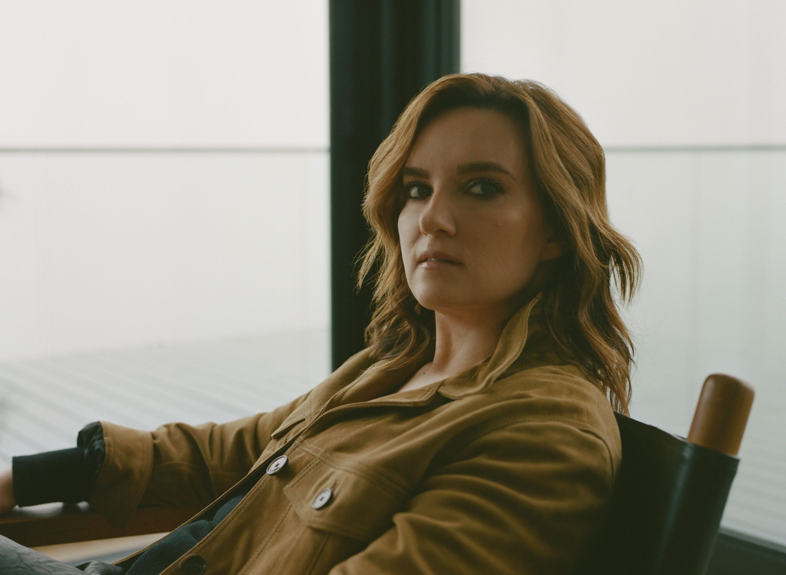
Photo credit: Victoria Stevens
Clark is one of her generation’s most respected songwriters and musicians. In addition to writing songs like “A Beautiful Noise,” the GRAMMY-nominated duet performed by Brandi Carlile and Alicia Keys, and Kacey Musgraves’ “Follow Your Arrow,” Clark has released three acclaimed albums of her own including 2020’s Your Life is A Record. The album landed on best-of-the-year lists at Rolling Stone, Entertainment Weekly, Variety and more and led NPR Music to call her, “a storyteller of the highest caliber,” The New Yorker to declare, “No one is writing better country songs than Brandy Clark is” and Slate to proclaim, “one of the greatest living short-story-song writers in country (which really means in any genre).”
BRANDY CLARK
1. Ain’t Enough Rocks (feat. Derek Trucks)
2. Buried
3. Tell Her You Don’t Love Her (feat. Lucius)
4. Dear Insecurity (feat. Brandi Carlile)
5. Come Back To Me
6. Northwest
7. She Smoked In The House
8. Up Above The Clouds – Cecilia’s Song
9. All Over Again
10. Best Ones
11. Take Mine
TOUR DATES
June 16-18—Kent, UK—Black Deer Festival
June 24—Katonah, NY—American Roots Music Festival
June 25—Vienna, VA—Out & About Festival at Wolf Trap
August 6—Richmond, VA—The National*
August 8—Wilmington, NC—Greenfield Lake Amphitheater*
August 9—Charleston, SC—Charleston Music Hall*
August 10—Greensboro, NC—Carolina Theatre*
August 11—Charlotte, NC—The Knight Theater*
August 17—Madison, WI August 17—Breese Stevens Field#
August 18—Beverly, MA—The Cabot*
August 19—Portland, ME—State Theatre*
August 20—Nashua, NH—Nashua Center for the Arts*
August 22—Northampton, MA—Academy of Music Theatre*
August 31—Highland Park, IL—Ravinia Festival#
September 14—Louisville, KY—Bourbon & Beyond Festival
March 1-8, 2024—Miami, FL—Cayamo Cruise
*with Mary Chapin Carpenter
#with Brandi Carlile
www.brandyclarkmusic.com
For more information, please contact Asha Goodman 615.320.7753,
Catherine Snead 615.320.7753 or Carla Sacks 212.741.1000 at Sacks & Co., asha.goodman@sacksco.com, catherine.snead@sacksco.com
or carla@sacksco.com.
Rick Gershon 818.953.3473, at Warner Records, rick.gershon@warnerrecords.com
