BEBE REXHA AND DAVID GUETTA REUNITE FOR EUPHORIC NEW SINGLE “ONE IN A MILLION”
LISTEN HERE

FOLLOWS GRAMMY-NOMINATED #1 HIT
“I’M GOOD (BLUE)”

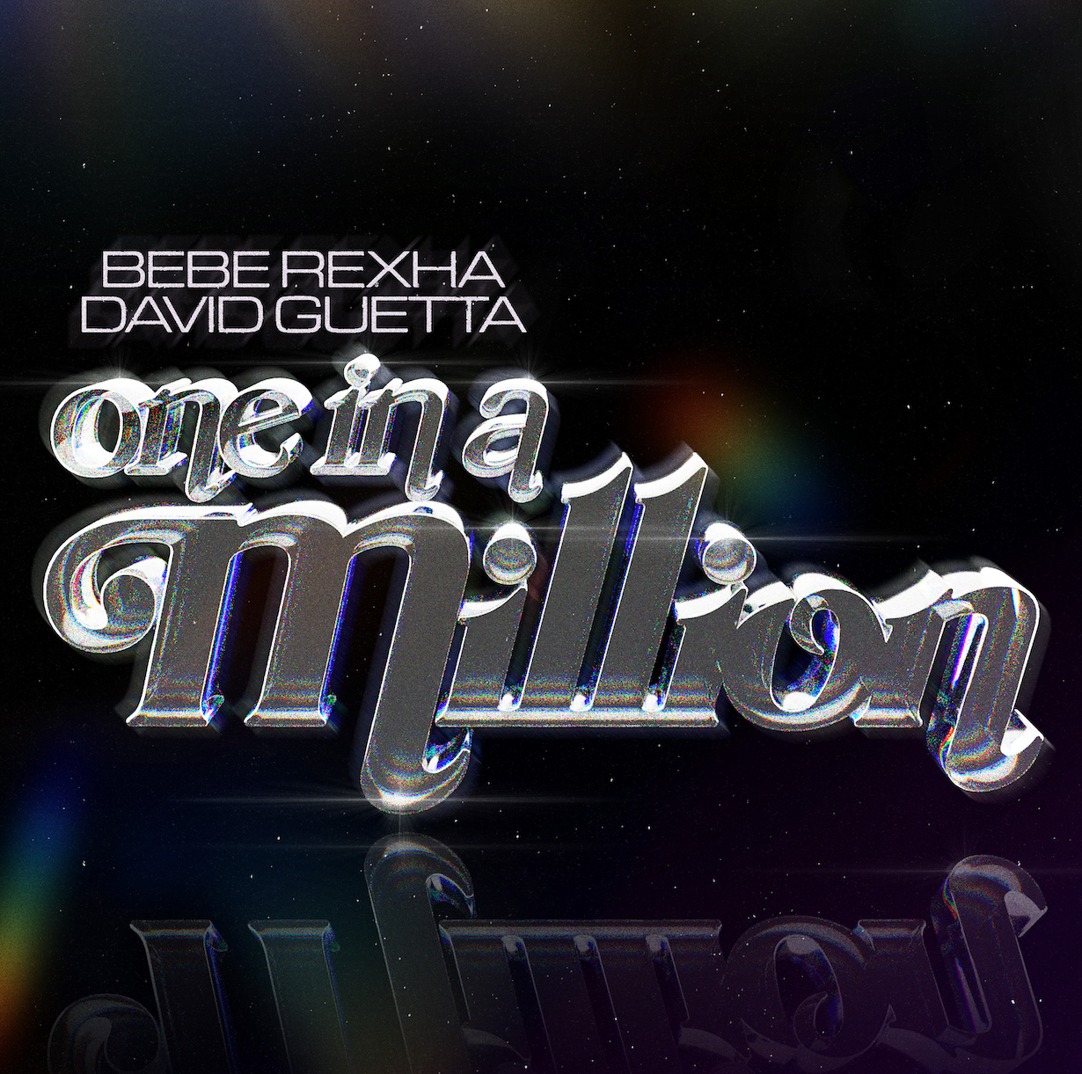
Hi-res download HERE

August 4, 2023 (Los Angeles, CA) – Today, multi-platinum hitmakers Bebe Rexha and David Guetta join forces — once again — for the soaring club-pop anthem “One in a Million.” Listen HERE via Warner Records. It follows their Grammy-nominated global chart-topper “I’m Good (Blue).”

“You're my one, one, one in a million, it's like someone picked you out of the sky,” Rexha sings over sparkling piano and cascading synths. Soon, the track builds to an explosive crescendo that harkens back to house music in its purest form — exhilarating beats, powerful vocals, and buoyant, overflowing melodies.

“One in a Million” is Rexha’s first new release since dropping her acclaimed third album Bebe, which includes fan-favorite collaborations “Satellite” featuring Snoop Dogg and “Seasons” featuring Dolly Parton. She recently wrapped up her North American Best F*n Night Of My Life Tour and is currently playing a series of dates across Europe. On September 22nd, she will take the stage at Life Is Beautiful Festival in Las Vegas.

This spring, Guetta unleashed global hit “Baby Don’t Hurt Me” with Anne-Marie and Coi Leray—a reinvention of the 1993 Haddaway hit “What Is Love”—which is currently top 15 at Top 40 radio. Last week, the French producer dropped the addictive anthem “Something To Hold On To” with MORTEN. With over 40 billion global streams and ‘Producer of the Year’ honors at both the BRIT and NRJ Awards, Guetta has now rocketed to the fourth most streamed artist on Spotify globally.

As for Rexha, she’s been churning out smashes of her own including multi-platinum G-Eazy collaboration “Me, Myself & I” and Martin Garrix-produced club sensation “In The Name Of Love.” In 2017, she struck chart gold with “Meant To Be,” a country duet with Florida Georgia Line that was certified Diamond for selling 10 million copies. After winding up her North American tour, she's currently playing a series of dates across Europe.

With “One in a Million” Rexha and Guetta have done it again, delivering a shimmering summer smash with a sweet, big-hearted message.

Hi-res download HERE

FOLLOW BEBE REXHA:
Official | Twitter | Instagram | Facebook | TikTok | Press Site

FOLLOW DAVID GUETTA:
YouTube | Twitter | Instagram | Facebook | Website | Spotify | TikTok

For more information, please contact:
Darren Baber | Warner Records
darren.baber@warnerrecords.com

Chris Iacullo | The Lede Company
chris.iacullo@ledecompany.com

Kristin Somin | The Lede Company
kristin.somin@ledecompany.com

Alex Labrie | The Lede Company
alex.labrie@ledecompany.com

