UK POP SENSATION GRIFF RETURNS WITH
NEW SINGLE “VERTIGO”
LISTEN HERE

JUST WRAPPED EUROPEAN STADIUM TOUR WITH COLDPLAY

Download hi-res artwork HERE

“Pop’s next powerhouse.” - Vogue

August 31, 2023 (Los Angeles, CA) — Today, Griff is back with brand new single “Vertigo.” Listen HERE via Warner Records.

Intimate, cinematic, and uplifting, “Vertigo” is a suitably dizzying and completely undeniable return from a young woman only just coming into her power. Self-produced over a single note by Griff and taking her distinct, 360-approach towards new heights, “Vertigo” captures the disorientation of your early twenties alongside a grounding wisdom that’s always reached beyond her years — “you’re scared of love? Well, aren’t we all?”

“’Vertigo’ refers to an emotional state — always feeling upside down,” Griff explains. "Experiencing love and growing up, it always feels like the world and my emotions are spinning faster than I can keep up with. ‘Vertigo’ is the beginning of a new creative chapter for me, and I’m excited for us all to go on this journey together.”

Griff is the multi-faceted modern pop star where normal rules need not apply. Born and raised in Kings Langley, England, she started making music early in her teens. She realised at an early age — whether through her Chinese-Jamaican roots or her all-encompassing approach spanning songwriting, production, fashion, and design — that she was different. From day one, Griff’s learning curve has proved similarly sideways: she played just one gig prior to the pandemic in support of DIY EP Mirror Talk, with lockdown mixtape One Foot In Front of The Other rocketing Griff to pop stardom whilst stuck in her bedroom. The barrier-breaking project won Griff the prestigious BRITS Rising Star award and two NME Awards. To date, she has amassed over 660M streams in support of homemade hits like “Black Hole” and “Head on Fire.”

Finally unleashed from lockdown, Griff has since been invited to tour with some of the world’s biggest artists (Dua Lipa, Coldplay, Ed Sheeran, Florence + the Machine) and built an impassioned fanbase wherever her signature bubble-ponytail took her. It’s a back-to-front breakthrough that has also seen Griff play her first ever festivals — most recently, opening for HAIMat All Points East — and sell out shows on her own, like London’s landmark Brixton Academy.

“Vertigo” is the sound of Griff with the ground beneath her feet again, and the future firmly in her grasp. New era, new hair, but the same once-in-a-generation talent unafraid to stand out.

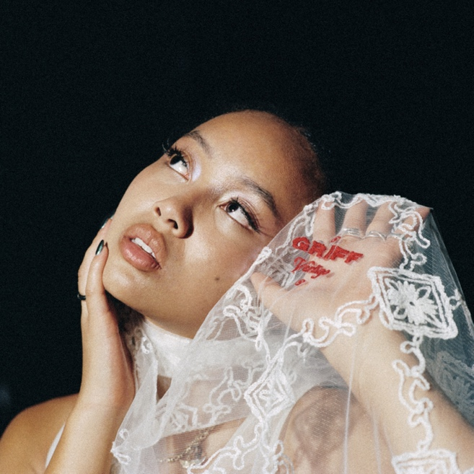
Download hi-res photo HERE

FOLLOW GRIFF:
Instagram | Twitter | Facebook | YouTube | TikTok | Press Materials

For more information, please contact:
Darren Baber | Warner Records
Darren.Baber@warnerrecords.com

