GRAMMY-NOMINATED DJ/PRODUCER ILLENIUM UNLEASHES NEW 45-TRACK REMIX ALBUM ILLENIUM (REMIXES)

LISTEN HERE

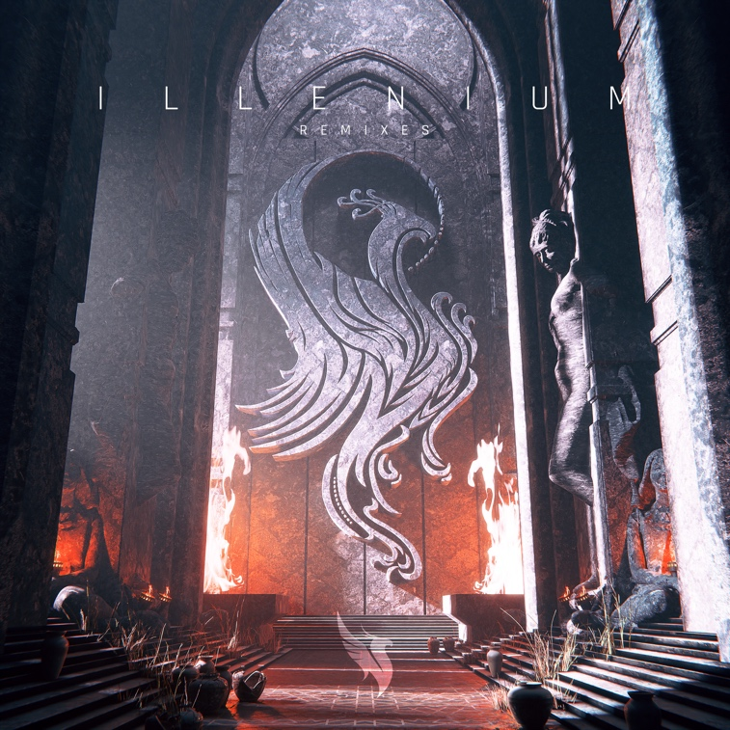
Download hi-res artwork HERE

September 29, 2023 (Los Angeles, CA) – Today, Grammy-nominated DJ/producer ILLENIUM recharges and reignites his latest project with brand-new remix album, ILLENIUM (Remixes). Listen HERE via Warner Records. The project finds him revisiting tracks from his self-titled fifth full-length offering, ILLENIUM, now joined by a dynamic cohort of talent, including Trivecta, Sickick, Crystal Skies, Culture Code, Friendzone, Mashbit, Surf Mesa, and Youth In Circles, to name a few.

The robust collection boasts a staggering 45 tracks, adding another dimension to the likes of “Starfall,” “From The Ashes” with Skylar Grey, “Lifeline” with Jxdn, and more. Notably, a contest winner handpicked by ILLENIUM also provided a stunning remix of “Back To You” with All Time Low. Once again, ILLENIUM (Remixes) illuminates the expanse of his ever-evolving sonic vision with this body of work. Check out the full tracklisting below.

It continues a banner year for ILLENIUM. He recently shared the details for the third installment of his history-making Trilogy concert series, Trilogy: Los Angeles, which will take place at SoFi Stadium on February 2nd and 3rd, 2024. In May, he shared his animated short film Starfall, and recently announced the accompanying graphic novel, releasing in November.

Earlier this year, ILLENIUM arrived as his third consecutive #1 debut on the Billboard Top Dance/Electronic Albums chart. A star-studded collection full of heart, soul, and cinematic beauty, the 16-track set includes the #1 dance hits “All That Really Matters” with Teddy Swims and “Luv Me A Little” with Nina Nesbitt. That’s just the tip of the iceberg as he invites Avril Lavigne, Travis Barker, Vera Blue, All Time Low, JVKE, and more to kick things into even higher gear.

He supported the record with his biggest international headline run to date, ILLENIUM LIVE, selling out gigs across North America—including his biggest show to date, Trilogy: Colorado at Empower Field at Mile High Stadium in Denver—and will touch down in Europe and Australia starting next month. Tickets for all dates are on sale HERE.

ILLENIUM (Remixes) Full Tracklisting:

- Starfall (Trivecta Remix)
- Starfall (Lost Prince Remix)
- Starfall (Gem & Touri Remix)
- Starfall (3thos x Draeden Remix)
- Starfall (VLCN Remix)
- All That Really Matters (with Teddy Swims) (Will Clarke Remix)*
- All That Really Matters (with Teddy Swims) (Mike Williams Remix)*
- All That Really Matters (with Teddy Swims) (Crystal Skies Remix)*
- Worst Day (with MAX) (Nikademis Remix)
- Worst Day (with MAX) (Tungevaag Remix)*
- Worst Day (with MAX) (Fight Clvb x Tannergard Remix)*
- From The Ashes (with Skylar Grey) (Jessica Audiffred Remix)
- From The Ashes (with Skylar Grey) (Paul Van Dyk Remix)*
- Lifeline (with jxdn) (Caslow Remix)
- Eyes Wide Shut (with Avril Lavigne & Travis Barker) (Vanic Remix)
- Eyes Wide Shut (with Avril Lavigne & Travis Barker) (Culture Code Remix)*
- Eyes Wide Shut (with Avril Lavigne & Travis Barker) (Sickick Remix)*
- Shivering (with Spiritbox) (Inhuman Remix)
- You Were Right (with Wooli & Grabbitz) (Kill The Noise Remix)
- You Were Right (with Wooli & Grabbitz) (Awakened Remix)
- You Were Right (with Wooli & Grabbitz) (Stryer Remix)
- You Were Right (with Wooli & Grabbitz) (L D R U Remix)
- You Were Right (with Wooli & Grabbitz) (Friendzone Remix)
- You Were Right (with Wooli & Grabbitz) (Bass Physics Remix)
- Insanity (with American Teeth) (Mazare Remix)
- Drwn (Chenda Remix)
- Otherside (with Said The Sky & Vera Blue) (Cadmium Remix)
- Otherside (with Said The Sky & Vera Blue) (Sadbois & NIO Remix)
- Otherside (with Said The Sky & Vera Blue) (if found Remix)
- Otherside (with Said The Sky & Vera Blue) (Zeroic Remix)
- Otherside (with Said The Sky & Vera Blue) (Tep No Remix)*
- I Want You 2 (Stay) (Slow Magic Remix)
- I Want You 2 (Stay) (9worlds Remix)
- I Want You 2 (Stay) (Mashbit Remix)
- With All My Heart (Surf Mesa Remix)*
- With All My Heart (Cedric Gervais Remix)*
- Back To You (with All Time Low) (Nurko Remix)
- Back To You (with All Time Low) (Awon Remix)
- Back To You (with All Time Low) (Youth In Circles Remix)
- Back To You (with All Time Low) (ryscu Remix)
- Nothing Ever After (with Motionless In White) (Caster Remix)
- Nothing Ever After (with Motionless In White) (VNDETTA Remix)
- Luv Me A Little (with Nina Nesbitt) (LINEAGE Remix)
- Luv Me A Little (with Nina Nesbitt) (Bonnie x Clyde Remix)*
- Luv Me A Little (with Nina Nesbitt) (A7S Remix)*

* = Previously Released

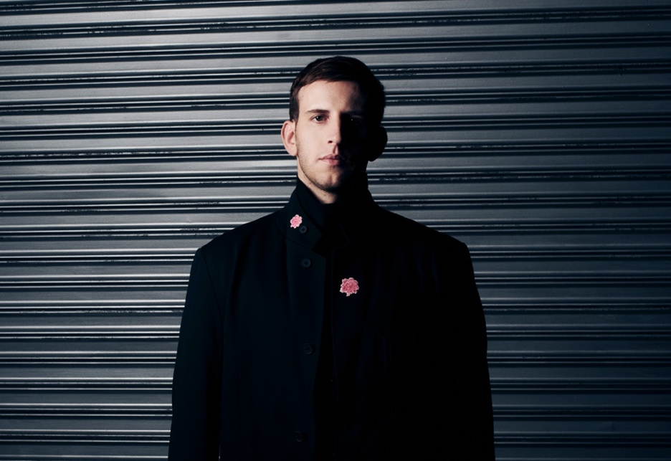
Credit: Lindsey Byrnes | Hi-Res Download HERE

FOLLOW ILLENIUM:
Website | Twitter | Instagram | Facebook | YouTube

For more information, please contact:
Darren Baber | Darren.Baber@warnerrecords.com

