POP PRODIGY JENNA RAINE UNVEILS BIG DUMB HEART, CHAPTER 2 EP
LISTEN HERE

INFECTIOUS VIDEO FOR BUZZING SINGLE “IT IS WHAT IT IS” OUT NOW
WATCH HERE

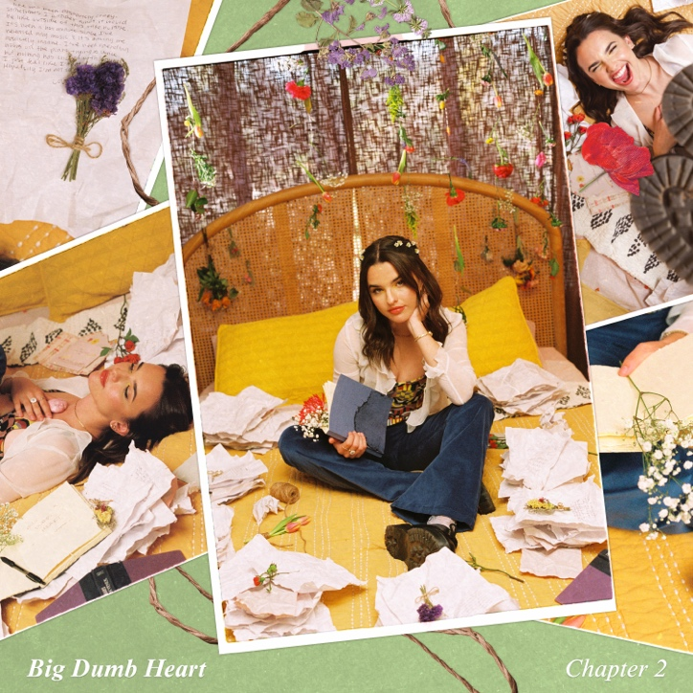
Download hi-res artwork HERE

August 25, 2023 (Los Angeles, CA) – Rising pop star Jenna Raine presents her anxiously awaited Big Dumb Heart, Chapter 2 EP today via Warner Records. Listen HERE.

To celebrate the arrival of the project, she shares the vibrant music video for her buzzing single “It Is What It Is.” Watch it HERE. The breezy and upbeat visual perfectly complements the track’s message, which continues to resonate in a big way.

In less than a month, “It Is What It Is” has already gathered 8 million total streams and incited a viral TikTok dance, gaining over 130 million views and inspiring 30,000 “creates” on the platform. It is notably her biggest and best launch since her original breakthrough “see you later (10 years).”

Right out of the gate, Billboard dubbed “It Is What It Is” a “brisk charmer that gives the singer-songwriter ample room to showcase her personality over a short run time,” and OnesToWatch attested, “It’s happy, it’s energetic, and it’s a much-needed burst of serotonin. Above all, it’s Raine at her finest.”

As a worthy sequel to this spring’s Big Dumb Heart, Chapter 1 EP, Jenna opens up like never before on Chapter 2. Propulsive palm-muted guitar kicks “Cruise Control” into high gear as she seizes the moment on the chantable chorus, “Trust the silence of the empty road, but now I don’t need to see where I’m going. For the moment, all I know is I’m taking off the cruise control.” Piano sets the scene for the vivid “Nights Like This.” Her vocal delivery cracks with raw emotion as she recalls “I put on a favorite sweater and we got breakfast for dinner and then they kicked us out. We went for a ride, laughed till we cried.” Then, there’s “What Are Friends For,” where the dreamy production underscores breathy verses as she pleads with a friend, “You can show up at my door and pour your heart out on the floor.”

Jenna also graces the current cover of Girls’ Life Magazine. View online and order HERE.

TRACKLISTING
- It Is What It Is
- Cruise Control
- Nights Like This
- What Are Friends For

ABOUT JENNA RAINE:
Jenna Raine takes life’s little lessons, moments of bliss, and unforgettable memories and turns them into the kind of pop music that you’ve got to sing with the windows down. The Dallas, Texas-born singer and songwriter continues to enchant audiences everywhere with her hyper-detailed, personal lyrics and towering hooks, tallying north of 220 million total streams to date. In 2021, “see you later (ten years)” initially took over TikTok, yet its success translated to DSPs, garnering over 100 million streams on Spotify. Landing a deal with Warner Records, she maintained this momentum with “Fumbled the Bag” and “Stupid Cupid.” In 2023, she served up the Big Dumb Heart, Chapter 1 EP followed by Big Dumb Heart, Chapter 2. The latter boasts the fan favorite anthem “It Is What It Is.” From the jump, the track resonated with listeners, piling up 8 million-plus streams in less than a month. At the same time, it set TikTok on fire with its own viral dance. Along the way, she has earned unanimous praise from Billboard, Variety, OnesToWatch, and more. Now, Raine is turning the page on her next chapter, and the story just keeps getting better.

###

FOLLOW JENNA RAINE:
Official | TikTok | Instagram | Twitter | Facebook | YouTube | Press Materials

For more information on Jenna Raine, please contact:
Darren Baber | Warner Records
Darren.Baber@warnerrecords.com

Patrice Compere | Warner Records
Patrice.Compere@warnerrecords.com

