NESSA BARRETT TEAMS UP WITH WHETHAN FOR INFECTIOUS NEW SINGLE “SICK OF MYSELF”

LISTEN HERE | WATCH HERE

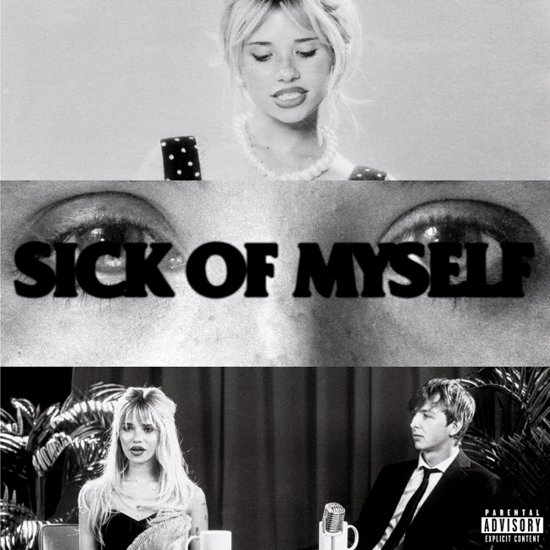
Download hi-res artwork HERE

September 8, 2023 (Los Angeles, CA) – Today, breakout pop sensation Nessa Barrett teams up with acclaimed producer Whethan for the intoxicating new single “sick of myself.” Listen HERE via Major Recordings / Warner Records. Whethan’s infectious beats are perfectly paired with Barrett’s sultry lilt to create a club-ready banger for the ages. “sick of myself” is accompanied by a cinematic video — watch it HERE.

“The medication didn’t work — broke up with him, it didn’t hurt,” she sings over Whethan's bone-rattling synths. “I still feel like a pyro, someone pass me a lighter.” The beat kicks in for the instantly catchy and endlessly relatable chorus: "Sick of myself, sick of my clothes / sick of these boys and their obvious jokes." The end result is a pulsing electro-thumper that is destined to ignite on dancefloors far and wide.

"’sick of myself’ is the perfect collaboration between Nessa and I’s sound and I'm excited to play this one out at upcoming shows,” says Whethan.

“So excited to be releasing this collab with Whethan,” says Nessa. “He’s such a talented, cool artist. I hope everyone loves this song as much as we do.”

Whethan, who has previously collaborated with the likes of Joji, Yeat, Megan Thee Stallion, The Chainsmokers, BoyWithUke, Meghan Trainor, jxdn, glaive, Oliver Tree, and more, is having a banner 2023 courtesy of the Elley Duhé-assisted “Money on the Dash," which cracked the top 40 on Billboard’s Dance US chart and has racked up over 75M streams.

“sick of myself” is Barrett's first release since dropping her highly anticipated new EP hell is teenage girl in July. The project delivers the kind of addictive, irreverent pop gems she has become known for. Barrett is currently gearing up for her Fall North American headline tour, where “sick of myself” is sure to be a stand-out of her stellar set.

About Whethan:
Since 2015, Chicago-based artist, producer, and remixer Whethan has quietly emerged as an influential and inescapable force in not only the electronic genre, but popular music at large. Beyond tallying over 1 billion global streams and counting, he notably became “the youngest artist ever on Australia’s Future Classics.” He earned a Gold single with “Good Nights” [feat. Mascolo] from 2018’s Life of a Wallflower, Vol. 1 and has collaborated with everyone from Dua Lipa, Charli XCX, and K.FLAY to Tom Morello of Rage Against The Machine, Portugal. The Man, Jeremih, The Knocks, and Wafia. In 2020, he reached another high watermark with his debut album, FANTASY. It incited tastemaker applause courtesy of Billboard, SPIN, Earmilk, Flaunt, American Songwriter, OnestoWatch, Dancing Astronaut, EDM.com, ThisSongIsSick, and more. In 2022, he followed up with his latest full-length album, MIDNIGHT. Along the way, he graced bills of marquee festivals such as Coachella, Lollapalooza, Outside Lands, and Electric Daisy Carnival in addition to selling out a co-headliner at the legendary Red Rocks Amphitheater and topping the lineup of MTV’s Snowglobe Music Festival.

About Nessa Barrett:
After being named as one of Billboard’s “21 Under 21” twice — as well as being featured on Ones to Watch’s list of “25 Artists to Watch in 2022,” Uproxx’s “Next Hitmakers List,” and People Magazine’s “Emerging Artist List” — Nessa Barrett has gone on to accumulate more than 1.5 billion global streams to date. She was also nominated for Push Performance of the Year at the 2022 MTV VMAs, performed at When We Were Young Festival, and took her show on the road for her sold out North American and European young forever tours. This Fall, she will hit the road once again, including performances at Austin City Limits Festival in October.

WHETHAN 2023 TOUR DATES:
* Supporting San Holo
9/29 Concord, NC Breakaway Festival
10/6 Inglewood, CA Kia Forum*
10/11 Morrison, CO Red Rocks Amphitheatre*

NESSA BARRETT 2023 TOUR DATES:
10/6 Austin, TX Austin City Limits Festival
10/9 Orlando, FL House of Blues
10/12 Fort Worth, TX Tannahill’s Tavern & Music Hall
10/13 Austin, TX Austin City Limits Festival
10/14 Austin, TX Emo’s
10/16 Nashville, TN Marathon Music Works
10/18 Raleigh, NC The Ritz
10/19 Norfolk, VA The NorVA
10/20 Wallingford, CT The Dome
10/23 Sayreville, NJ Starland Ballroom
10/24 Baltimore, MD Rams Head Live
10/27 Pittsburgh, PA Stage AE
10/28 Newport, KY MegaCorp Pavilion
10/29 Columbus, OH Kemba Live
10/3 Milwaukee, WI The Rave
11/1 St. Louis, MO The Pageant
11/3 Fort Collins, CO The Aggie
11/4 Boulder, CO Boulder Theatre
11/7 Las Vegas, NV House of Blues
11/8 San Diego, CA Observatory North Park
11/10 Anaheim, CA House of Blues Anaheim
11/13 San Jose, CA San Jose Civic
11/15 Seattle WA Showbox SODO
11/16 Portland, OR Crystal Ballroom

Follow Nessa Barrett:
Official | TikTok | Instagram | Twitter | Facebook | YouTube | Press Materials | Store

Follow Whethan:
Official | TikTok | Instagram | Twitter | Facebook | YouTube | Store

Nessa Barrett contact:
Darren Baber | Warner Records
Darren.Baber@warnerrecords.com

Whethan contact:
Ceri Roberts | Warner Records
Ceri.Roberts@warnerrecords.com

