DAVID GUETTA & MORTEN TEAM UP FOR NEW FUTURE RAVE SINGLE “SOMETHING TO HOLD ONTO”
FT. CLEMENTINE DOUGLAS

LISTEN HERE

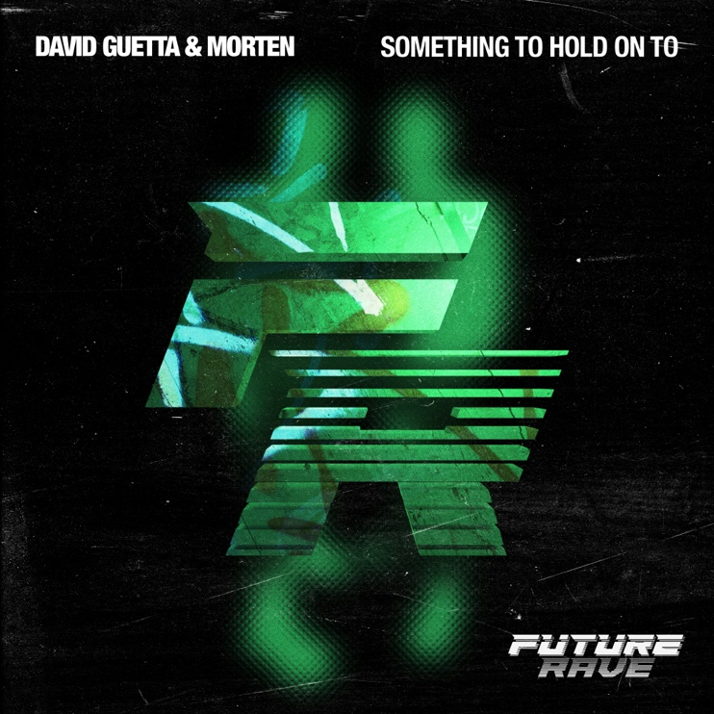
Download hi-res artwork HERE

July 28, 2023 (Los Angeles, CA) — Today, David Guetta and MORTEN’s cutting-edge Future Rave sound returns with their new smash single, “Something To Hold Onto.” Listen HERE. The global duo returns in style on this Future Rave club banger, combining stunning vocals with captivating house strings and electrifying tones. Featuring a roof-raising lead performance from the UK’s Radio 1 2022 Dance Awards ‘Vocalist of the Year,’ in-demand songwriter Clementine Douglas, “Something To Hold Onto” is guaranteed to send sparks flying on the dancefloor.

With 800+ million streams across 20+ releases and remixes, David Guetta and MORTEN continue to dominate the music scene. Over the past three years, they have teamed up to create a brand-new dance music culture by unleashing their pioneering “Future Rave” sound. Emerging from their desire to play something new in their sets, the inventive genre brings sounds and formats from the underground to the masses. With Future Rave, the duo is bringing the best elements of both the EDM and underground scenes together, while keeping the cutting-edge sound ever evolving.

After a sold-out US tour in 2022, which saw the pair perform at Exchange LA, Brooklyn Mirage and in front of millions on the mainstage of EDC Las Vegas, David Guetta and MORTEN took Future Rave to the iconic island of Ibiza for an astonishing 18-week residency at Hï Ibiza. This season, the Future Rave excitement returns to Ibiza for a series of highly anticipated events, with their single launch event taking place tonight (7/28).

David Guetta is fresh off a legendary run, with over two billion streams combined for the smash hit “Baby Don’t Hurt Me” featuring pop megastars Anne-Marie and Coi Leray and the multi-platinum, Grammy-nominated “I’m Good (Blue)” with superstar Bebe Rexha, which topped charts and broke records globally. With over 40 billion global streams and winning ‘Producer of the Year’ at both the BRIT and NRJ Awards, David Guetta has now skyrocketed to the #4 most streamed artist on Spotify globally, selling over 50 million records worldwide. He has over 24 million Spotify followers and over his career has reached #1 on iTunes charts in over 113 countries.

Joining the Future Rave party on “Something To Hold Onto,” songwriter, vocalist and producer Clementine Douglas has become a go-to writer-singer for the Dance world over the past 18 months, rounding off 2022 by winning the UK’s Radio 1 Dance Awards ‘Vocalist of the Year.’ With cuts including P!nk, Riton, MK, Galantis, Major League Djz, Chase & Status, David Guetta, TSHA, Sub Focus, Dom Dolla, current Sonny Fodera collaboration “Asking” and more to come, her ability to breathe life into tracks and take them to the next level is up there with the best. Continuing her fast rise, she is currently working with Rudimental, Fraser T. Smith, The Blessed Madonna, Meduza, Jax Jones, Leigh-Anne Pinnock and more.

An electrifying new Future Rave classic, “Something To Hold Onto” shows David Guetta and MORTEN at the peak of their powers and at the pioneering frontier of house music.

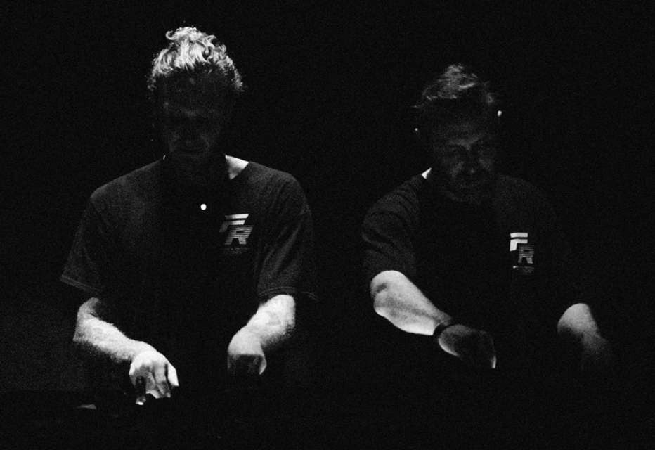

Follow David Guetta:
YouTube | Instagram | Twitter | Facebook | Website | Spotify

Follow MORTEN:
Instagram | TikTok | Website | Spotify

For more information on David Guetta, please contact:
Darren Baber | Warner Records
Darren.Baber@warnerrecords.com

