NESSA BARRETT REMEMBERS HER BEST FRIEND WITH NEW SINGLE “CLUB HEAVEN”
LISTEN HERE | WATCH HERE

CHURCH CLUB FOR THE LONELY TOUR KICKS OFF TODAY AT AUSTIN CITY LIMITS


Download hi-res artwork HERE

October 6, 2023 (Los Angeles, CA) – Today, breakout pop sensation Nessa Barrett releases her heartfelt new single “club heaven.” Listen HERE via Warner Records and watch the video HERE. The touching anthem soars with the artist's earnest and vulnerable exploration of grief and healing. “club heaven” coincides with the start of Barrett's Fall headlining tour, which kicks off today at Austin City Limits Festival. Full list of dates below.

The pop artist has been forthright in the past with fans about mourning the loss of her best friend, Cooper. On the track, she pays tribute to their relationship. "It's one of the most special songs I’ve ever written," Barrett says. "I had to heal in order to be in a place to release it, and I can’t wait for everyone to feel it with me. This song is for anyone who is missing someone. This one is for you, Coop.”

In honor of Cooper, Nessa has released new “we hate paparazzi” merch — an idea they both talked about prior to his passing — available for pre-order HERE. A portion of the proceeds will be donated to Coop's Advice, to raise awareness about mental health and addiction.

“club heaven” is Barrett’s first release since collaborating with Whethan on “sick of myself,” which followed the release of her highly anticipated hell is teenage girl EP in July. That project is packed with the singer’s sultry brand of pop that is catching fire with fans.

About Nessa Barrett:
After being named as one of Billboard’s “21 Under 21” twice — as well as being featured on Ones to Watch’s list of “25 Artists to Watch in 2022,” Uproxx’s “Next Hitmakers List,” and People Magazine’s “Emerging Artist List” — Nessa Barrett has gone on to accumulate more than 1.5 billion global streams to date. She was also nominated for Push Performance of the Year at the 2022 MTV VMAs, performed at When We Were Young Festival, and took her show on the road for her sold out North American and European young forever tours. This Fall, she will hit the road once again, including performances at Austin City Limits Festival in October.

NESSA BARRETT 2023 TOUR DATES:

NORTH AMERICA:
10/6 Austin, TX Austin City Limits Festival
10/9 Orlando, FL House of Blues
10/12 Fort Worth, TX Tannahill’s Tavern & Music Hall
10/13 Austin, TX Austin City Limits Festival
10/14 Austin, TX Emo’s
10/16 Nashville, TN Marathon Music Works
10/18 Raleigh, NC The Ritz
10/19 Norfolk, VA The NorVA
10/20 Wallingford, CT The Dome
10/23 Sayreville, NJ Starland Ballroom
10/24 Baltimore, MD Rams Head Live
10/27 Pittsburgh, PA Stage AE
10/28 Newport, KY MegaCorp Pavilion
10/29 Columbus, OH Kemba Live
10/3 Milwaukee, WI The Rave
11/1 St. Louis, MO The Pageant
11/3 Fort Collins, CO The Aggie
11/4 Boulder, CO Boulder Theatre
11/7 Las Vegas, NV House of Blues
11/8 San Diego, CA Observatory North Park
11/10 Anaheim, CA House of Blues Anaheim
11/13 San Jose, CA San Jose Civic
11/15 Seattle WA Showbox SODO
11/16 Portland, OR Crystal Ballroom

AUSTRALIA + NEW ZEALAND:
12/12 Brisbane, AUS The Tivoli
12/13 Newtown, AUS Enmore Theatre
12/16 Melbourne, AUS Forum Melbourne
12/17 Melbourne, AUS Forum Melbourne
12/19 Auckland, NZ The Powerstation

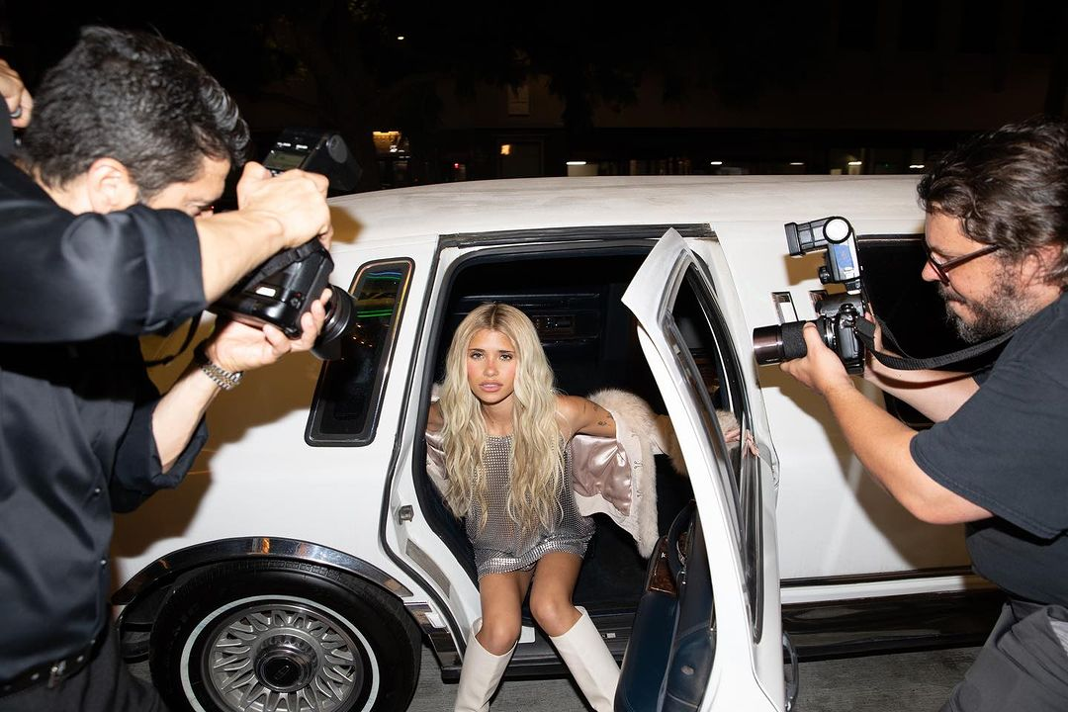
Credit: Colin Miller
Download hi-res photo HERE

Follow Nessa Barrett:
Official | TikTok | Instagram | Twitter | Facebook | YouTube | Press Materials | Store

For more information, please contact:
Darren Baber | Darren.Baber@warnerrecords.com
Regional/Tour: Delanee Wilson | Delanee.Wilson@warnerrecords.com



