RISING STAR RETT MADISON UNVEILS NEW TRACK AND VIDEO “FORTUNE TELLER”
OUT TODAY VIA WAR BUDDHA/WARNER RECORDS

TICKETS ON SALE NOW FOR UPCOMING U.S. TOUR WITH MEDIUM BUILD
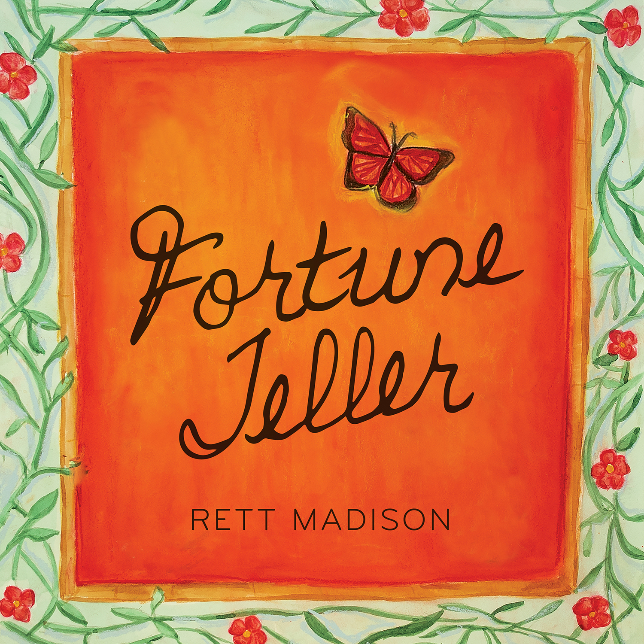
Download hi-res single art HERE | Download hi-res press photo by Mikayla Miller HERE
August 18, 2023 (Los Angeles, CA)—Today, Los Angeles-based vocalist, songwriter and multi-instrumentalist Rett Madison unveils a new heartfelt track, “Fortune Teller,” via Nashville’s War Buddha Records and Warner Records. The video, directed by Joelle Grace Taylor (Kaytranada, Ariana Greenblatt, Rob Lowe) and choreographed by Carlena Britch (Justin Bieber, Beyonce, Gwen Stefani), is also out today—watch HERE and listen HERE. More music from Madison is imminent.
“While I’m no longer a religious person, I still consider myself to be very spiritual,” says Madison. “A few months after I lost my mom, I sought out psychics and mediums because I was curious if anyone could connect to my mother’s spirit. I was really seeking comfort and reassurance at the time.
I wrote ‘Fortune Teller’ after an emotional reading with my friend and psychic medium, Natalie James Taylor, who also plays the role of the infomercial psychic in the music video. It was a full circle moment to have Natalie on set. She’s brought me comfort and clarity during our readings over the past few years and has helped me connect with my mother in spirit. Natalie is incredibly gifted and kind, and I’m so excited that she makes a cameo in the music video.
When I started to imagine concepts for the music video, I had a distant memory of an infomercial for a psychic hotline that I must have seen on television when I’d stay up past my bedtime as a kid. I really wanted the video to feel lighthearted and fun in contrast to the lyrics so recreating 90s infomercials felt like a perfect match.”
Additionally, Madison will tour the U.S. with Medium Build next month before playing her first headline show in London—get tickets HERE and see full routing below. Madison recently wrapped a run of U.S. dates with The Head And The Heart, Andy Grammer and Fitz & The Tantrums.
Madison most recently unveiled a new version of “Pin-Up Daddy” featuring acclaimed vocalist and songwriter Katie Pruitt, which was released in June in celebration of Pride month. The original version of “Pin-Up Daddy” is taken from Madison’s debut album of the same name, produced by Theo Katzman (Kesha, Carly Rae Jepsen, Vulfpeck) and released independently in 2021 to critical acclaim.
Originally from West Virginia, Rett Madison is a queer singer-songwriter and multi-instrumentalist based in Los Angeles. She has been featured in publications such as Billboard, American Songwriter and Rolling Stone, where her music was described as “simultaneously brazen and vulnerable,” giving her a place “in the new school of acclaim-worthy troubadours.” She has sung backing vocals for artists such as Lorde and Kate Nash and opened for artists including Melissa Etheridge, Sheryl Crow, Elle King and more. Having independently released a handful of singles ahead of her 2021 debut album, Pin-Up Daddy, she’s worked with some of the most talented players today, including Theo Katzman, Brian Jones, Lee Pardini and Joe Dart.
RETT MADISON LIVE
September 2—London, UK —The Slaughtered Lamb
September 21—Louisville, KY—Zanzabar§
September 22—Pittsburgh, PA—Club Cafe§
September 23—Columbus, OH—The Basement§
September 25—Chicago, IL—Schubas Tavern§
September 26—Minneapolis, MN—7th Street Entry§
September 27—Omaha, NE—Reverb Lounge§
September 29—Denver, CO—Globe Hall§
October 1—Oklahoma City, OK—Pony Boy§
§ with Medium Build
For more information, please contact:
Rick Gershon | rick.gershon@warnerrecords.com
Reid Kutrow | reid.kutrow@sacksco.com
Ethan Jacobs | ethan.jacobs@sacksco.com
Carla Sacks | carla@sacksco.com
.

