RICKY MONTGOMERY’S NEW ALBUM RICK ARRIVES TODAY
LISTEN HERE

2024 NORTH AMERICAN HEADLINE TOUR JUST ANNOUNCED
TICKETS ON SALE HERE

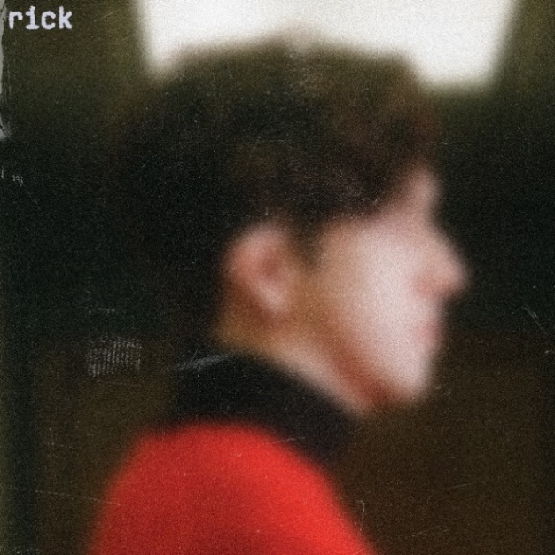
Hi-res press photos + artwork available here

“The listener can’t help but pay attention to Montgomery”
– Billboard

“Vibey bedroom pop-esque vulnerab[ility]… with the musician stepping into a more comfortable and mature sound”
– V Magazine

“better than ever, with a sharpened musical identity and narrative direction.”
– Wonderland Magazine

September 29, 2023 (Los Angeles, CA) – Breakout alt-pop artist Ricky Montgomery proudly presents his much-anticipated major label debut album, Rick, today via Warner Records. Listen to Rick HERE, and purchase physical formats of Rick HERE, including vinyl, CD, and cassette.

Working alongside GRAMMY-winning vets Dan Wilson and Jeremy Hatcher and GRAMMY-nominated producer Tommy English, the album is a soul-searching mix that balances sadness and doubt with lightness and levity. The 14-track body of work unfolds as a poignant pastiche of personal moments and memories stitched together by his eloquent songcraft, artful beat-work, and delicate instrumentation. Against this backdrop, he urges you to finally meet Rick. Its title alludes to Montgomery’s father, nicknamed Rick, a name he always assumed he’d eventually take on—“it seemed more ‘adult,’” he quips—but never had the nerve to.

“Rick is about my long, awkward path toward remembering myself as an artist. It’s been embarrassing and difficult, but also thrilling—kinda like changing your first name,” he says. “It’s everything I’ve ever wanted to do but was too scared to try.”

Rick features Ricky’s latest hit “Boy Toy” which continues to rise, thanks in part to his 1.7M TikTok followers and a buzzing anime trend on the platform that’s historically become a unique and powerful driving force for his 1+ billion stream catalog. Learn more in his Polygon feature here. The new album also features playful yet multi-layered and emotional singles “Don’t Say That” and “Eraser,” his emotionally charged “Black Fins” which recounts his father’s 2009 suicide in Mexico, plus 10 new tracks such as “Truth or Dare” which debuts today alongside an official visualizer – watch it here.

In support of the record, he will embark on his biggest North America headline tour yet in 2024: "The Rick Tour: Another Rick in the Wall.” The five-week jaunt kicks off on February 13 in Phoenix, AZ at The Van Buren, stops in major markets coast-to-coast, and concludes with a hometown gig on March 23 in Los Angeles, CA at The Wiltern. Tickets are on sale now at rickymontgomery.com/#tour.

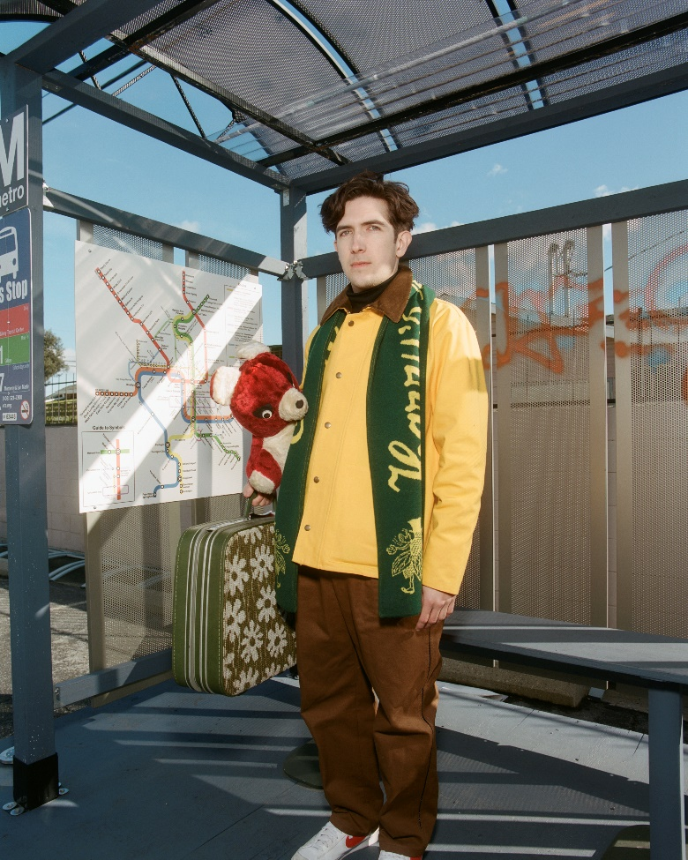

‘RICK’ TRACKLISTING
- One Way Mirror
- Boy Toy
- Truth or Dare
- I’m Just Joking In This Interlude (Interlude)
- In Your Pocket
- Don’t Say That
- Eraser
- We Got Married Twice (Interlude)
- Type A
- Paper Towel
- Sometimes I Need To Be Alone
- Ethan’s Song
- Black Fins
- Ribbons (Outro)

2024 TOUR DATES
2/13 Phoenix, AZ The Van Buren
2/15 Austin, TX Emo’s
2/16 Dallas, TX House of Blues
2/17 Houston, TX White Oak Music Hall
2/19 Orlando, FL The Plaza Live
2/20 Atlanta, GA Center Stage
2/22 Norfolk, VA The NorVa
2/23 Silver Spring, MD The Fillmore Silver Spring
2/24 New York, NY Terminal 5
2/26 Philadelphia, PA TLA (SOLD OUT!)
2/27 Boston, MA Royale
2/28 Montreal, QC Le Studio TD
3/1 Toronto, ON Danforth Music Hall (SOLD OUT!)
3/2 Detroit, MI Saint Andrew's Hall (SOLD OUT!)
3/3 Columbus, OH Newport Music Hall
3/5 Chicago, IL The Riviera Theatre
3/6 St. Louis, MO The Pageant
3/8 Madison, WI The Sylvee
3/9 Minneapolis, MN First Avenue
3/12 Denver, CO Gothic Theatre
3/13 Salt Lake City, UT Depot
3/15 Vancouver, BC Vogue
3/16 Seattle, WA Showbox Market
3/17 Portland, OR Wonder Ballroom
3/19 San Francisco, CA Regency
3/22 San Diego, CA SOMA
3/23 Los Angeles, CA The Wiltern

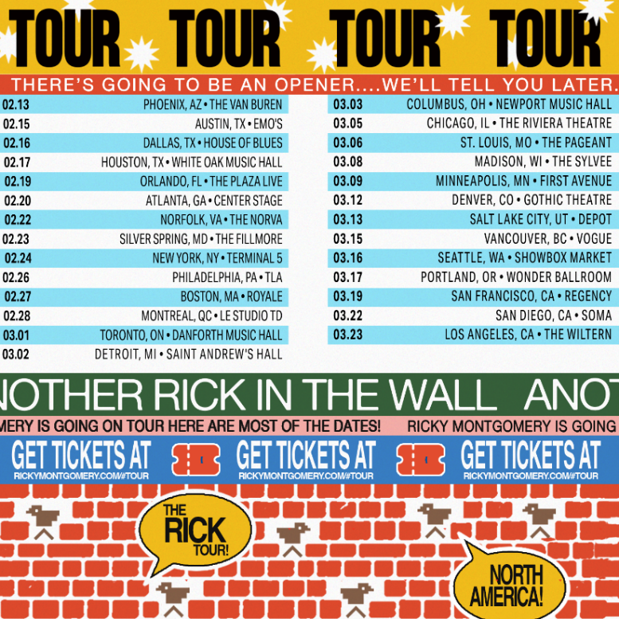
Download hi-res admat here

ABOUT RICKY MONTGOMERY:
Music always lures Ricky Montgomery back. He blames the internet. First a devotee of the Vine underground, and now—nearly a decade and several jobs later—an unexpected hitmaker, the Los Angeles native has spent the last few years trying to reconcile with his artist self. He recently surpassed 1 billion global streams thanks to Platinum indie-pop hits “Mr. Loverman” and “Line Without a Hook.” But those songs, written when he was a teen, have come to feel like they were by a whole other person—at least to Ricky. In 2023, we get to meet Ricky’s new chapter, a sophomore set that comes seven years later, rich with electro-laced, emo-tinged alt-pop that spins stories about life in all its messy and mundane glory. Ricky's journey fits the bill: a childhood in L.A. interrupted by divorce, an adolescence playing in the basement bands of suburban Missouri, a viral explosion on a soon-to-implode platform, and a brief music career back on the West Coast that sent his songs up the Rock and Alternative charts. That was in 2014, before life intervened and he quit music for good… until the world discovered his sunny, sardonic songs. With millions of socials followers and a string of sold-out tours under his belt, Ricky now sets out to document "my long, awkward path toward remembering myself as an artist," he says. "It’s been embarrassing and difficult, but also thrilling. It’s everything I’ve ever wanted to do but was too scared to try.”

###
For more information, contact:
Ceri Roberts, Ceri.Roberts@warnerrecords.com
Patrice Compere, Patrice.Compere@warnerrecords.com

Press Materials:
press.warnerrecords.com/rickymontgomery

Follow Ricky Montgomery:
INSTAGRAM | TWITTER | YOUTUBE | TIKTOK

