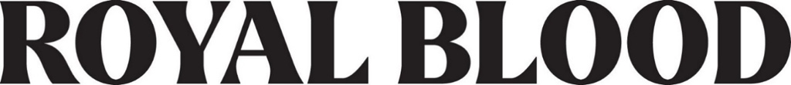

NEW ALBUM BACK TO THE WATER BELOW OUT NOW
LISTEN HERE

WATCH THE VIDEO FOR “SHINER IN THE DARK” HERE

NORTH AMERICAN HEADLINE TOUR KICKS OFF NEXT MONTH

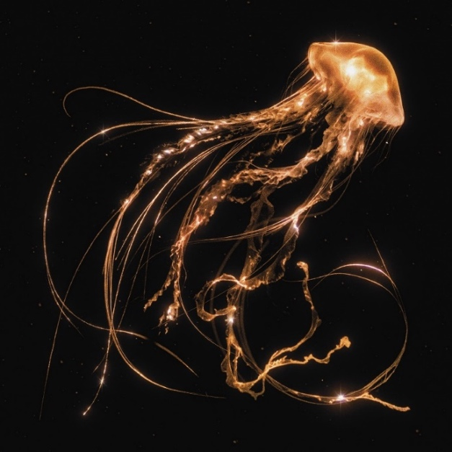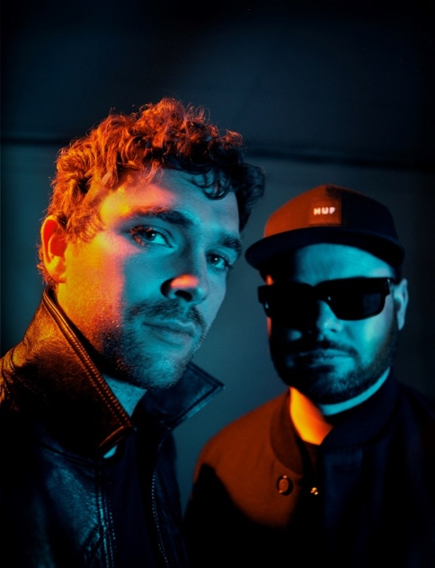
Download high-res Back To The Water Below artwork HERE | Photo by Tom Beard HERE

September 1, 2023 (Los Angeles, CA) — Today, Royal Blood unveil their highly anticipated new album Back To The Water Below. The album is launched alongside a video for new single “Shiner In The Dark.” Listen to the album HERE and watch the video HERE.

When Mike Kerr and Ben Thatcher started work on Back To The Water Below, they cast aside any preconceptions of what their band could be. They allowed themselves the freedom to embrace other ideas, at times being guided by melodies rather than riffs and rhythms, and at others deploying whatever instrumentation they felt best complemented the songs. Key to achieving their creative liberation was the decision to produce the record entirely independently for the first time — not to mention, having the freedom to stroll down to their studio space near their homes in Brighton whenever a moment of inspiration struck. While everything had changed for Royal Blood over the course of the previous decade, the reason for forming the band was completely unchanged: the simple joy of Mike plugging in, Ben picking up his sticks, and the pair making a racket for the sheer fun of it.

Kerr says, “I think this record was about letting the ideas take us where they needed to go, and off the back of ‘Typhoons,’ we felt permission to go to those places with more confidence and knowledge of how to execute them. If there was a song that was calling us to do something that wasn’t typically what we’re known for, we felt more like that’s where we were going to go. The songs are in charge and if that means having a record that is quite varied, that’s what we were going to go for. As a result, we’ve made a rollercoaster of a record.”

That rollercoaster ride has been demonstrated by the album’s previous singles, “Mountains At Mignight” and “Pull Me Through.” The new single “Shiner In The Dark” continues that unpredictable streak as it sets a rock ‘n’ roll swagger to the tight, danceable rhythms that pulsated throughout the Typhoons album. Meanwhile, the other songs on Back To The Water Below are just as essential. Devoid of distortion, “The Firing Line” represents a bigger departure, its ‘90s alt-rock tone and an underbelly of psychedelia later elevated by a chiming piano melody, while “Tell Me When It’s Too Late” erupts into a maximalist wall-of-sound. It ends on a high with the ethereal “Waves,” which opens with melancholy dream pop atmospherics before taking flight with an expansive shoegaze-tinged finale.

In addition to its digital release, Back To The Water Below is available on physical formats which include a Deluxe Edition marbled vinyl, complete with a signed insert and a bonus two-track 7” vinyl. This, together with a range of album bundles, are available HERE.

Royal Blood will celebrate the release of Back To The Water Below with their upcoming North American headline tour, kicking off on September 16 with a performance at Sea.Hear.Now Festival in Asbury Park, NJ. See HERE for a full list of shows and accompanying ticket details.

Back To The Water Below Tracklist:
- Mountains At Midnight
- Shiner In The Dark
- Pull Me Through
- The Firing Line
- Tell Me When It’s Too Late
- Triggers
- How Many More Timres
- High Waters
- There Goes My Cool
- Waves
Deluxe Edition 7” single bonus tracks:
- Supermodel Avalanches
- Everything’s Fine

North American Tour Dates:

Sep 16 Asbury Park, NJ Sea. Hear. Now Festival
Sep 18 Detroit, MI The Fillmore Detroit
Sep 19 Cleveland, OH Agora Theater
Sep 21 Louisville, KY Louder Than Life Festival
Sep 22 Saint Louis, MO The Pageant
Sep 23 Chicago, IL Riviera Theatre
Sep 25 Toronto, ON Queen Elizabeth Theatre
Sep 26 Montreal, QC MTELUS
Sep 27 Boston, MA Roadrunner
Sep 29 New Haven, CT College Street Music Hall
Sep 30 Philadelphia, PA The Fillmore
Oct 02 Brooklyn, NY Brooklyn Steel
Oct 03 New York, NY Webster Hall
Nov 09 Los Angeles, CA The Wiltern
Nov 10 Oakland, CA Fox Theater
Nov 11 Santa Cruz, CA The Catalyst
Nov 13 Seattle, WA Paramount Theatre
Nov 14 Vancouver, BC Queen Elizabeth Theatre
Nov 15 Portland, OR Crystal Ballroom
Nov 17 Salt Lake City, UT Union Event Center
Nov 18 Englewood, CO Gothic Theatre
Nov 20 Tulsa, OK Cain’s Ballroom
Nov 21 Dallas, TX South Side Ballroom
Nov 22 Austin, TX ACL Live at The Moody Theater
Nov 25 Albuquerque, NM Sunshine Theater
Nov 26 Phoenix, AZ The Van Buren
Nov 27 San Diego, CA The Sound

# # #

For more information, please contact:
National: Rick Gershon Rick.Gershon@warnerrecords.com
Regional: Delanee Wilson Delanee.wilson@warnerrecords.com

Follow Royal Blood:
Website | Spotify | Apple Music | YouTube | Facebook | Instagram | Twitter | TikTok | Press Materials

