ZACH BRYAN RELEASES NEW SELF-TITLED ALBUM
LISTEN HERE

16 SONGS WITH COLLABORATIONS FROM KACEY MUSGRAVES, THE LUMINEERS, THE WAR AND TREATY, SIERRA FERRELL
AVAILABLE NOW VIA WARNER RECORDS

2024 TOUR DATES COMING SOON

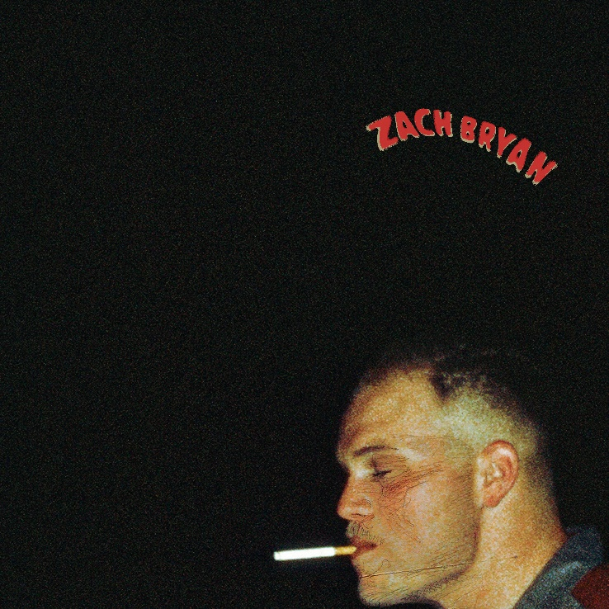
Click HERE for hi-res album art

“I do not and will not fear tomorrow because I feel as though today
has been enough.” - Fear and Friday’s (Poem)

August 25, 2023 (Los Angeles, CA) – Singer-songwriter-producer Zach Bryan releases his highly anticipated new album, Zach Bryan, today via Warner Records. Listen HERE. Expansive yet intimate, the 16-track set explores the Grammy-nominated artist’s Oklahoma roots as well as his vast and varied confluence of musical and literary influences. Written and produced by Bryan himself, the self-titled album is a raw and unfiltered communique from the songs’ creator directly to the heart of his global audience. The album will be available on vinyl and CD on October 13 — pre-order HERE.

A few of the new songs have been previewed live or on social media and have already become sing-along fan-favorites in concert. Among them is the anthemic "Overtime," with its uplifting energy and sweeping chorus. The 27-year-old Navy vet also recently shared a snippet of "Spotless," a heartfelt collaboration with alt-folk legends The Lumineers. “I ain’t spotless, neither is you," Bryan and Lumineers frontman Wesley Schultz sing, "But once in my life I’m gonna see it through."

The album also boasts appearances from country superstar Kacey Musgraves on album highlight “I Remember Everything,” as well as features from Sierra Ferrell on “Holy Roller” and The War and Treaty on “Hey Driver.” Other standout tracks, which capture Bryan's honest and relatable storytelling and poignant delivery, are "El Dorado," "Tourniquet," and album-closer "Oklahoma Son."

Zach Bryan arrives as he wraps up his sold-out Burn, Burn, Burn Tour, which reaches its finale in Kansas City, MO on August 30. 2023 has been an explosive year for Bryan, who earned a Grammy nomination for his 5x platinum-certified single “Something in the Orange,” which is now officially the longest charting country single for a male artist on Billboard’s Hot 100 at an astounding 66 consecutive weeks.

Those achievements follow the release of his chart-topping 2022 album, American Heartbreak — a critical sensation that continues to collect universal accolades and unstoppable momentum, appearing on numerous Year-End Best Of 2022 lists. It emerged as the #1 Country Album on Spotify for 2022. The platinum-certified American Heartbreak remained in the top 10 in the US for more than a year after its initial release and garnered a total of 16 RIAA track certifications. Bryan has accrued over 6.9 billion global streams across his catalog to date.

Now, with his new album and 2024 tour dates coming soon, Bryan follows through on his promise to deliver music that is uniquely American and sincere, unfettered by trends or categories—music that represents his singular voice in the culture of music.

“I’ve learned that every waking moment is enough, and excess never leads to better things. It only piles and piles upon things that are already abundantly in front of you.” - Fear and Friday’s (Poem)

Zach Bryan tracklisting:

- “Fear and Friday’s (Poem)”
- “Overtime”
- “Summertime’s Close”
- “East Side of Sorrow”
- “Hey Driver” (feat. The War and Treaty)
- “Fear and Friday’s”
- “Ticking”
- “Holy Roller” (feat. Sierra Ferrell)
- “Jake’s Piano / Long Island”
- “El Dorado”
- "I Remember Everything” (feat. Kacey Musgraves)
- “Tourniquet”
- “Spotless” (feat. The Lumineers)
- “Tradesman”
- “Smaller Acts”
- “Oklahoman Son”

Remaining 2023 Burn, Burn, Burn Tour Dates:
Aug 25 Glendale, AZ Desert Diamond Arena
Aug 27 Wichita, KS INTRUST Bank Arena
Aug 29 Lincoln, NE Pinnacle Bank Arena
Aug 30 Kansas City, MO T-Mobile Center

# # #

For more information, please contact:
Rick Gershon | Warner Records
Rick.Gershon@warnerrecords.com

FOLLOW ZACH BRYAN:
Website | Instagram | TikTok | X | YouTube | Press Materials

