BENSON BOONE RELEASES NEW BALLAD
“TO LOVE SOMEONE” — LISTEN HERE

MTV GLOBAL PUSH ARTIST

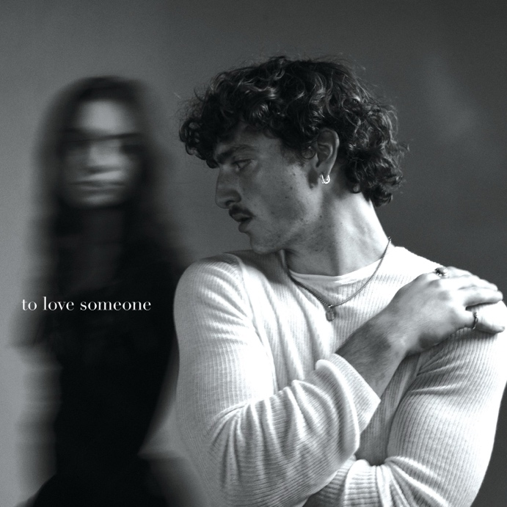
Download hi-res artwork HERE

November 10, 2023 (Los Angeles, CA) – Today, rising pop artist Benson Boone releases his emotional new single “To Love Someone.” Listen HERE via Night Street Records/Warner Records. The song arrives just one month after Boone was named MTV’s Global PUSH Artist for October.

"To Love Someone" is Boone’s first new release since dropping his PULSE EP earlier this year, which includes highlight tracks “What Was,” “Little Runaway,” and “Sugar Sweet.” To celebrate the release, Boone took off on a sold out headline tour across North America and Europe.

The EP was preceded by his 2022 piano ballad “Before You” and the Walk Me Home… EP, which includes hits like “GHOST TOWN.” The latter became Boone's first entry on the Billboard Hot 100 and reached the Top 25 at both Top 40 and Hot AC radio. It also became his first RIAA-certified Gold record, followed by “In The Stars,” which is now certified Platinum.

Boone was discovered by Imagine Dragons superstar Dan Reynolds. Since then, he has earned more than 1.7 billion global streams to date, as well as praise from Billboard, who lauded his “restrained vocals” and Consequence, who dubbed the newcomer “an exciting new voice.” Now, with “To Love Someone,” Boone forges ahead, leaning into nostalgic, bittersweet imagery and delivering melodies you can’t help but sing along to.

Photo credit: Dennis Leupold
Download hi-res image HERE

###

FOLLOW BENSON BOONE:
TikTok | Instagram | Twitter | Facebook | YouTube

For more information, please contact:
Darren Baber | Warner Records
Darren.Baber@warnerrecords.com

