BREAKOUT POP ARTIST JENNA RAINE DROPS
NEW SINGLE “BIG DUMB HEART”
LISTEN HERE | WATCH HERE

FOLLOWS VIRAL HIT "IT IS WHAT IT IS"

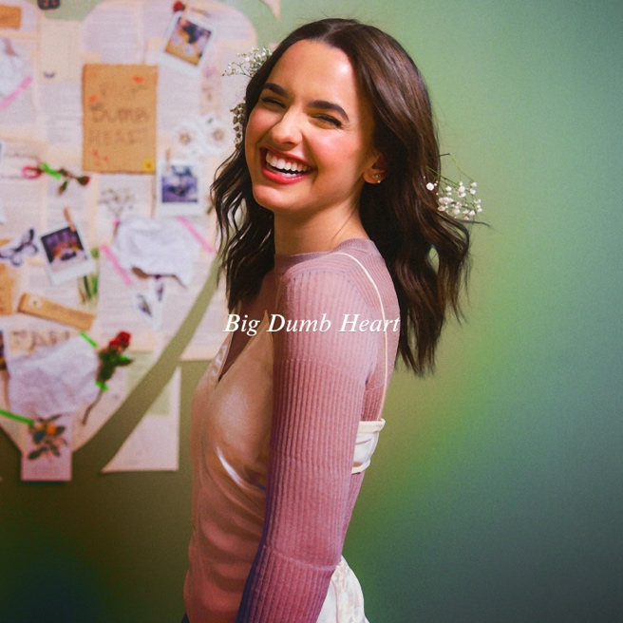
Download hi-res artwork HERE

November 10, 2023 (Los Angeles, CA) – Today, rising pop artist Jenna Raine releases her new single “Big Dumb Heart.” Listen HERE and watch the visualizer HERE. The anthem arrives on the heels of her recent viral hit “It Is What It Is,” which exploded on TikTok, garnering over 5 million views on her video that inspired its own dance trend and spawned over 40 thousand creates on the platform.

"Big Dumb Heart" follows the release of Raine’s latest EP, Big Dumb Heart, Chapter 2, which includes the fan-favorite “It Is What It Is” in addition to standout track “Cruise Control.” It followed Big Dumb Heart, Chapter 1, which boasts the infectious anthems “Stupid Cupid” and “Crickets.” In 2021, she became an online sensation with the defiantly hopeful “see you later (ten years),” which went on to amass over 100 million streams.

These breakout moments recently earned her a performance at this year’s MTV VMAs Block Party, garnered buzz from Rolling Stone, Billboard, and V Magazine, and landed her on the cover of Girls' Life Magazine.

Since day one, Raine has led with a big smile and boundless energy. Now, “Big Dumb Heart” offers even more free-flowing feels for all the world to enjoy.

ABOUT JENNA RAINE:
Jenna Raine takes life’s little lessons, moments of bliss, and unforgettable memories and turns them into the kind of pop music that you’ve got to sing with the windows down. The Dallas, Texas-born singer and songwriter continues to enchant audiences everywhere with her hyper-detailed, personal lyrics and towering hooks, tallying north of 220 million total streams to date. In 2021, “see you later (ten years)” initially took over TikTok, yet its success translated to DSPs, garnering over 100 million streams on Spotify. Landing a deal with Warner Records, she maintained this momentum with “Fumbled the Bag” and “Stupid Cupid.” In 2023, she served up the Big Dumb Heart, Chapter 1 EP followed by Big Dumb Heart, Chapter 2. The latter boasts the fan favorite anthem “It Is What It Is.” From the jump, the track resonated with listeners, piling up 8 million-plus streams in less than a month. At the same time, it set TikTok on fire with its own viral dance. Along the way, she has earned unanimous praise from Billboard, Variety, OnesToWatch, and more. Now, Raine is turning the page on her next chapter, and the story just keeps getting better.

###

FOLLOW JENNA RAINE:
Official | TikTok | Instagram | Twitter | Facebook | YouTube | Press Materials

For more information on Jenna Raine, please contact:
Darren Baber | Warner Records
Darren.Baber@warnerrecords.com

Patrice Compere | Warner Records
Patrice.Compere@warnerrecords.com

