RICKY MONTGOMERY RELEASES “BOY TOY (ACOUSTIC)”
LISTEN HERE – WATCH HERE

ACCLAIMED NEW ALBUM RICK OUT NOW

November 17, 2023 (Los Angeles, CA) – Breakout alt-pop artist Ricky Montgomery shares an upbeat acoustic version of his fan favorite single “Boy Toy,” off his recently-released major label debut album, Rick. Listen to “Boy Toy (Acoustic)” HERE and watch the visualizer HERE!

On the new version, Ricky strips the song down to its bare essentials, placing its sticky hook front-and-center. The original “Boy Toy” had a viral breakthrough earlier this fall, thanks in part to his 1.7M TikTok followers and a buzzing anime trend on the platform that’s historically become a unique and powerful driving force for his 1+ billion stream catalog. Learn more in his Polygon feature here.

About “Boy Toy (Acoustic),” he commented, “I wrote ‘Boy Toy’ on acoustic guitar. The melody reminded me of my favorite folk-rock/punk bands like Violent Femmes. As we built up the version of the song that would end up on Rick, I never stopped wanting to hear what an acoustic version would sound like. So I made one with my friends, and I love it just as much as the original.”

With 2 billion streams and 8 billion TikTok views, Ricky continues to foster his devoted young fanbase that hangs onto every word of his sunny, soul-searching alt-pop about life in all its messy and mundane glory. The new 14-track album incited unanimous praise from fans and critics alike, with WONDERLAND promising, “this album is set to be a defining chapter in the career of Montgomery, fully coming into his own as an artist with depth, character and presence.” Billboard raved, “The listener can’t help but pay attention to Montgomery” and FAULT Magazine professed, “The album is a soul-searching journey through life’s trials and triumphs, woven together by Montgomery’s eloquent songwriting skills, sometimes whimsical narratives and always emotive storytelling.” Listen to Rick HERE, and purchase physical formats of Rick HERE, including vinyl, CD, and cassette.

Next up, he will embark on his biggest North America headline tour yet in 2024: "The Rick Tour: Another Rick in the Wall” – see a full list of dates below, and purchase tickets at rickymontgomery.com/#tour.

2024 TOUR DATES
2/13 Phoenix, AZ The Van Buren
2/15 Austin, TX Emo’s
2/16 Dallas, TX House of Blues
2/17 Houston, TX White Oak Music Hall (SOLD OUT!)
2/19 Orlando, FL The Plaza Live (SOLD OUT!)
2/20 Atlanta, GA Center Stage (SOLD OUT!)
2/22 Norfolk, VA The NorVa
2/23 Silver Spring, MD The Fillmore Silver Spring
2/24 New York, NY Terminal 5
2/26 Philadelphia, PA TLA (SOLD OUT!)
2/27 Boston, MA Royale (SOLD OUT!)
2/28 Montreal, QC Le Studio TD (SOLD OUT!)
3/1 Toronto, ON Danforth Music Hall (SOLD OUT!)
3/2 Detroit, MI Saint Andrew's Hall (SOLD OUT!)
3/3 Columbus, OH Newport Music Hall
3/5 Chicago, IL The Riviera Theatre
3/6 St. Louis, MO The Pageant
3/8 Madison, WI The Sylvee
3/9 Minneapolis, MN First Avenue
3/12 Denver, CO Gothic Theatre
3/13 Salt Lake City, UT Depot
3/15 Vancouver, BC Vogue
3/16 Seattle, WA Showbox Market (SOLD OUT!)
3/17 Portland, OR Wonder Ballroom
3/19 San Francisco, CA Regency
3/22 San Diego, CA SOMA
3/23 Los Angeles, CA The Wiltern

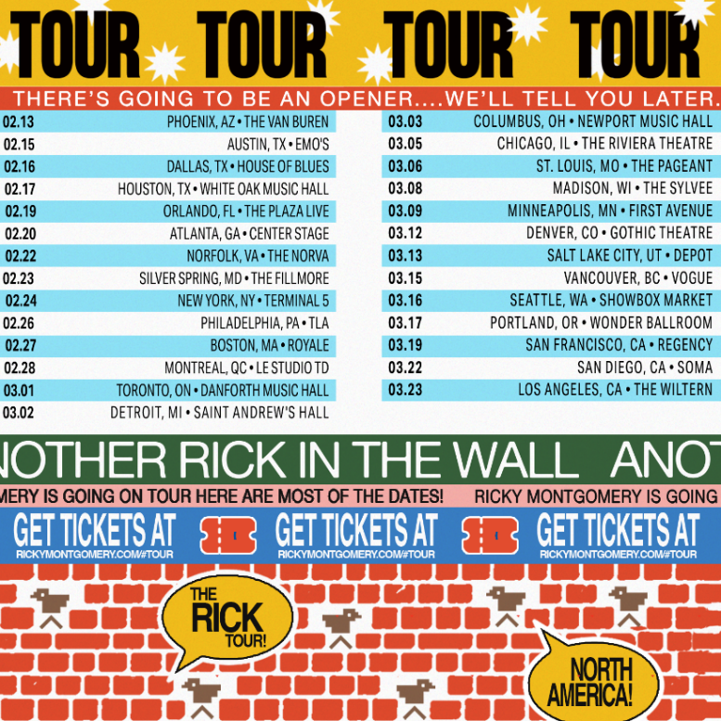
Download hi-res admat here

###
For more information, contact:
Ceri Roberts, Ceri.Roberts@warnerrecords.com
Patrice Compere, Patrice.Compere@warnerrecords.com

Press Materials:
press.warnerrecords.com/rickymontgomery

Follow Ricky Montgomery:
INSTAGRAM | TWITTER | YOUTUBE | TIKTOK

