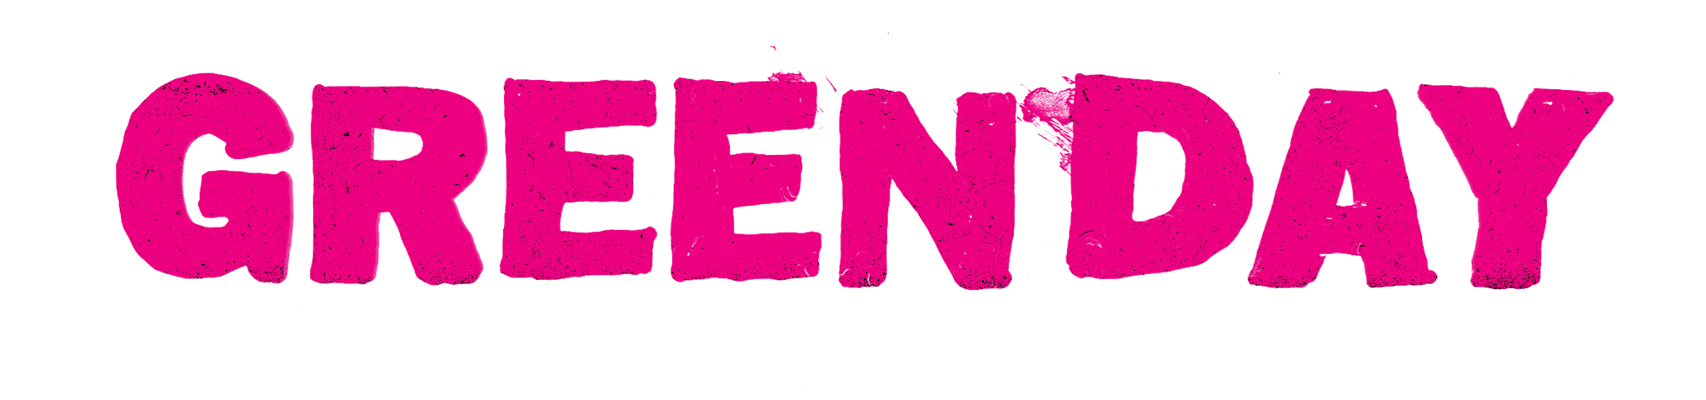
GREEN DAY UNVEILS HIGHLY ANTICIPATED BRILLIANT ROCK MASTERPIECE
SAVIORS

LISTEN HERE

MASSIVE GLOBAL STADIUM TOUR KICKS OFF IN MAY
PLAYING DOOKIE AND AMERICAN IDIOT IN THEIR ENTIRETY – TICKETS HERE

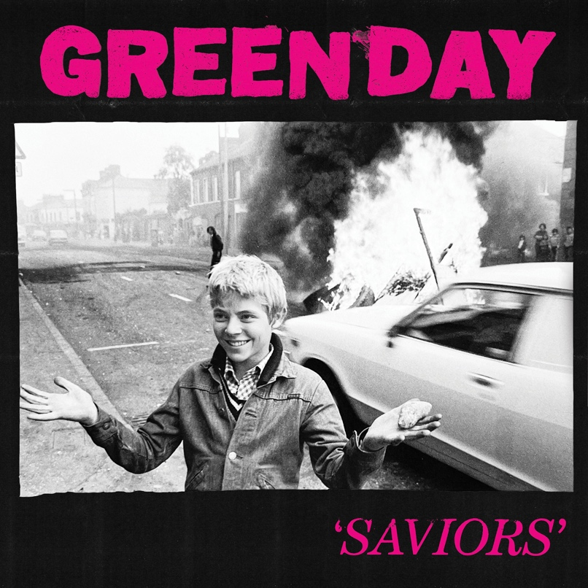
Saviors Artwork

“Huge songs and snotty satire for a world on fire” - Rolling Stone

“Saviors has fire in its belly and ice in its veins" - The Sunday Times

January 19, 2024 (Los Angeles, CA) - Global rock superstars Green Day – Billie Joe Armstrong, Mike Dirnt, and Tré Cool – have unveiled their highly anticipated 14th studio album, Saviors. Along with the record, the band released a video for new track “Bobby Sox,” which has all the classic punk rock panache that only Green Day can deliver.

Listen to Saviors HERE
Watch the “Bobby Sox” video HERE

“Bobby Sox” is one of my favorite songs on the album,” shares Billie Joe Armstrong. “It’s the Nineties song that we never wrote. It started out being a song I wrote for my wife but as it materialized, I wanted to switch it up and added, ‘Do you wanna be my boyfriend?’ on top of ‘Do you wanna be girlfriend’... So the song becomes a kind of universal anthem.”

Saviors features previously released bombastic tracks “One Eyed Bastard,” “Dilemma,” “Look Ma, No Brains!,” and “The American Dream Is Killing Me,” which were all met with huge praise from Rolling Stone, Alternative Press, SPIN, Stereogum, Brooklyn Vegan, and more. Just last night, Green Day celebrated the album release with an intimate show at NYC’s Irving Plaza, as a part of SiriusXM’s Small Stage Series. The concert follows their takeover of Dick Clark’s New Year’s Rockin’ Eve, where the band kicked off 2024 with cuts from Dookie, American Idiot, and a killer TV debut of “Dilemma,” which Rolling Stone hailed as “one of the album’s best songs.”

Over the last few months, Green Day have given fans a taste of what to expect from their forthcoming world tour with surprise performances around the world. Whether they were packing a pub in the U.K. for an impromptu intimate performance, or rocking out with diehard fans at a sold-out surprise show in Las Vegas just days before their killer headline sets at When We Were Young Festival, Green Day made sure to bring the energy leading up to the birth of Saviors.

Recorded in London and Los Angeles, Saviors is the latest powerful collaboration between Green Day and Grammy-winning producer Rob Cavallo, whose notable previous work with Green Day includes two of the band’s most iconic albums, 1994’s Dookie and 2004’s American Idiot.

Green Day’s larger-than-life global stadium tour – The Saviors Tour, fueled by Monster Energy – kicks off in Europe this May before making its way to North America in July for an intoxicating summer run through the states. Earlier this week, the band revealed on Howard Stern’s SiriusXM show that, for the first time ever, they’ll be performing both Dookie and American Idiot albums in their entirety this summer in celebration of their 2024 milestone anniversaries, along with fan favorites and cuts off the new album. All tour dates can be found HERE and below.

THE SAVIORS UK/EU TOUR DATES:
With support from Nothing But Thieves, The Hives, Donots, The Interrupters and Maid of Ace

Thu May 30 – Monte do Gozo, Spain – O Son do Camino*
Sat Jun 1 – Madrid Spain – Road to Rio Babel*
Wed Jun 5 – Lyon Decines – LDLC Arena - with The Interrupters
Fri Jun 7 – Nurnberg Germany – Rock im Park*
Sat Jun 8 – Nurburgring Germany – Rock am Ring*
Mon Jun 10 – Berlin Germany – Waldbühne - with Donots
Tue Jun 11 – Hamburg Germany – Trabrennbahn Bahrenfeld - with Donots
Sat Jun 15 – Interlaken Switzerland – Greenfield Festival*
Sun Jun 16 – Milan Italy – I Days - Hippodrome La Maura*
Tue Jun 18 – Paris France – Accor Arena - with The Interrupters
Wed Jun 19 – Arnhem Netherlands – GelreDome - with The Hives & The Interrupters
Fri Jun 21 – Manchester UK – Emirates Old Trafford - with Nothing But Thieves & Maid of Ace
Sun Jun 23 – Isle of Wight UK – Isle of Wight Festival*
Tue Jun 25 – Glasgow UK – Bellahouston Park - with Nothing But Thieves & Maid of Ace
Thu Jun 27 – Dublin Ireland – Marlay Park - with Nothing But Thieves & Maid of Ace
Sat Jun 29 London UK – Wembley Stadium - with Nothing But Thieves & Maid of Ace
*Festival Date

THE SAVIORS NORTH AMERICAN TOUR DATES:
With support from The Smashing Pumpkins, Rancid, and The Linda Lindas

Mon Jul 29 – Washington, DC – Nationals Park
Thu Aug 01 – Toronto, ON – Rogers Centre
Sat Aug 03 – Montreal, QC – Osheaga Music and Arts Festival*
Mon Aug 05 – New York, NY – Citi Field
Wed Aug 07 – Boston, MA – Fenway Park
Fri Aug 09 – Philadelphia, PA – Citizens Bank Park
Sat Aug 10 – Hershey, PA – Hersheypark Stadium
Tue Aug 13 – Chicago, IL – Wrigley Field
Thu Aug 15 – St. Louis, MO – Hollywood Casino Amphitheatre !
Sat Aug 17 – Minneapolis, MN – Target Field
Tue Aug 20 – Kansas City, KS – Azura Amphitheatre !
Thu Aug 22 – Cincinnati, OH – Great American Ballpark
Sat Aug 24 – Milwaukee, WI – American Family Field
Mon Aug 26 – Charlotte, NC – PNC Music Pavilion !
Wed Aug 28 – Atlanta, GA – Truist Park
Fri Aug 30 – Nashville, TN – Geodis Park
Sun Sep 01 – Pittsburgh, PA – PNC Park
Wed Sep 04 – Detroit, MI – Comerica Park
Sat Sep 07 – Denver, CO – Coors Field
Tue Sep 10 – Austin, TX – Germania Insurance Amphitheater !
Wed Sep 11 – Arlington, TX – Globe Life Field
Sat Sep 14 – Los Angeles, CA – SoFi Stadium
Wed Sep 18 – Phoenix, AZ – Chase Field
Fri Sep 20 – San Francisco, CA – Oracle Park
Mon Sep 23 – Seattle, WA – T-Mobile Park
Wed Sep 25 – Portland, OR – Providence Park
Sat Sep 28 – San Diego, CA – Petco Park

*Festival Date
!With Support from Rancid and The Linda Lindas only

ABOUT GREEN DAY:
Formed in 1986 in Berkeley, CA, Green Day is one of the world’s best-selling bands of all time, with more than 75 million records sold worldwide and 10 billion cumulative audio/visual streams. The five-time Grammy Award-winning Rock and Roll Hall of Fame inductees released their breakout album Dookie in 1994, which sold over 10 million and achieved 10x Platinum Diamond status, is widely credited with popularizing and reviving mainstream interest in punk rock, catapulting a career-long run of #1 hit singles. Entertainment Weekly calls Green Day, “The most influential band of their generation,” while Rolling Stone attests, “Green Day have inspired more young bands to start than any act this side of Kiss, and that doesn't seem to be changing.” In 2004, Green Day released the rock opera American Idiot which captured the nation’s attention, selling more than 8 million copies in the U.S. alone and taking home the Grammy Award for Best Rock Album. Mojo declared “It's exhilarating stuff, the kind of record that sets new parameters as to what is possible from a punk rock'n'roll band in the 21st century.” In 2010, a stage adaptation of American Idiot debuted on Broadway to critical and commercial acclaim. Released in 2020, Green Day’s thirteenth studio album Father Of All... debuted at #1 on Billboard’s Album Sales Chart and #1 in both the U.K. and Australia. Pitchfork declared, “Green Day’s most fetching and youthful songs in ages. The trio sounds reinvigorated, more like hungry newcomers staking their claim.” In July 2021, Green Day embarked on The Hella Mega Tour (w/ Fall Out Boy & Weezer). The global tour included 29 sold-out stadium gigs – including renowned venues like London Stadium and Los Angeles’ Dodger Stadium. Their highly anticipated 14th studio album Saviors is out now. They’ll be embarking on a global stadium tour – The Saviors Tour – this summer.

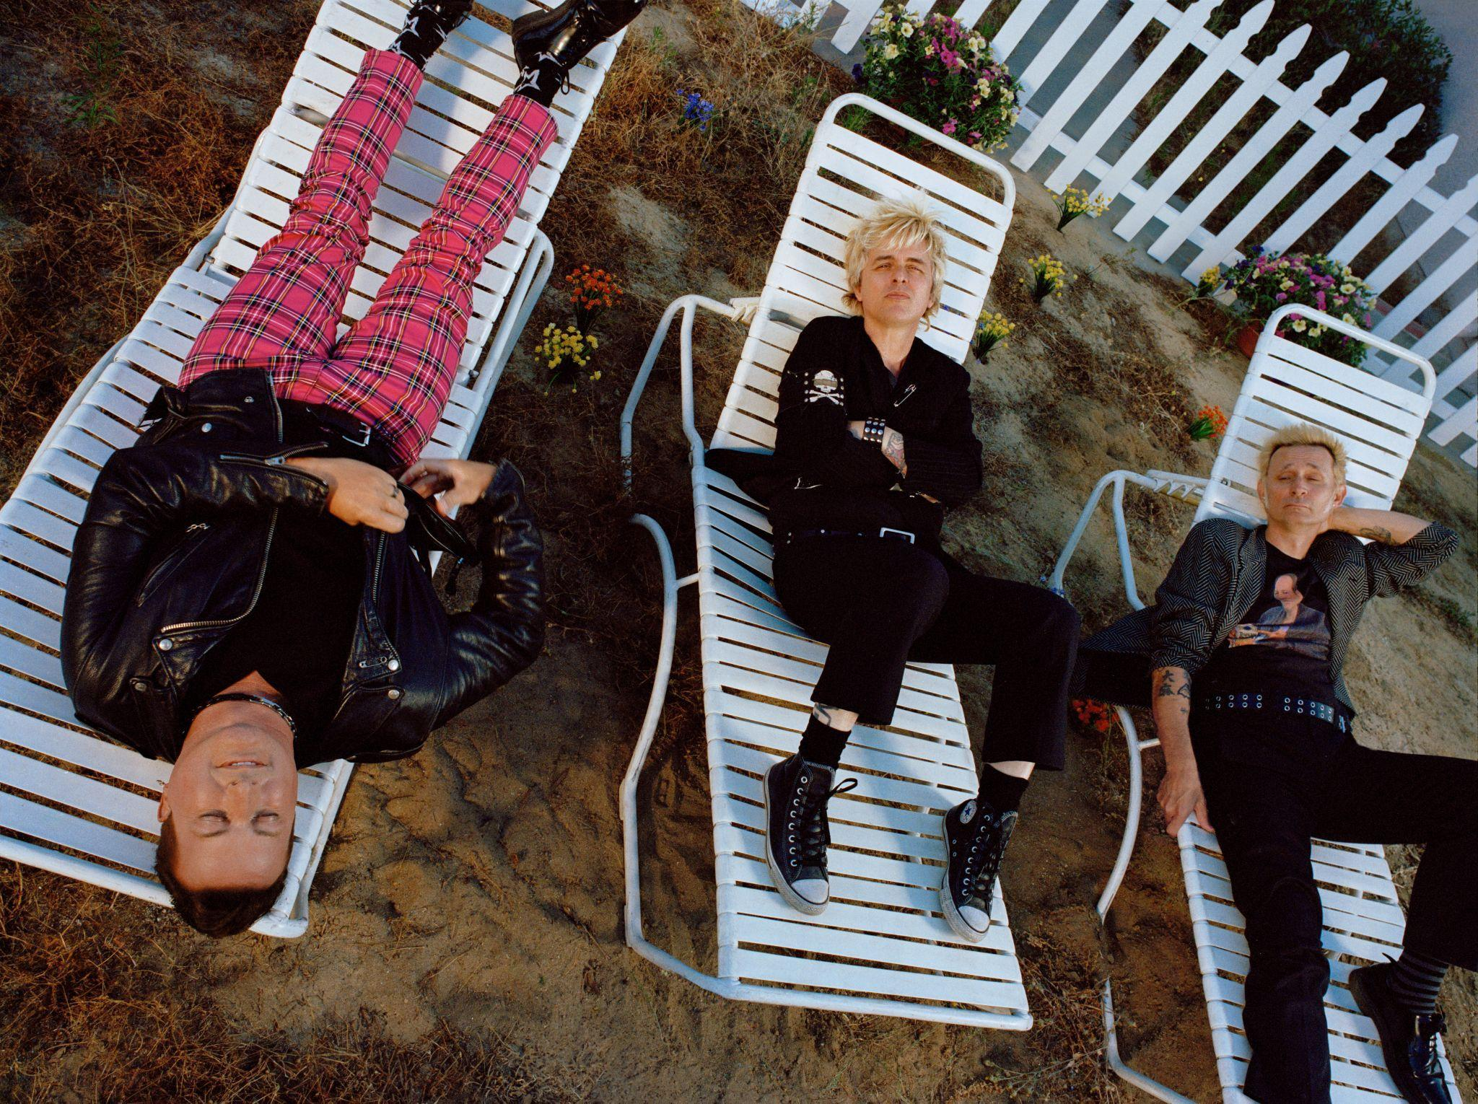
Photo credit: Emmie America

FOLLOW GREEN DAY
Facebook | Twitter | TikTok | Instagram | YouTube | Press Site | Website

For more information, contact:
Luke Burland | 2b Entertainment
luke@2bentertainment.net

Jenny Huynh | 2b Entertainment
jenny@2bentertainment.net

Laura Swanson | Warner Records
laura.swanson@warnerrecords.com

