LINKIN PARK UNVEIL CAREER-SPANNING ALBUM
PAPERCUTS (SINGLES COLLECTION 2000-2023)

PRE-ORDER/PRE-SAVE HERE

“IN THE END” RECEIVES RIAA DIAMOND (10X MILLION) CERTIFICATION

PAPERCUTS TO BE RELEASED
APRIL 12TH ON WARNER RECORDS

COLLECTION FEATURES NEVER-BEFORE-RELEASED
TRACK “FRIENDLY FIRE” FROM
ONE MORE LIGHT-ERA

LISTEN HERE
WATCH VIDEO HERE

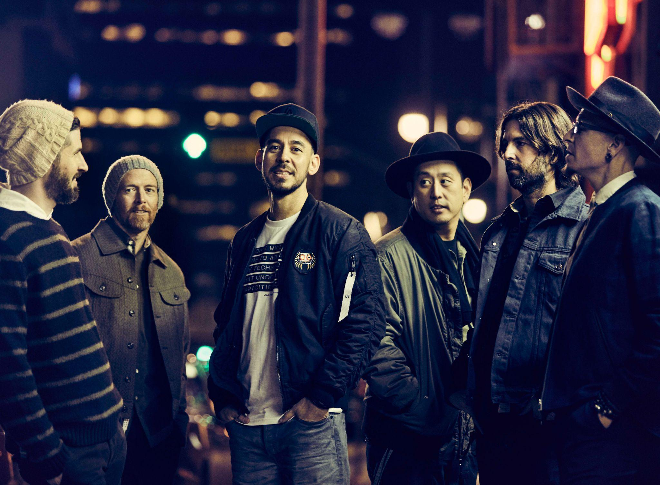
Hi-res image HERE
February 23, 2024 (Los Angeles, CA) – Assembling an essential collection of generational anthems, LINKIN PARK will present their first-ever career-spanning greatest hits album entitled Papercuts (Singles Collection 2000-2023) on April 12TH via Warner Records.

Pre-order/Pre-save HERE. It will be available at all DSPs and in various physical configurations, including CD, Cassette, and double Vinyl. For the latter, there are several limited edition color vinyl variants, a Zoetrope picture disc and black vinyl.

The fan enthusiasm and fervor for both Hybrid Theory (20TH Anniversary Edition) in 2020 and Meteora (20TH Anniversary Edition) last year ultimately inspired the band to curate and carefully piece together what would become Papercuts. It offers a comprehensive retrospective of their journey so far in the span of one album highlighted by everything from “Crawling” and “Somewhere I Belong” to the sought-after rarity “QWERTY.”

Check out the full tracklisting below.

In addition to the classics, LINKIN PARK uncovered the never-before-released track “Friendly Fire.” Recorded during the 2017 sessions for their seventh album One More Light, it features a powerhouse vocal performance from the late Chester Bennington. The video was directed and edited by long-time collaborator Mark Fiore and features never-before-seen studio and live footage - watch HERE. Cinematic keys and a delicate beat underline emotionally charged verses as humming guitar uplifts the introspective chorus, “We’re pulling apart for no reason, we’re pulling a trigger in a useless war…what are we fighting for.” It embodies the style, soul, and spirit of classic LP.

About “Friendly Fire” Brad Delson added, “‘Friendly Fire’ was always one of our favorite songs from the One More Light sessions. Something about it wasn’t quite right so as close as it got to the finish line, we chose to set it aside for later. When we started looking for an unreleased track to include on our greatest hits collection, I was blown away by the power of the song, the power of the storytelling, the power of the vocal, the sonic landscape and I actually thought that it was closer than maybe we had realized at the time.

We got together to work on it and connect some of the missing pieces that for whatever reason hadn’t revealed themselves during the recording of One More Light. I can’t wait for people to hear it. It’s such a beautiful, compelling, heartbreaking, hopeful story and it really resonates with me today.”

Said Mike Shinoda, “In the making of each Linkin Park album, I want to love and believe in each individual song completely. I hope that if any one track is heard on its own in the world, it is something I can feel proud of, and something that takes root inside the listener and becomes part of the energy that connects us.

Curating the tracks for Papercuts was a joy. Each song in this collection is both a singular moment on our timeline and an evolving story that is as much ours as it is yours. From our first release ‘One Step Closer’ to the brand-new ‘Friendly Fire,’ this tracklist spans all our chapters so far. Thank you for being a part of our journey. We hope you enjoy Papercuts.”

Additionally, “In The End” just achieved a Diamond Certification (10x Million) from the RIAA. It stands out as the band’s most-streamed song with over 1.8 billion Spotify streams and 1.7 billion YouTube views on the music video. This marks their first Diamond Certification for a single. It notably graces the tracklisting of their 12x-platinum Diamond-Certified full-length debut, Hybrid Theory.

In 2023, LINKIN PARK unleashed Meteora 20th Anniversary Edition. It soared to #1 on the Billboard Top Hard Rock Albums Chart, Top Rock Albums Chart, Top Catalog Albums Chart, and Top Vinyl Albums Chart in addition to landing in the Top 3 of the Top Album Sales Chart and vaulting into the Top 10 of the Billboard 200 at #8. Not to mention, the single “Lost” took flight as the biggest rock song of 2023 and earned the “first #1 debut on Billboard’s Rock & Alternative Airplay Chart in over a decade!” Simultaneously, it became the band’s highest-charting Billboard Hot 100 entry since 2012, bowing at #38! Thus far, it has amassed over 166 million Spotify streams and 78 million YouTube views on the stunning music video. Meteora 20th Anniversary Edition was chronicled and celebrated by The New York Times, The FADER, The Howard Stern Show, KROQ, and more.

Papercuts arrives April 12!

PAPERCUTS (Singles Collection 2000-2023) Tracklisting:
1. Crawling
2. Faint
3. Numb/Encore
4. Papercut
5. Breaking The Habit
6. In The End
7. Bleed It Out
8. Somewhere I Belong
9. Waiting For The End
10. Castle Of Glass
11. One More Light
12. Burn It Down
13. What I’ve Done
14. QWERTY
15. One Step Closer
16. New Divide
17. Leave Out All The Rest
18. Lost
19. Numb
20. Friendly Fire

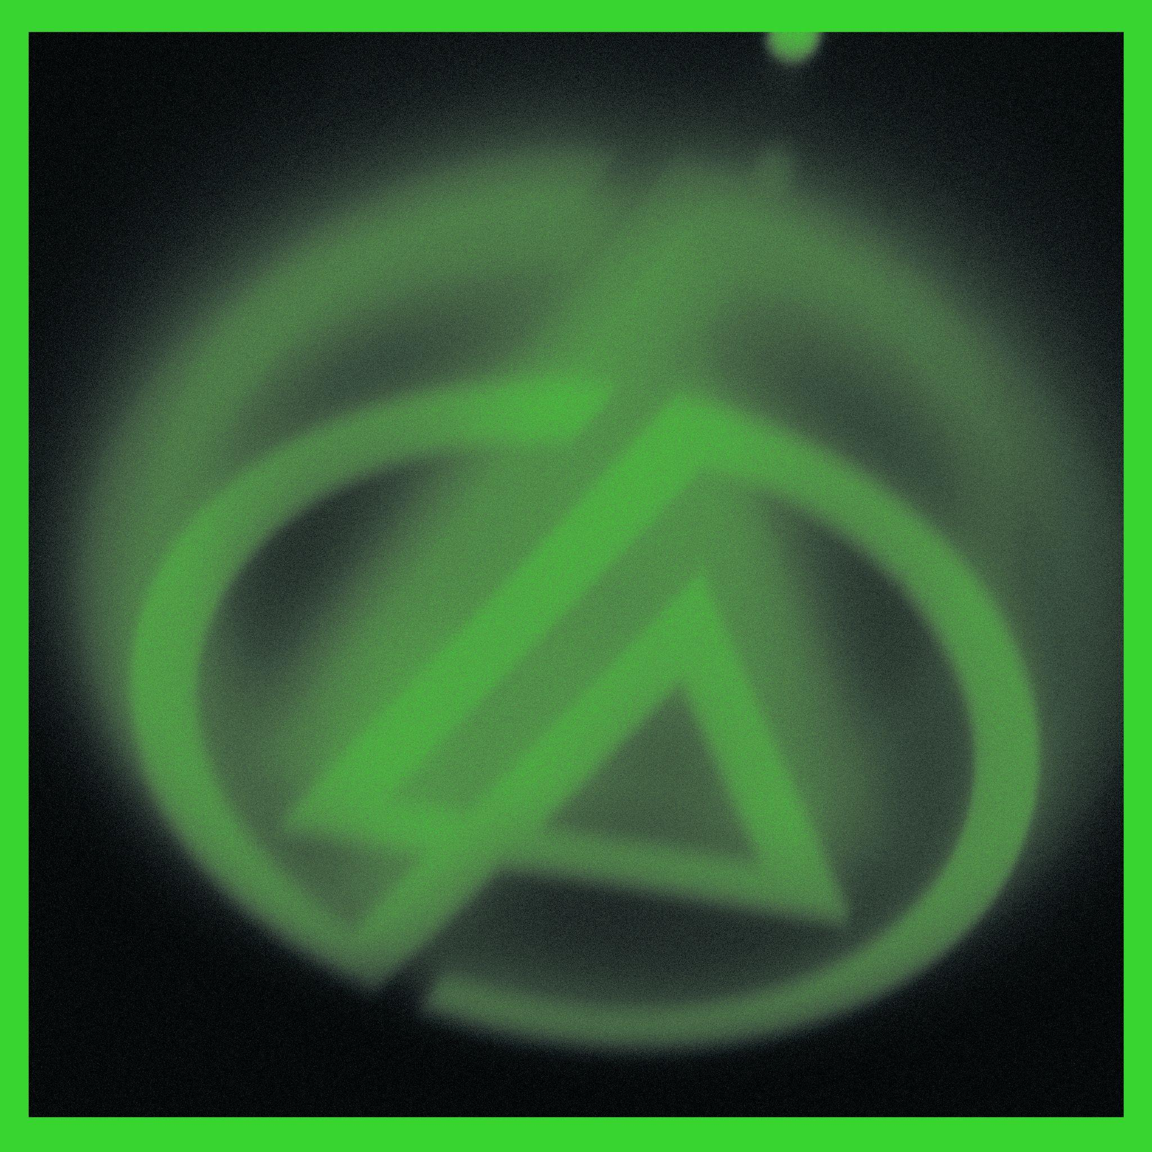
Hi-res cover art HERE

ABOUT LINKIN PARK:
LINKIN PARK emerged as an innovative musical force and one of the best-selling artists of the last twenty years. Their RIAA Diamond-certified full-length debut, Hybrid Theory, stands out as the “best selling debut of the 21st century,” while landmark sophomore album Meteora bowed at #1 on the Billboard Top 200 before going 8X-Platinum in the U.S. The band’s worldwide sales across the entire catalog eclipses 100 million, and among numerous accolades and honors, they have garnered 2 GRAMMY® Awards, 5 American Music Awards, 4 MTV VMA Awards, 10 MTV Europe Music Awards and 3 World Music Awards. Selling out stadiums worldwide, they’ve headlined global music festivals such as Download and Reading & Leeds in the UK, Rock in Rio in Portugal, Rock Am Ring and Rock Im Park in Germany, and Summer Sonic in Japan. They also remain the first and only Western rock band to play a five-stadium tour in China. 2017’s Gold-certified One More Light marked their fifth #1 debut on the Billboard 200. In 2020, the band celebrated their groundbreaking debut album, Hybrid Theory, by releasing a comprehensive 20th anniversary edition super deluxe box set which features their RIAA Diamond-certified single “In The End.”. In 2023, the band released Meteora 20th Anniversary Edition, which topped the charts and featured the newly-uncovered song “Lost.” The emotionally charged single was originally recorded during sessions for their second studio album Meteora (2003), and soon after its February 10, 2023 release, “Lost” hit #1 at both Alternative and Rock radio.

Follow LINKIN PARK:
Official Site | Facebook | Twitter | Instagram | YouTube | TikTok

Download hi-res assets:
press.warnerrecords.com/linkinpark

