Sir Rod Stewart & Jools Holland Partner Up For A Sparkling Salute To The Big Band Years!
Collaborative Studio Album Swing Fever
out February 23rd, 2024 on Warner Music
First Track ‘Almost Like Being In Love’ - Out Today
LISTEN HERE
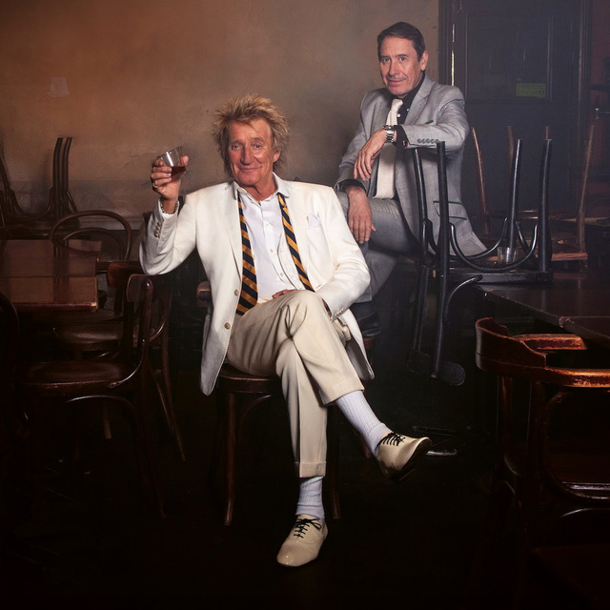
Credit: Jonas Mohr

Sir Rod Stewart and Jools Holland with his Rhythm & Blues Orchestra present the exquisite
Swing Fever - a 13-track sparkling salute to the timeless songs of the big band years, reignited by two true giants of their craft - out February 23rd, 2024 on Warner Music.
For the first time, Britain's new partners in swing have united on record to share their peerless dexterity on a tribute to such truly great songs as 'Ain't Misbehavin’, 'Frankie And Johnny’, 'Sentimental Journey' and 'Lullaby Of Broadway’.

Swing Fever is the realisation of conversations between Rod and Jools that began in the pandemic years, and of Rod's dream of making an album of the songs that were, in many ways, the rock 'n' roll of their day. Sitting down together, Jools recounts: "I was just packing up to go away for Christmas, and you rang me. We hadn't really spoken at any length before. I thought 'I love Rod, how exciting,' and you said 'I want to do a record.' I'd been a fan of Rod forever but we realised with the old music that we liked a lot of the same things."
"I'd already started making a swing album, but it didn't turn out how I wanted it," explains Rod. "It was more Frank Sinatra than it was Louis Prima, let's say. So I cancelled that, and then I realised the guy I should go to is Jools. Also, our fanatical model railway enthusiasm bonded us together. So we started recording."
The first track to be released is a superb working of show tunes ‘Almost Like Being In Love’ - written by Alan Jay Lerner and Frederick Loewe, and made famous by Frank Sinatra & Nat King Cole. Listen HERE.
"I didn't really know that song, but it's one of my favourites now” comments Jools. “I looked up the different versions of it, and there are loads. What we try and do is get to the essence of it. If there are lots of complicated chords, we get rid of those and just play the simple ones. There's a John Lee Hooker record where he's teaching the blues, and he says 'Listen children, throw all those fancy chords away. Just play the one chord, make that sound good, then you can think about playing another one.' We also spoke about trying to make it a bit Django Reinhardt-esque, and we got a guy from Liverpool called Gary Potter, who's like the top Django guy. He's really great, he's got the spirit of Django."
Over roughly a dozen collective sessions, the intimacy of the recording space combined with the enduring brilliance of the songbook to create a sound that's infectious and irresistible – and it sounds live because that's what it was.
"I've got to give credit to Jools' orchestra, and especially the drums [Gilson Lavis] and bass [Dave Swift]," says Rod. "Gilson is the nearest thing I've heard to Charlie Watts, in being able to do a backbeat properly. Great band, and this man Jools with the old piano. Steaming! And his brother Chris on the Hammond. The orchestra rehearsed them a couple of times when I wasn't there, then they went in and did three a day, which is quite remarkable. Jools' studio is so small. It's ok if it's a three-piece band, but we had 18 pieces in there at one time. It just unites everybody.”
Rod Stewart is one of the best-selling artists, with over 250 million albums sold worldwide. His signature voice, style and songwriting have transcended all genres of popular music, from rock, folk, soul, R&B, and even the Great American Songbook; making him one of the few stars to enjoy chart-topping albums throughout every decade of his career. He’s earned countless of the industry’s highest awards, among them, two inductions into the Rock and Roll Hall of Fame, the ASCAP Founders Award for songwriting, New York Times bestselling author, Grammy™ Living Legend, and in 2016 he officially became “Sir Rod Stewart” after being knighted at Buckingham Palace for his services to music and charity.
Some of his major hits include "Gasoline Alley," "Every Picture Tells a Story," "Mandolin Wind," "You Wear It Well," "The Killing of Georgie," "Tonight's the Night," "You're In My Heart (The Final Acclaim)," "Da Ya Think I'm Sexy?," "Young Turks," "Forever Young," "Hot Legs," "Infatuation," the unforgettable "Maggie May," and many more.
Jools sums up the spontaneous charm of Swing Fever; "The effect that this music has on me, and whenever I put it on where people are, they feel this thing, they want to move. Music is an expression of a lot of different things, and joy is an important part of what it does. You can feel the joy in this music, and it's unashamed joy as well."
Swing Fever is available on Black Vinyl, Colour Vinyl, CD & Digital - pre-order HERE.
Swing Fever Tracklisting
- Lullaby Of Broadway
- Oh Marie
- Sentimental Journey
- Pennies From Heaven
- Night Train
- Love Is The Sweetest Thing
- Them There Eyes
- Good Rockin’ Tonight
- Ain’t Misbehavin’
- Frankie And Johnny
- Walkin’ My Baby Back Home
- Almost Like Being In Love
- Tennessee Waltz

