DUA LIPA ANNOUNCES
HIGHLY-ANTICIPATED THIRD ALBUM
RADICAL OPTIMISM OUT MAY 3RD

PRE-ORDER / PRE-SAVE HERE

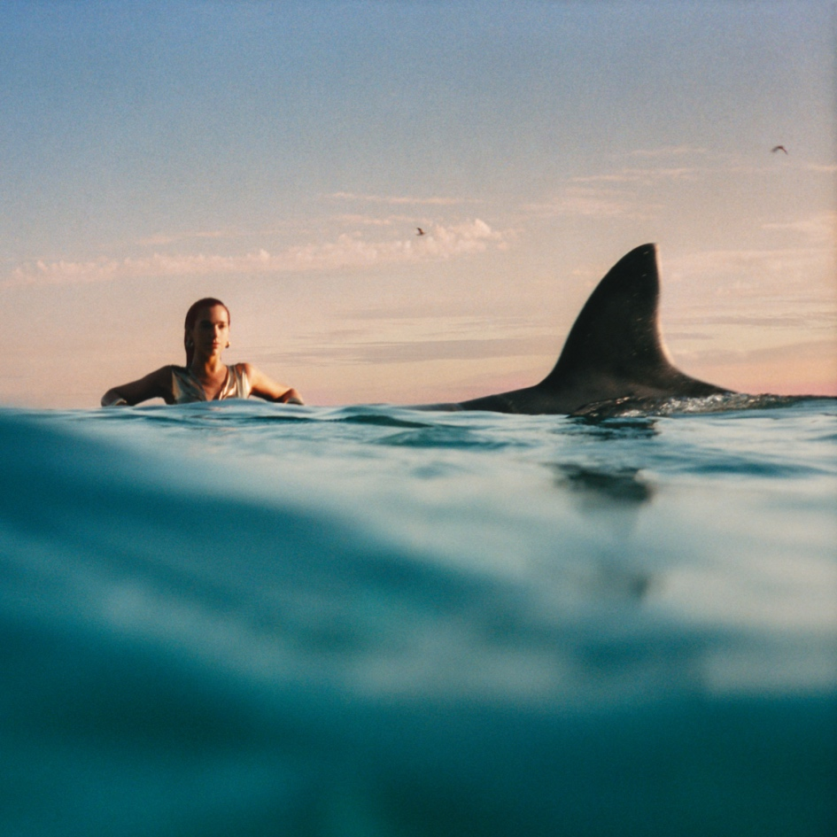
Radical Optimism Album Artwork

Today, 3x GRAMMY and 7x BRIT Award-winning global pop powerhouse Dua Lipa announces her highly-anticipated third album, Radical Optimism. The album will be released May 3rd and consist of 11 songs including the euphoric club-ready track “Houdini” and recently released single “Training Season.” You can pre-order/pre-save Radical Optimism here.

Inspired by Dua’s own self-discovery, Radical Optimism is an album that taps into the pure joy and happiness of having clarity in situations that once seemed impossible to face. The hard goodbyes and vulnerable beginnings that previously threatened to crush your soul, become milestones as you choose optimism and start to move with grace through the chaos.

Rolling Stone has called the album “pop bliss,” while noting it is “uniquely and utterly Dua Lipa: confident dance pop full of witty Instagram-caption-ready one-liners.”

Infused with the energy of Dua’s hometown, London, the attitude of the album embodies the rawness, honesty, confidence and freedom of ‘90s Britpop. Radical Optimism transports its listener to a dreamy pop world rich in musicality, lyrically unapologetic and sonically liberating.

“A couple years ago, a friend introduced me to the term Radical Optimism. It’s a concept that resonated with me, and I became more curious as I started to play with it and weave it into my life,” Dua shares. “It struck me – the idea of going through chaos gracefully and feeling like you can weather any storm. At the same time, I found myself looking through the music history of psychedelia, trip hop, and Britpop. It has always felt so confidently optimistic to me, and that honesty and attitude is a feeling I took into my recording sessions.”

Dua worked with a team of core collaborators throughout the project including Caroline Ailin, Danny L. Harle, Tobias Jesso Jr. and Kevin Parker.

Earlier this month, Dua opened up the BRIT Awards with an electric performance of “Training Season” and subsequently took home her 7th BRIT Award for Best Pop Act. She also opened up the GRAMMY Awards this year, where she performed a medley of “Training Season,” “Dance The Night” and “Houdini.” Dua recently became the first female artist to have four songs each with over two billion streams on Spotify (“One Kiss,” “Don't Start Now,” “New Rules” and “Levitating”).

Radical Optimism Tracklist:
- End Of An Era
- Houdini
- Training Season
- These Walls
- Whatcha Doing
- French Exit
- Illusion
- Falling Forever
- Anything For Love
- Maria
- Happy For You

Pre-order / Pre-save Radical Optimism HERE

Photo Credit: Tyrone Lebon

Follow Dua Lipa:
WEBSITE | INSTAGRAM | TIKTOK | X | FACEBOOK

About Dua Lipa
3x GRAMMY and 7x BRIT Award-winning global pop powerhouse Dua Lipa has announced her highly anticipated third album Radical Optimism will be released May 3rd. The album features the recently released “Training Season” and the euphoric club-ready track “Houdini,” which has become Dua’s longest running solo No. 1 on the UK Airplay charts and drew in over 12 million YouTube views within 24 hours of release. “Houdini” garnered immediate praise across the board from the likes of Billboard and Rolling Stone, who lauded the track as “a neo-psychedelic dance-floor rager," to Pitchfork and Vogue, who called it “a pop masterclass.” “Houdini” followed Dua’s hit song "Dance The Night" from the box office sensation Barbie, which landed on the Oscars shortlist and earned nominations at the Golden Globes, Critics Choice Awards and the GRAMMYs.

Dua's certified platinum sophomore album Future Nostalgia solidified her position as both a critical success and top radio performer. The GRAMMY-nominated record was the longest running top 10 album by a female artist on the Billboard 200 in 2021, and spawned multiple worldwide hit singles, with “Levitating” earning certified diamond status and the title of Billboard’s No. 1 Hot 100 Song of 2021.

Dua has found superstar status on stage and off, thanks to her many passions outside of music. 2022 saw Dua launch Service95, a global style, culture and society editorial platform that now comprises a weekly newsletter, the Service95 book club and the Dua Lipa: At Your Service podcast, which has been lauded by The Sunday Times and The Guardian, and was named one of the Best Podcasts of 2022 by Spotify. Having graced every major fashion magazine worldwide from Vogue and Elle to W and Dazed, Dua added "designer" to her resume in 2023 when she co-designed Versace's "La Vacanza" collection alongside Donatella Versace herself, which Vogue deemed "the hottest collaboration of the summer."

Dua’s eponymous 2017 debut album is certified platinum, spawned six platinum tracks, and made her the first female artist in BRIT Awards history to pick up five nominations in a single year. Dua has a total of 10 GRAMMY nominations, with three wins for Best Pop Vocal Album, Best New Artist and Best Dance Recording. Across platforms globally, she has amassed over 40 billion streams and holds the record for having the top two most streamed albums by a female artist of all time on Spotify.

