OCTOBER 24, 2018
FOR IMMEDIATE RELEASE

DIERKS BENTLEY WITH BROTHERS OSBORNE,
FLORIDA GEORGIA LINE WITH BEBE REXHA,
KACEY MUSGRAVES, PISTOL ANNIES, AND THOMAS RHETT
ADDED AS PERFORMERS AT “THE 52nd ANNUAL CMA AWARDS”

Country Music’s Biggest Night™ to Air Live from Bridgestone Arena
Wednesday, Nov. 14 on the ABC Television Network

NASHVILLE – Dierks Bentley with Brothers Osborne, Florida Georgia Line with Bebe Rexha, Kacey Musgraves, Pistol Annies, and Thomas Rhett have been added to the lineup of performers for “The 52nd Annual CMA Awards,” hosted for the 11th consecutive year by Brad Paisley and Carrie Underwood. Country Music’s Biggest Night™ will air live from Bridgestone Arena in Nashville, Wednesday, Nov. 14 at 8:00pm ET / 7:00pm CT on the ABC Television Network.

Previously announced performers for the CMA Awards include Kelsea Ballerini, Luke Bryan, Kenny Chesney, Dan + Shay, Old Dominion, Carrie Underwood, and Keith Urban. Additional performers and presenters will be announced in the coming weeks.

Bentley is a three-time CMA Awards winner and 24-time career nominee. He returns this year with his seventh nod for Male Vocalist of the Year and sixth nod for Album of the Year.

Brothers Osborne, three-time CMA Awards winners and seven-time career nominees, are the reigning Vocal Duo of the Year winners, bringing home the Award consecutively in 2016 and 2017. They return this year with their fourth consecutive Vocal Duo of the Year nomination.

Florida Georgia Line are six-time Vocal Duo of the Year nominees consecutively from 2013 – 2018, and three-time winners in the category (2013 – 2015). They have 11 career CMA Awards nominations with four total wins.

Musgraves is a 15-time CMA Awards nominee and two-time winner. She returns this year with her fifth Female Vocalist of the Year nomination and third Album of the Year nomination.

Pistol Annies (Miranda Lambert, Ashley Monroe and Angaleena Presley) are two-time CMA Awards nominees, receiving nods in 2013 for Music Video of the Year and Musical Event of the Year.

Rexha is a first-time CMA Awards nominee, receiving two nods this year in the Musical Event of the Year and Single of the Year categories for her crossover collaboration “Meant to Be” with Florida Georgia Line.

Thomas Rhett is a ten-time CMA Awards nominee, receiving three nods this year. He returns with his second consecutive nominations in the Male Vocalist of the Year and Music Video of the Year categories, and first nomination for Album of the Year. His first CMA Awards win was in 2016 for Single of the Year.

“The 52nd Annual CMA Awards” is a production of the Country Music Association. Robert Deaton is the Executive Producer, Gary Halvorson is the Director, and David Wild is the Head Writer.

For more information on “The 52nd Annual CMA Awards,” please visit CMAawards.com and follow CMA on Facebook, Instagram and Twitter. Fans can listen to music featuring the CMA Awards nominees and performers, on Amazon Music, Apple Music, Pandora, Spotify, and Vevo. To celebrate “The 52nd Annual CMA Awards,” the official merchandise line featuring tees, sweatshirts and other gifts is now available online.

Suggested tweet: MORE ADDED TO @CountryMusic’s #CMAawards LINEUP! @DierksBentley with @BrothersOsborne, @KaceyMusgraves, @PistolAnnies, @FLAGALine with @BebeRexha, and @ThomasRhett take the stage LIVE Wed, Nov. 14 at 8|7c on @ABCNetwork. <<link>>

About CMA Awards
The first “CMA Awards Banquet and Show” was held in 1967. The following year, the CMA Awards was broadcast for the first time – making it the longest running, annual music awards program on network television. The CMA Awards have aired on ABC since 2006. ABC is the network home of the CMA Awards and CMA’s other two television properties, “CMA Fest” and “CMA Country Christmas.”

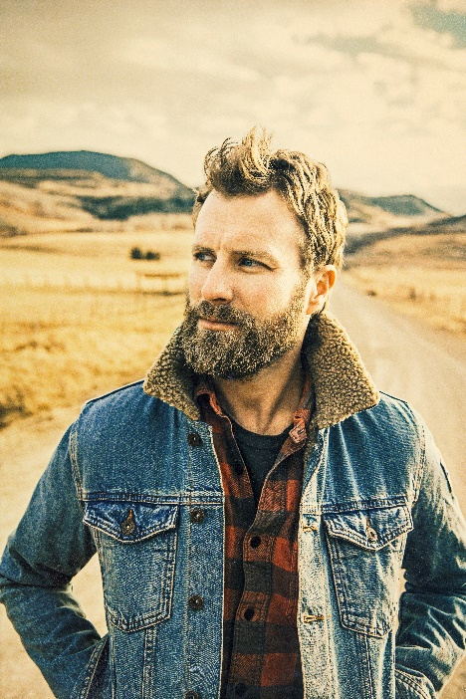
Dierks Bentley will perform with Brothers Osborne during “The 52nd Annual CMA Awards” live from Bridgestone Arena in Nashville Wednesday, Nov. 14 (7:00 – 10:00 PM/CT) on the ABC Television Network.
Photo credit: Jim Wright
Download photo

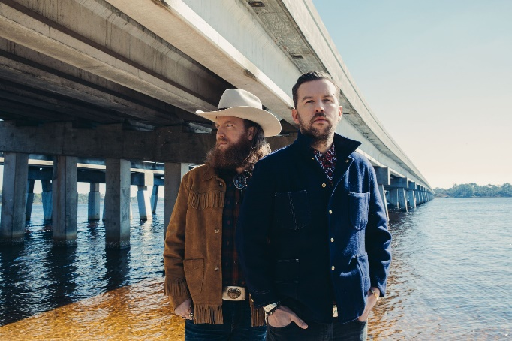
Brothers Osborne will perform with Dierks Bentley during “The 52nd Annual CMA Awards” live from Bridgestone Arena in Nashville Wednesday, Nov. 14 (7:00 – 10:00 PM/CT) on the ABC Television Network.
Photo credit: Alysse Gafkjen
Download photo

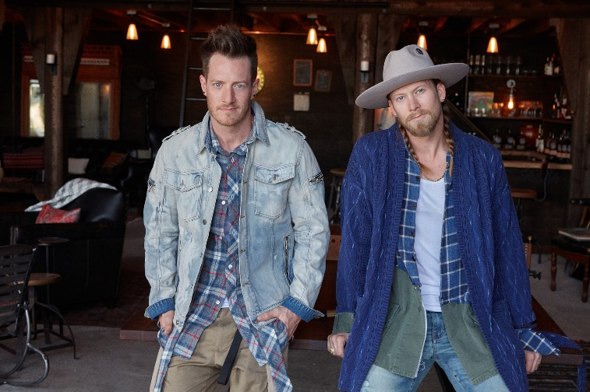
Florida Georgia Line will perform with Bebe Rexha during “The 52nd Annual CMA Awards” live from Bridgestone Arena in Nashville Wednesday, Nov. 14 (7:00 – 10:00 PM/CT) on the ABC Television Network.
Photo credit: Ryan Smith
Download photo

Kacey Musgraves will perform during “The 52nd Annual CMA Awards” live from Bridgestone Arena in Nashville Wednesday, Nov. 14 (7:00 – 10:00 PM/CT) on the ABC Television Network.
Photo credit: Jamie Nelson
Download photo

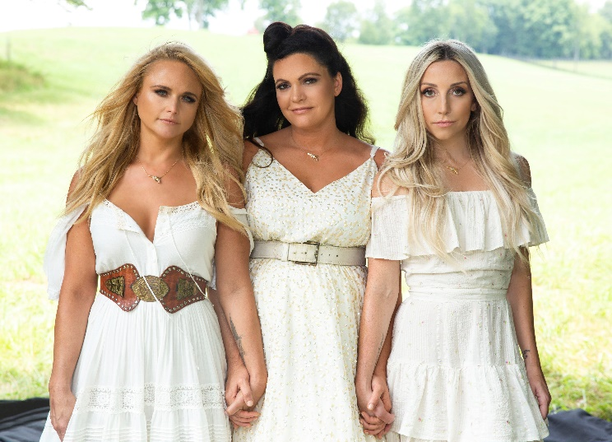
Pistol Annies will perform during “The 52nd Annual CMA Awards” live from Bridgestone Arena in Nashville Wednesday, Nov. 14 (7:00 – 10:00 PM/CT) on the ABC Television Network.
Photo credit: Miller Mobley
Download photo

Bebe Rexha will perform with Florida Georgia Line during “The 52nd Annual CMA Awards” live from Bridgestone Arena in Nashville Wednesday, Nov. 14 (7:00 – 10:00 PM/CT) on the ABC Television Network.
Photo credit: Sasha Samsonova
Download photo

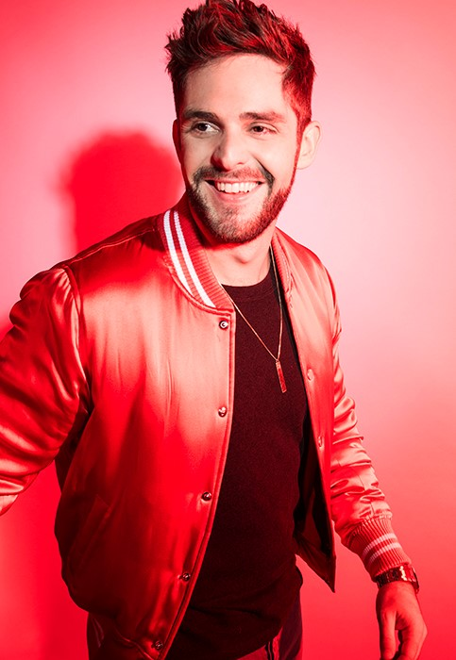
Thomas Rhett will perform during “The 52nd Annual CMA Awards” live from Bridgestone Arena in Nashville Wednesday, Nov. 14 (7:00 – 10:00 PM/CT) on the ABC Television Network.
Photo credit: John Shearer
Download photo

Brad Paisley and Carrie Underwood return for the 11th consecutive year to co-host “The 52nd Annual CMA Awards” live from Bridgestone Arena in Nashville Wednesday, Nov. 14 (7:00 – 10:00 PM/CT) on the ABC Television Network.
Photo credit: Ed Herrara/ABC
Download photo

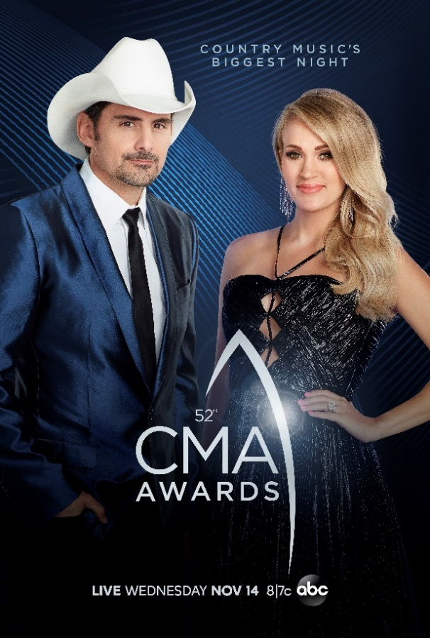
The official key art for “The 52nd Annual CMA Awards,” co-hosted by Brad Paisley and Carrie Underwood live from Bridgestone Arena in Nashville Wednesday, Nov. 14 (7:00 – 10:00 PM/CT) on the ABC Television Network.
Photo credit: CMA/ABC
Download photo

Download nominee bios and photos, and promotional assets for “The 52nd Annual CMA Awards,” at CMApress.com.

Press Contacts:
Amber Williams, CMA
Vice President, Communications & Talent Relations
awilliams@cmaworld.com

Catharine McNelly, CMA
Director, Communications
cmcnelly@cmaworld.com

