**cid:image001.gif@01D5CA32.604AFB80**

**AVENGED SEVENFOLD’S 2008 CD *DIAMONDS IN THE ROUGH* RELEASED DIGITALLY AND ON VINYL FOR THE FIRST TIME TODAY**

**2008 LIVE DVD *LIVE IN THE LBC* OUT DIGITALLY MARCH 6**

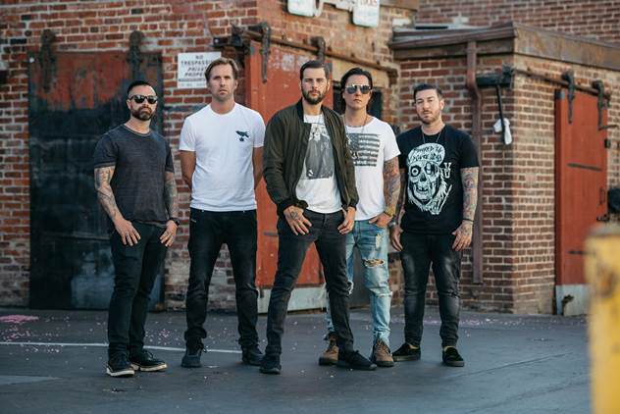

**February 7, 2020 (Los Angeles, CA) –** Grammy-nominated rock band Avenged Sevenfold have released their platinum-certified CD, *Diamonds in the Rough*,digitally for the very first time today via Warner Records. Originally released in 2008 as a compilation CD of B-sides recorded during the making of the band’s self-titled debut, the new digital version is expanded by five new tracks, including recently-released track “Set Me Free,” as well as other hard-to-find tracks such as “St, James,” “4AM,” “Lost It All,” and the band’s cover of Black Sabbath’s “Paranoid.” *Diamonds In The Rough* is also available on limited edition clear vinyl starting today. On March 6, the audio from *Live In The LBC*, which was originally released as a live DVD from the band’s 2008 show at Long Beach Arena, will be released digitally.

**Listen/Share *Diamonds In The Rough*** [**HERE**](https://a7x.lnk.to/diamonds)

**Pre-Order *Live In The LBC*** [**HERE**](https://a7x.lnk.to/lbc)

Avenged Sevenfold co-founder and singer M. Shadows explains, "It’s very typical of musicians to write 20 to 30 songs for a particular album. Most of the time, they take the best of the bunch and call it a day, discarding the rest. We have never written like that. We don’t usually finish songs unless they are fulfilling a purpose. The one exception to this was during the self-titled era. We were experimenting with our sound, producing ourselves and we had no one to reel us in. Eventually, the unreleased songs from these sessions were released under the name*Diamonds in the Rough*. We've heard the demand from many fans that want to stream the album and we wanted to make it special. So, we have remastered the album and added some hard to find tracks. We even found an unreleased track from the *Hail to the King* sessions that we think you will enjoy."

***Diamonds In The Rough* Tracklisting:**

1. Demons
2. Girl I Know
3. Crossroads
4. Flash Of The Blade (Iron Maiden Cover)
5. Until The End
6. Tension
7. Walk (Pantera Cover)
8. The Fight
9. Dancing Dead
10. Almost Easy (CLA Mix)
11. Afterlife (Alternate Version)

**Additional tracks added to new expanded version**:

1. St. James (bonus track on *Hail To The King* limited edition)
2. Set Me Free (unreleased; recorded during the *Hail To The King* sessions)
3. 4 AM (B-side on the *Welcome to the Family* EP)
4. Lost It All (Bonus track on Japanese edition of *Nightmare*)
5. Paranoid (Black Sabbath cover)

***Live In The LBC* Tracklisting:**

1. Critical Acclaim (Live)
2. Second Heartbeat (Live)
3. Afterlife (Live)
4. Beast and the Harlot (Live)
5. Scream (Live)
6. Seize the Day (Live)
7. Walk (Live)
8. Bat Country (Live)
9. Almost Easy (Live)
10. Gunslinger (Live)
11. Unholy Confessions (Live)
12. A Little Piece of Heaven (Live)

Avenged Sevenfold became one of the world’s biggest rock bands by creating a sound that broke through obstacles of language, distance and culture. They raised the stakes and standards for the genre with a string of blockbuster albums, including their 2003 gold-certified *Waking The Fallen*, 2005 platinum-selling breakthrough, *City Of Evil*, 2007’s platinum-selling *Avenged Sevenfold* and two consecutive No. 1’s on *Billboard*’s Top 200 Albums chart: 2010’s *Nightmare* and 2013’s *Hail To The King*. They’ve achieved Diamond, Platinum and Gold awards for album sales in a dozen countries, racked up over a billion video views and a billion-plus Spotify streams, and have consistently been one of the most-played bands on rock radio for over a decade with multiple No. 1 singles. Hailing from Huntington Beach, CA, the band is known for their spectacular live shows, consistently selling out arenas and headlining the most prestigious rock festivals around the globe including Download (UK), Soundwave (Australia), Hellfest (France), Summer Sonic (Japan) and Graspop (Belgium), amassing a diehard international fan base whose members number in the millions.

# # #

**For further information contact:**

National: [Jaime.Rosenberg@warnerrecords.com](mailto:Jaime.Rosenberg@warnerrecords.com)

Tour/Regional: [Patrice.Compere@warnerrecords.com](mailto:Patrice.Compere@warnerrecords.com)

**Follow Avenged Sevenfold:**

Website: [www.avengedsevenfold.com](https://nam04.safelinks.protection.outlook.com/?url=https%3A%2F%2Favengedsevenfold.com%2F&data=02%7C01%7CPatrice.Compere%40warnerrecords.com%7C8d57f9af50d640b91ad408d7992bcbc3%7C8367939002ec4ba1ad3d69da3fdd637e%7C0%7C0%7C637146285689114326&sdata=goKh9%2B0xVD0ZozJFNCVn2h3VlZafymTXjbyFVKuyxIQ%3D&reserved=0)

Facebook: [facebook.com/AvengedSevenfold](https://nam04.safelinks.protection.outlook.com/?url=https%3A%2F%2Fwww.facebook.com%2FAvengedSevenfold&data=02%7C01%7CPatrice.Compere%40warnerrecords.com%7C8d57f9af50d640b91ad408d7992bcbc3%7C8367939002ec4ba1ad3d69da3fdd637e%7C0%7C0%7C637146285689114326&sdata=eeu9wZk1TWBun%2BXf7IOD%2Fdq6Zl%2FLrCK5CJoRpp3c8zQ%3D&reserved=0)

Twitter: [@TheOfficialA7X](https://nam04.safelinks.protection.outlook.com/?url=https%3A%2F%2Ftwitter.com%2FTheOfficialA7X&data=02%7C01%7CPatrice.Compere%40warnerrecords.com%7C8d57f9af50d640b91ad408d7992bcbc3%7C8367939002ec4ba1ad3d69da3fdd637e%7C0%7C0%7C637146285689124281&sdata=O70D%2BCpUQ8mnUPh6Ej5h1xY9hanawxplWeQtqQe%2Bwpc%3D&reserved=0)

Instagram: [@avengedsevenfold](https://nam04.safelinks.protection.outlook.com/?url=https%3A%2F%2Fwww.instagram.com%2Favengedsevenfold%2F&data=02%7C01%7CPatrice.Compere%40warnerrecords.com%7C8d57f9af50d640b91ad408d7992bcbc3%7C8367939002ec4ba1ad3d69da3fdd637e%7C0%7C0%7C637146285689124281&sdata=kp56Fi9WMg%2B2qP%2Bh3GlWX1mBVwB%2BYgo0zK8fRjCo2uM%3D&reserved=0)

YouTube: [youtube.com/avengedsevenfold](https://nam04.safelinks.protection.outlook.com/?url=https%3A%2F%2Fwww.youtube.com%2Fuser%2Favengedsevenfold&data=02%7C01%7CPatrice.Compere%40warnerrecords.com%7C8d57f9af50d640b91ad408d7992bcbc3%7C8367939002ec4ba1ad3d69da3fdd637e%7C0%7C0%7C637146285689124281&sdata=Qe1v6PGwLlisd0li83Ay80agsMAZJkti%2BAEftf0v2FQ%3D&reserved=0)

**Press materials:**

[press.warnerrecords.com/avengedsevenfold](https://press.warnerrecords.com/avengedsevenfold/)