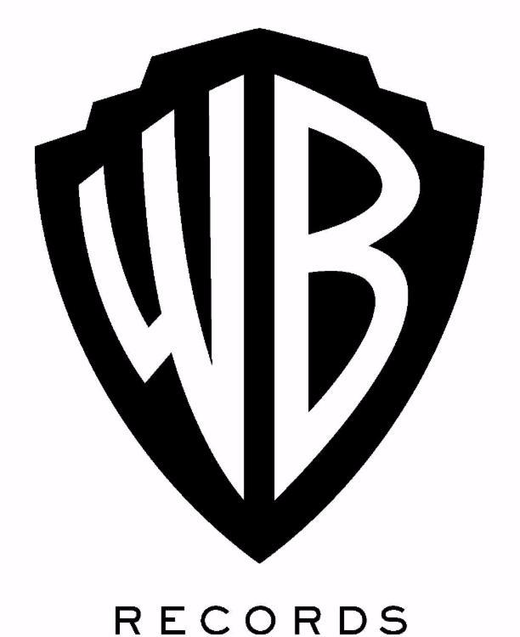

ANDRA DAY RELEASES OFFICIAL VIDEO FOR “STAND UP FOR SOMETHING” FEATURING COMMON

PENNED BY ICONIC SONGWRITER DIANE WARREN

ANDRA DAY AND COMMON TO PERFORM THE SONG AT CMT ARTISTS OF THE YEAR OCTOBER 18

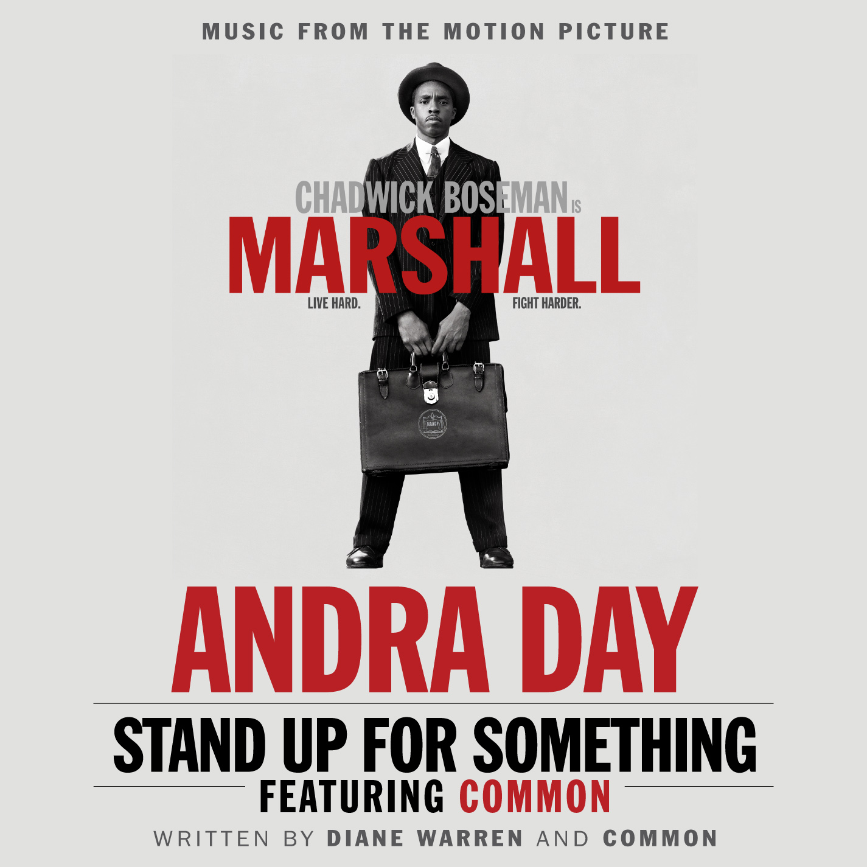

October 13, 2017 (Burbank, CA) — Today, Andra Day releases the official video for “Stand Up For Something” featuring Common.

The movie’s official soundtrack album, out now, includes Andra Day’s empowering new anthem “Stand Up For Something” [feat. Common], while the GRAMMY® Award-nominated platinum soul powerhouse makes her big-screen debut in the film.

Get the soundtrack HERE via Warner Bros. Records.

Since its release last month, “Stand Up For Something” has quietly generated substantial buzz. The Hollywood Reporter placed it among the frontrunners for “Best Original Song” at The Academy® Awards.

Watch the official video HERE.

To encourage healing in the wake of tragedy, the duo will take the stage to perform “Stand Up For Something” at the eighth annual CMT Artists of the Year special. The ceremony airs live from Nashville at the Schermerhorn Symphony Center on October 18 at 8:00 p.m. ET. Be sure to tune in.

Download/stream “Stand Up For Something”:
https://wbr.lnk.to/sufs

The original song was written for Marshall by GRAMMY®, Emmy®, and Golden Globe® Award-winning and eight-time Academy® Award-nominated legend Diane Warren and Academy® Award and GRAMMY® Award-winning hip-hop icon and actor Common. It spotlights Day’s show-stopping and stunning vocals over powerful production, as well as thought-provoking rhymes from Common. In addition, Marshall marks Day’s on-screen debut in the film.

Share what you are standing up for on social media with #StandUpForSomething and join the conversation on https://AndraDay.com.

About Marshall:
Starring Chadwick Boseman, Josh Gad, Kate Hudson, Dan Stevens, Sterling K. Brown, and James Cromwell, Marshall is based on a true incident in the life of Thurgood Marshall, when he was a young lawyer, long before his appointment to the U.S. Supreme Court. As the nation teeters on the brink of WWII, a nearly bankrupt NAACP sends Marshall to conservative Connecticut to defend a black chauffeur against his wealthy socialite employer in a sexual assault and attempted murder trial that quickly became tabloid fodder. In need of a high profile victory but muzzled by a segregationist court, Marshall is partnered with Samuel Friedman, a young Jewish lawyer who has never tried a case. Marshall and Friedman struggle against a hostile storm of fear and prejudice, driven to discover the truth in the sensationalized trial that helped set the groundwork for the Civil Rights Movement to come.

About Andra Day:
Carried by enough conviction to incite cultural change, Andra Day’s full-length debut Cheers to the Fall [Warner Bros. Records] garnered a 2016 GRAMMY® Award nomination in the category of “Best R&B Album,” while its ubiquitous lead single “Rise Up” achieved a nod for “Best R&B Performance” and earned an RIAA Platinum certification in addition to amassing more than 37 million Spotify streams. Andra has performed everywhere: The Late Show with Stephen Colbert, Ellen, Dancing with the Stars, The View, Hallmark’s National Christmas Tree Lighting, Audience TV, the CMA Country Christmas, and the America’s Got Talent Holiday Spectacular.

Quietly recognized amongst some of music’s most legendary names, the singer paid tribute to Ray Charles at The Smithsonian and shared the stage for performances with everyone from Chinese piano virtuoso Lang Lang, Bonnie Raitt, and Stevie Wonder to Ellie Goulding, Alicia Keys, and John Legend. Her voice abounded throughout the halls of the historic 2016 Democratic National Convention as well at the “International Day of the Girl” event at The White House. Along the way, she graced the cover of Essence Magazine and achieved the prestigious “Powerhouse Award” at the Billboard Women in Music event. Expanding its influence into different genres, the Mstr Rogers Remix of “Rise Up” would also soundtrack a Google Home campaign.

2017 kicked off with two show-stopping performances by the chanteuse at the 48th Annual NAACP Image Awards and a knockout Bee Gees tribute during the 59th Annual GRAMMYs®. Hyatt welcomed Andra as the voice of its “For A World Of Understanding” campaign, breathing new life into the Burt Bacharach and Hal David classic “What The World Needs Now Is Love.” As she continues to rise, work has already begun on her second full-length album due out this year.

###

For further information on Andra Day, contact Phylicia Fant at Warner Bros. Records publicity:
818-953-3781 / phylicia.fant@wbr.com

Digital Assets:
Download/stream “Stand Up For Something” here
Watch “Stand Up For Something” here
Follow Andra Day:
Website: http://www.andraday.com
Facebook: https://www.facebook.com/AndraDayMusic/
Twitter: @AndraDayMusic
Instagram: @AndraDayMusic

Press Materials:
http://press.wbr.com/andraday

