ADAM MELCHOR SIGNS DEAL WITH WARNER RECORDS,
RELEASES NEW TRACK “BEGIN AGAIN”

MELCHOR LULLABY HOTLINE, VOL. 1 SET FOR RELEASE MARCH 19

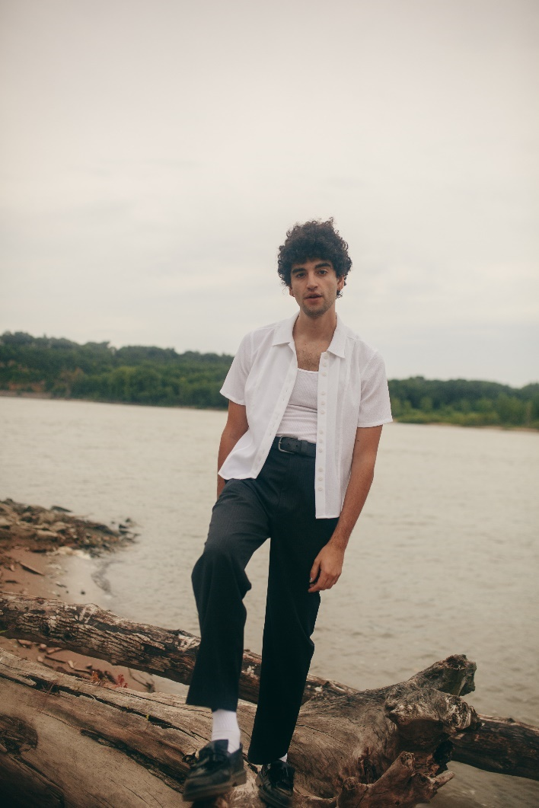

February 19, 2021 – (Los Angeles, CA) - New Jersey-born and Los Angeles-based singer, songwriter, and producer Adam Melchor shares new track “Begin Again,” the latest off his forthcoming project Melchor Lullaby Hotline, Vol. 1, due out March 19th. Adam also officially announces his signing to Warner Records, in partnership with R&R Records, after amassing north of 40 million streams and attracting acclaim from Billboard, NPR, American Songwriter, Wonderland and more. Listen to “Begin Again” HERE and watch the accompanying video HERE.

About the new track, Adam explains, “You ever show up on someone’s doorstep or hit up your ex after a long night of drinking, broken teeth and large amounts of regret? If so, this song is for you: the person who wants to get back, to find love again, and make it work with the one who may have got away.”

“Begin Again” follows the release of “Last Time,” heralds the arrival of Melchor Lullaby Hotline, Vol. 1. Last year, Adam first introduced the Melchor Lullaby Hotline, urging fans to text or email him every Sunday to hear a new song. By the end of the year, he personally sent 44 songs to a rapidly growing list of almost 10,000. The result is the forthcoming mixtape, which is part Lullaby Hotline highlights and part brand new material, making it the perfect mixtape for fans to consume cover to cover. On February 22, the rising troubadour will elevate the hotline to the next level, launching The Lullaby Hotline Podcast, a weekly podcast designed to help fans relax, unwind and fall asleep to the sound of his latest tunes.

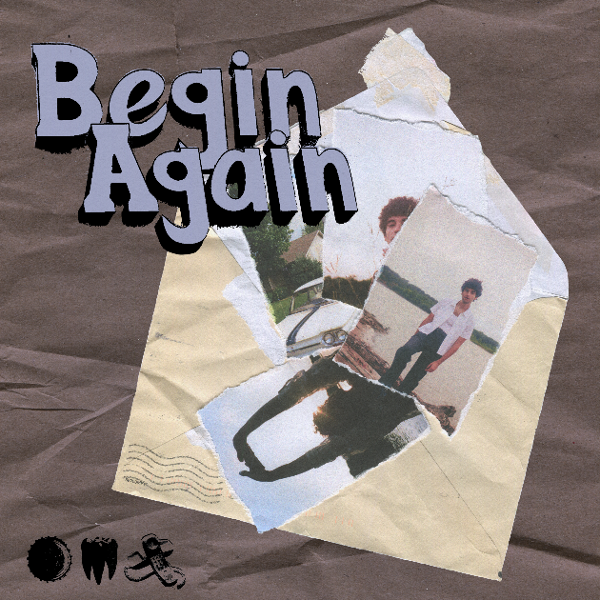
Hi-res artwork + photos available HERE

More about Adam Melchor:
Adam Melchor’s journey thus far has been far from conventional. Long story short, this proud Jersey boy picked up a guitar and eventually fulfilled his lifelong dream of becoming a musician in Los Angeles. But in reality, he got there by singing for mobsters “well-suited insurance guys” at pizza parlors, getting an Opera degree, playing thousands of hours in various dives, churches, and restaurants (sometimes in the same day), and driving across the country to the West Coast in an old Toyota Camry (twice). Moving to Los Angeles during 2018, he had sessions with everyone from Charlie Puth to The Chainsmokers, and has also toured alongside Mt. Joy, Dodie, Rodrigo Y Gabriela, and JS Ondara. Picking up steam, his single “Real Estate” gained impressive traction leading up to the 2020 SUMMER CAMP EP. At the onset of the Global Pandemic, he launched Melchor’s Lullaby Hotline, where he personally replied to fan texts and emails with a new demo each Sunday. He eventually sent out about 40 original songs to 10,000 fans. After racking up more than 40 million streams and garnering acclaim from NPR, Wonderland Magazine, Billboard, Atwood Magazine, and more, he properly introduces himself and shares the juicy details of this story on his forthcoming mixtape, Melchor Lullaby Hotline, Vol. 1.

###

For more information, contact:
Darren Baber, Darren.Baber@warnerrecords.com
Ceri Roberts, Ceri.Roberts@warnerrecords.com

Press Materials:
press.warnerrecords.com/adam-melchor

Follow Adam Melchor:
Instagram | TikTok | YouTube

