Adam Melchor Shares Cover of My Chemical Romance Classic
“i’m not okay”

Watch the Acoustic Video HERE

Melchor Lullaby Hotline, Vol. 1 Out Next Friday, March 19

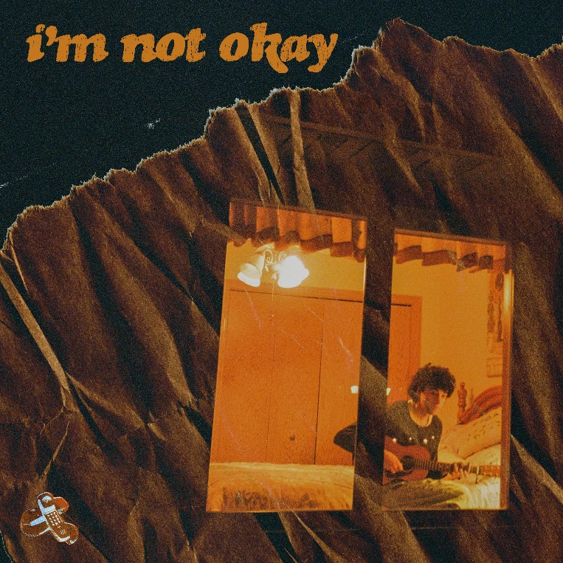

“Adam Melchor is a singer-songwriter from New Jersey with the acoustic chops of an angel.” – Esquire

“Adam Melchor is One To Watch in 2021.” – Idolator

“A strong start for Melchor, who no doubt has an exciting year ahead.” – Ones To Watch

March 12, 2021 (Los Angeles, CA) – Today, New Jersey-born and Los Angeles-based singer, songwriter, and producer Adam Melchor shares a delicate new take on My Chemical Romance’s early 2000’s classic “i’m not okay.” Melchor revealed the track release yesterday on social media, surprising fans with an intimate acoustic video shot in Minnesota. Listen to “i’m not okay” HERE and watch the acoustic video HERE.

About the unexpected song choice, he explains, “Growing up in New Jersey, My Chemical Romance were on everyone’s speakers and in everyone’s CD players. There’s a MCR song for pretty much any mood you’re in. I covered this because firstly, no one was okay in 2020, and secondly because I was really missing New Jersey and the people who live there. This song became a sort of teleportation device to get me back to the place I used to call home. Also, because this is a pretty heavy electric guitar song, I thought hearing a light fingerpicking acoustic guitar arrangement of it would be fun.”

The new cover follows recently released singles “Begin Again” and “Last Time,” arriving just days before the release of his forthcoming project, Melchor Lullaby Hotline, Vol. 1, out next Friday, March 19th on Warner Records/R&R Records. Adam first introduced the Melchor Lullaby Hotline at the onset of the global pandemic, urging fans to text or email him every Sunday to hear a new song. The result is the forthcoming mixtape, which is part Lullaby Hotline highlights and part brand new material. Last month, the rising troubadour elevated the hotline to the next level, launching The Lullaby Hotline Podcast, a weekly podcast designed to help fans relax, unwind and fall asleep to the sound of his latest tunes.

More about Adam Melchor:
Adam Melchor’s journey thus far has been far from conventional. Long story short, this proud Jersey boy picked up a guitar and eventually fulfilled his lifelong dream of becoming a musician in Los Angeles. But in reality, he got there by singing for mobsters “well-suited insurance guys” at pizza parlors, getting an Opera degree, playing thousands of hours in various dives, churches, and restaurants (sometimes in the same day), and driving across the country to the West Coast in an old Toyota Camry (twice). Moving to Los Angeles during 2018, he had sessions with everyone from Charlie Puth to The Chainsmokers, and has also toured alongside Mt. Joy, Dodie, Rodrigo Y Gabriela, and JS Ondara. Picking up steam, his single “Real Estate” gained impressive traction leading up to the 2020 SUMMER CAMP EP. After racking up more than 40 million streams and garnering acclaim from NPR, Wonderland Magazine, Billboard, Atwood Magazine, and more, he properly introduces himself and shares the juicy details of this story on his forthcoming mixtape, Melchor Lullaby Hotline, Vol. 1.

###

For more information, contact:
Darren Baber, Darren.Baber@warnerrecords.com
Ceri Roberts, Ceri.Roberts@warnerrecords.com

Press Materials:
press.warnerrecords.com/adam-melchor

Follow Adam Melchor:
Instagram | TikTok | YouTube

