ADAM MELCHOR ENLISTS LENNON STELLA FOR
DREAMY NEW SONG “LIGHT YEAR”
LISTEN HERE

WATCH THE STUNNING VIDEO HERE

“Adam Melchor is a singer-songwriter from New Jersey with the acoustic chops of an angel.” – Esquire

“Adam Melchor is One To Watch in 2021.” – Idolator

“A strong start for Melchor, who no doubt has an exciting year ahead.” – Ones To Watch

April 28, 2021 (Los Angeles, CA) – On the heels of his acclaimed debut mixtape Melchor Lullaby Hotline, Vol. 1, New Jersey-born and Los Angeles-based singer/songwriter Adam Melchor enlists Platinum-certified pop artist Lennon Stella for new song “Light Year,” out now on Warner Records. Awash in dreamy and nostalgic melodies, the soothing new collaboration comes alongside a stunning video shot in Nashville – watch it here.

“Sometimes we put on a face when people ask how we are and we don’t tell them how we really feel because we’re afraid of the true feelings we would say out loud,” Adam states. “‘Light Year’ is a song about feeling far from the things you love, the people you love, the place you want to be or even the emotions you strive to feel.”

“Light Year” follows last month’s release of Melchor’s Lullaby Hotline, Vol. 1 – a soothing balm after a dark past year for the world – which earned acclaim from the likes of Esquire, SPIN, Billboard, Idolator, and more. Heralded by singles “Begin Again” “Last Time,” and My Chemical Romance cover “I’m not okay,” the 12-track record was largely inspired by the Melchor Lullaby Hotline, which Adam launched at the onset of the COVID lockdown last year, urging fans to text or email him every Sunday to hear a new song. By the end of the year, he personally sent 44 songs to a rapidly growing list of almost 10,000.

Beginning tomorrow, Adam will embark on a 10-date socially-distanced tour with Flipturn, making stops at small capacity, outdoor venues across the southern US. Tickets are available for purchase here.

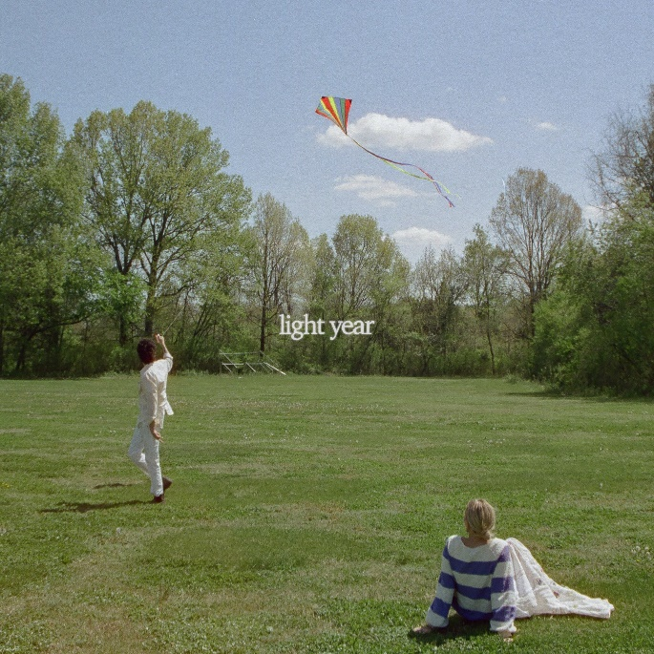
High res artwork + photos available here

About Adam Melchor:
Adam Melchor’s journey thus far has been far from conventional. Long story short, this proud Jersey boy picked up a guitar and eventually fulfilled his lifelong dream of becoming a musician in Los Angeles. But in reality, he got there by singing for mobsters “well-suited insurance guys” at pizza parlors, getting an Opera degree, playing thousands of hours in various dives, churches, and restaurants (sometimes in the same day), and driving across the country to the West Coast in an old Toyota Camry (twice). Moving to Los Angeles during 2018, he had sessions with everyone from Charlie Puth to The Chainsmokers, and has also toured alongside Mt. Joy, Dodie, Rodrigo Y Gabriela, and JS Ondara. Picking up steam, his single “Real Estate” gained impressive traction leading up to the 2020 SUMMER CAMP EP. After racking up more than 40 million streams and garnering acclaim from NPR, Wonderland Magazine, Billboard, Atwood Magazine, and more, he properly made his debut earlier this year with Melchor Lullaby Hotline, Vol. 1.

About Lennon Stella:
Lennon Stella first rose to popularity when she was just 12 years old as part of the duo Lennon & Maisy, alongside her younger sister, and gained national attention with a cover of Robyn’s “Call Your Girlfriend.” Lennon went on to star in the ABC/CMT smash Nashville as Maddie Conrad for six years. Kickstarting her solo recording career, Lennon debuted with her 2018 Love, me EP, which bowed in the Top 5 of the Billboard “Heatseekers Albums” chart, that included the single "La Di Da," amassing more than 151 million Spotify streams and counting. Lennon was named among Refinery29’s “Young Celebrities to Watch in 2019”, Teen Vogue’s “16 Musicians You Need to Be Listening to in 2019” and most recently Amazon Music’s Artist to Watch for 2020. Following multiple nominations and her win for “Breakthrough Artist of the Year” at the 2020 Juno Awards, Lennon is currently nominated for three 2021 Juno Awards, including “Juno Fan Choice,” “Single of the Year” for “Kissing Other People,” and “Pop Album of the Year” for Three. Two. One.

On April 24, 2020, Lennon released her highly anticipated debut album Three. Two. One. via RECORDS LLC./Columbia Records. The 13-track LP includes standout tracks “Kissing Other People” and “Jealous” as well as a solo version of Lennon’s song “Golf on TV” with JP Saxe. Three. Two. One. was named one of Vulture’s ‘Best Albums - Spring 2020’ with the publication declaring: “Stella’s solo debut [Three. Two. One.] proves her mettle in a pop field of play.” It was also proclaimed “Stella’s shining moment” by American Songwriter while Earmilk coined it “a formal introduction to a blooming high-profile artist.”

###

For more information, contact:
Darren Baber, Darren.Baber@warnerrecords.com
Ceri Roberts, Ceri.Roberts@warnerrecords.com

Press Materials:
press.warnerrecords.com/adam-melchor

Follow Adam Melchor:
Instagram | TikTok | YouTube

