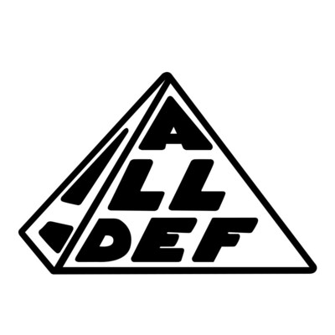

January 18, 2021

https://www.youtube.com/watch?v=FZ9a_HXBWsk

