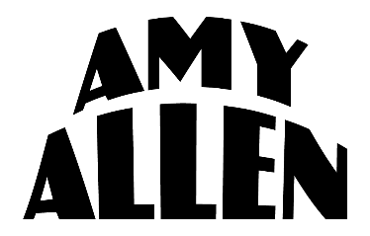

AMY ALLEN CALLS FOR CHANGE IN REFLECTIVE NEW SONG “ONE”

PREMIERED TODAY FOLLOWING AMY’S HAND-CRAFTED LIVESTREAM EVENT AMY ALLEN & FRIENDS CELEBRATE EARTH DAY

LISTEN HERE

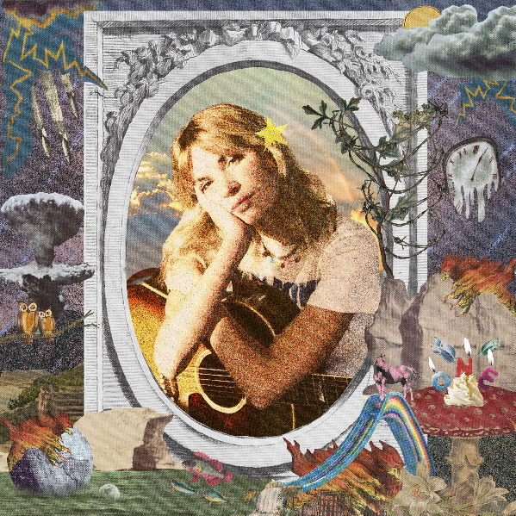
High res artwork + photos here

April 22, 2021 (Los Angeles, CA) – In honor of Earth Day, singer, songwriter, producer and multi-instrumentalist Amy Allen shares reflective new song “One” on Warner Records, which just premiered as the conclusion to her virtual Earth Day benefit event Amy Allen & Friends Celebrate Earth Day. Listen to “One” HERE and watch the accompanying lyric video HERE.

About the song, Amy explains, “‘One’ is a song for anyone who feels helpless in this terrifyingly big and flawed world. I wrote this as a reminder to myself that even when I feel like a drop in the ocean, it’s still important to try to make a change, no matter how small."

Amy headlined and hosted the hand-crafted virtual event earlier today, raising awareness for global environmental change agents such as the Surfrider Foundation, Ecosia, Greenpeace, and Parks Project. As an award-winning songwriter for some of the biggest names in music, Amy was uniquely able to curate the lineup by enlisting some of her most talented friends – Adam Melchor (with Emily Warren), Alexander23, Chelsea Cutler, Dan Wilson, Griff, Fletcher, Jensen McRae, Madeline The Person, and Vance Joy – each of whom personally selected an environmental organization to support.

Having spent the prior few years co-writing some of pop’s biggest hits (Harry Styles, Halsey, Selena Gomez and more), “One” and other recent call-to-action tune “What A Time To Be Alive” (feat. Pink Sweat$) are the latest in a string of debut solo releases that have introduced Amy Allen as a songwriter and artist for her generation, offering a birds-eye view of life as a young woman in 2021 America. Her incredibly personal and impactful songs “Queen of Silver Linings,” “Difficult,” and “Heaven” have earned critical acclaim from Flaunt, American Songwriter, WWD, Refinery29, People Magazine and more, while catching the attention of the likes of Elton John and Sam Smith.
# # #

For further information, please contact Warner Records Publicity:
Darren Baber / Ceri Roberts
Darren.Baber@warnerrecords.com / Ceri.Roberts@warnerrecords.com

Follow Amy Allen:
Official | Instagram | Twitter | Facebook | YouTube | Press Materials

