GLOBAL POP SUPERSTAR ANITTA UNLEASHES “LOCO” NEW SINGLE & VIDEO

Anitta Garners Two Nominations for the Premio Lo Nuestro Awards - “Female Artist of the Year (Urban)” & “Crossover Song of the Year”

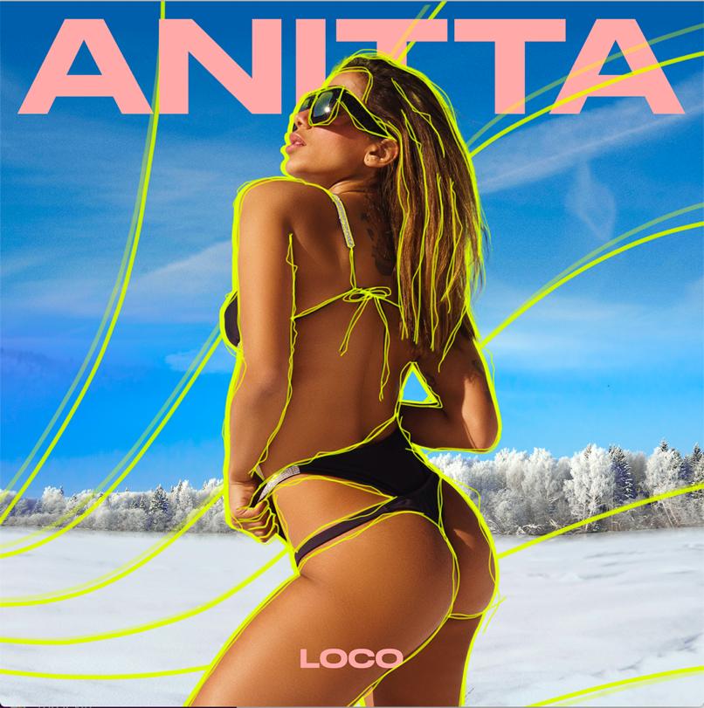
Click here for hi-res single cover

January 29, 2021 (Los Angeles, CA) — This winter just got a whole lot hotter…

Today, Brazilian global pop superstar Anitta returns with a brand new single and music video entitled “Loco.” Listen to “Loco” HERE and watch the captivating music video HERE.

On the track, seductive verses dip in and out of a bouncy reggaeton beat punctuated by Middle Eastern-style influences. Anitta’s hummable hook tops off the unpredictable production with intoxicating energy. Quite fittingly, she goes crazy in the best way for the accompanying visual. She initially teased out its arrival by appearing on YouTube’s RELEASED Thursday night. She took fans behind-the-scenes and divulged secrets about the song until the countdown ended and the clip premiered.

In the video, she and a swimsuit-clad girl gang take over the slopes, twerking down a mountain and practically melting the snow in the process. You’ve just got to see it. This is the ultimate winter mood!

Next up, she’s nominated in the categories of “Female Artist of the Year (Urban)” and “Crossover Song of the Year” for her smash “Me Gusta” featuring Cardi B and Myke Towers at the 2021 Premio Lo Nuestro Awards. It airs live from Miami February 18th on Univision. Be sure to tune in.

Speaking of “Me Gusta,” it has popped off as one of her biggest smashes yet with 223 million-plus streams. Last year, she inked her deal with Warner Records and immediately hit the ground running. After 6 Latin GRAMMY® Award nominations, 7 MTV EMA wins, 5.2 billion YouTube views, and 8.6 billion streams, she’s gearing up for her hottest year yet.

Get ready to go “Loco” with Anitta.

ABOUT ANITTA:
Since breaking through in Brazil six years ago, Anitta has become the leading artist of a new generation of Latin American music. As the biggest ever global female popstar to come from Brazil, she has amassed 50 million Instagram followers and over 14 million YouTube subscribers garnering more than 5.2 billion views. Anitta has been named among the world’s 15th most influential musicians on social media by Billboard. In July 2013, she released her self-titled first album, Anitta, which consisted of 14 new tracks, most of which were written by her. Anitta’s second album, Ritmo Perfeito, was released in July 2014, followed by her third album, Bang, in 2016. The album contained 15 original tracks and the music video for the album’s title song, “Bang,” has garnered over 404 million views since its release. Her latest album, Kisses, was released in April 2019 and marks Anitta’s first trilingual album with songs in Spanish, Portuguese, and English. Kisses was nominated for “Best Urban Album'' at the 2019 Latin GRAMMY® Awards. Since 2014, Anitta has been named “Best Brazilian Act” at the MTV Europe Music Awards for five consecutive years. She was a highlight of the 2016 Rio Olympic Games’ Opening Ceremony, where she performed alongside Brazilian singer/songwriters Gilberto Gil and Caetano Veloso. Anitta has graced the covers of countless magazines including Vogue Brazil, Marie Claire Brazil, GQ Mexico, and GQ Brazil. Anitta has worked with the likes of Madonna, Major Lazer, J Balvin, Diplo, Ozuna, and Maluma among others. Most recently she released “Tócame” feat. Arcangel & De La Ghetto” and “Fuego” with DJ Snake and Sean Paul. Anitta is currently in the studio recording her fifth album, which will be in English, Spanish, and Portuguese.

###

FOLLOW ANITTA
Instagram | Facebook | Twitter | YouTube

