GLOBAL POP SUPERSTAR ANITTA RELEASES BRAND NEW SINGLE & MUSIC VIDEO “GIRL FROM RIO”

VIDEO BROADCAST PREMIERE ON MTV LIVE, MTVU, MTV NETWORK & THE VIACOM CBS TIMES SQUARE BILLBOARD

GRACES MAY COVER OF ALLURE

ANNOUNCES TELEVISION TAKEOVER BEGINNING MAY 3 ON NBC’S TODAY SHOW & MAY 4 ON ABC’S JIMMY KIMMEL LIVE!

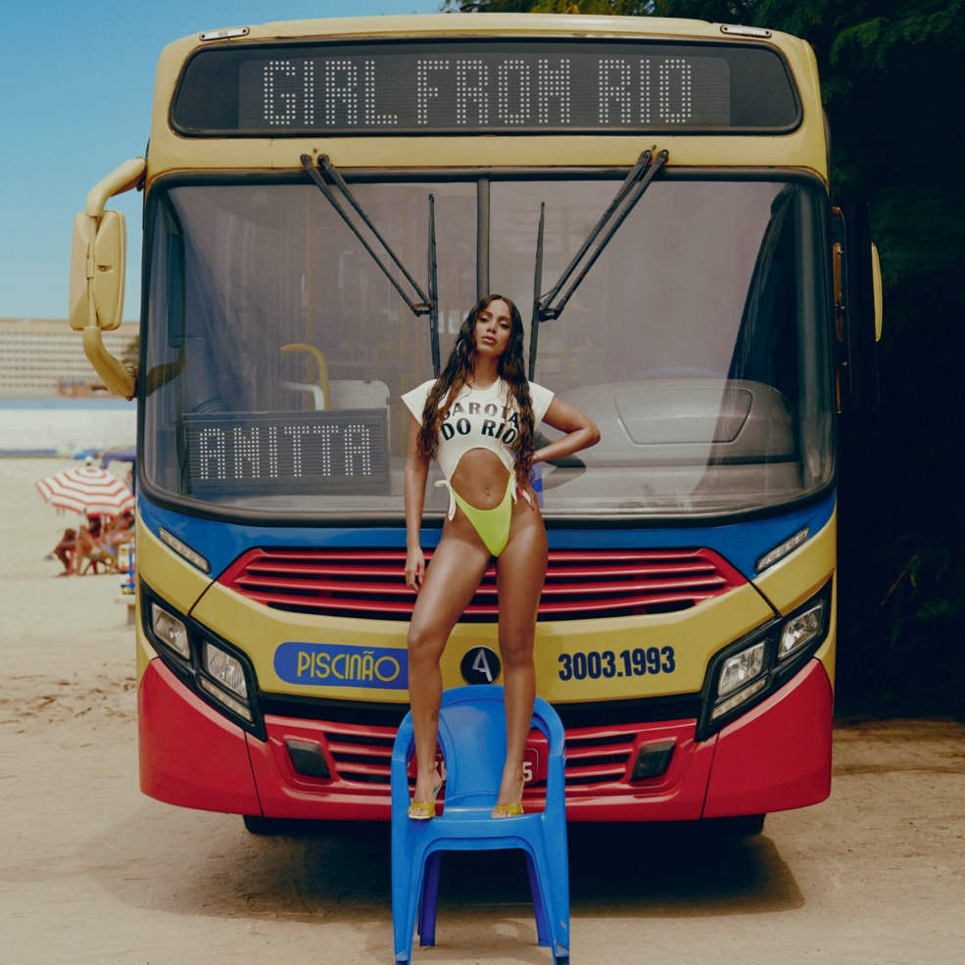
Click here for hi-res image

April 30, 2021 (Los Angeles, CA) — Brazilian global pop superstar Anitta unveils her signature single and video, “Girl From Rio.' The video is a celebratory homage to the resilient and vibrant culture of her hometown of Rio de Janeiro. The clip made its global broadcast premiere today on MTV Live, MTVU, and across MTV’s global network of channels, as well as on the Viacom CBS Times Square billboard. Listen to “Girl From Rio” HERE, and watch the music video HERE.

Updating the melody of “The Girl From Ipanema” with a 21st century twist, Anitta serves up a sassy and sexy ode to the ladies of her hometown. Her cheeky and clever verses give way to the immediately chantable hook, “Hot girls where I’m from. We don’t look like models. Tanned lines, big curves, and the energy glows, you’ll be falling in love with the real Rio.”

The blockbuster visual seamlessly brings the song to life. Nodding to classic mid-century musicals, Anitta dons a forties-era bathing suit like a vixen from the rudder of a WWII plane and launches into a stunning routine surrounded by sailors enamored with her. Fast-forward to modern day, she gives audiences a look at the ultimate beach day in Rio—and it’s every bit as hot as you’d hope it would be!

At the 2021 Latin American Music Awards, Anitta described “Girl From Rio” as her “favorite song ever” to Billboard.

Anitta will deliver the debut television performance of the single on NBC’s Today Show on May 3rd and the following evening, May 4th on ABC’s Jimmy Kimmel LIVE! Anitta will also perform on the first-ever televised special of the Latin GRAMMY® Celebra: Ellas Y Su Música airing May 9th on Univision.

Anitta continues to make headlines worldwide. She recently lit up the stage at the Latin American Music Awards by joining forces with Maluma, Wisin, and Myke Towers for a powerhouse rendition of “Mi Niña” and taking home the award for “Favorite Artist Female.” She graced the most recent cover of Allure who christened her, “An uncensored force changing the face and flavor of Brazilian beauty.”

Anitta is currently putting the finishing touches on her debut album for Warner Records with her management S10 Entertainment.

ABOUT ANITTA:
Since breaking through in Brazil six years ago, Anitta has become the leading artist of a new generation of Latin American music. As the biggest ever global female popstar to come from Brazil, she has amassed 52 million Instagram followers and over 15 million YouTube subscribers garnering more than 5.3 billion views. Anitta has been named among the world’s 15th most influential musicians on social media by Billboard. In July 2013, she released her self-titled first album, Anitta, which consisted of 14 new tracks, most of which were written by her. Anitta’s second album, Ritmo Perfeito, was released in July 2014, followed by her third album, Bang, in 2016. The album contained 15 original tracks and the music video for the album’s title song, “Bang,” has garnered over 405 million views since its release. Her latest album, Kisses, was released in April 2019 and marks Anitta’s first trilingual album with songs in Spanish, Portuguese, and English. Kisses was nominated for “Best Urban Album'' at the 2019 Latin GRAMMY® Awards. Since 2014, Anitta has been named “Best Brazilian Act” at the MTV Europe Music Awards for five consecutive years. She was a highlight of the 2016 Rio Olympic Games’ Opening Ceremony, where she performed alongside Brazilian singer/songwriters Gilberto Gil and Caetano Veloso. Anitta has graced the covers of countless magazines including Vogue Brazil, Marie Claire Brazil, GQ Mexico, and GQ Brazil. Anitta has worked with the likes of Madonna, Major Lazer, J Balvin, Diplo, Ozuna, and Maluma among others. Most recently, Anitta released “Tócame” feat. Arcangel & De La Ghetto, “Fuego” with DJ Snake and Sean Paul, “Loco” and “Me Gusta” featuring Cardi B and Myke Towers which popped off as one of her biggest smashes yet with 223 million-plus streams. Newly signed to Warner Records, Anitta is currently in the studio recording her fifth album, which will be in English, Spanish, and Portuguese.

###
FOLLOW ANITTA
Instagram | Facebook | Twitter | YouTube | TikTok

