MARSHMELLO & ANNE-MARIE’S “FRIENDS”
CERTIFIED PLATINUM BY RIAA

NORTH AMERICAN TOUR INCLUDES SOLD-OUT HEADLINE SHOWS
AND STADIUM DATES OPENING FOR ED SHEERAN

ANNE-MARIE PERFORMS NEW SINGLE “2002” ON
“GOOD MORNING AMERICA” MONDAY, SEPTEMBER 3

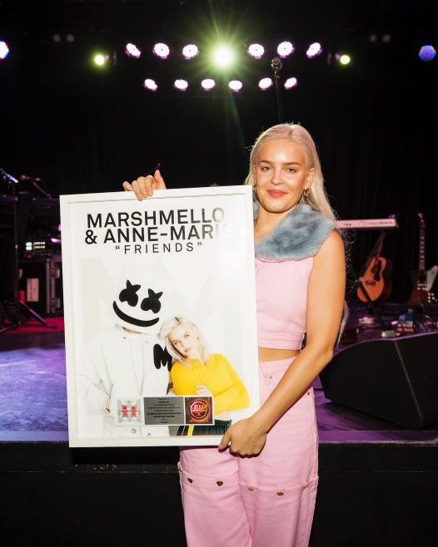
﻿[Photo Credit: Ryan Hadji]

August 22, 2018 (Los Angeles, CA) – Marshmello and Anne-Marie’s “FRIENDS” – the lead single from her debut album, Speak Your Mind (Warner Bros. Records) – has been certified platinum by the RIAA. Anne-Marie was awarded the platinum plaque prior to her sold-out headline show at the Roxy Theatre in West Hollywood, CA. “FRIENDS” – a staple at Top 40 and Hot AC radio – is closing in on half-a-billion Spotify streams while views of the official video have surpassed 300 million worldwide.

Anne-Marie comments, “I love Marshmello! Working with him was so much fun and I can’t wait to work with him again. Talented, humble, lovely human.....I mean, Marshmello!”

Anne-Marie is currently touring North America, supporting Ed Sheeran on his stadium run which kicked off last weekend at the Rose Bowl in Pasadena, CA. As the tour crosses the country, she has also found time for a series of sold-out headline shows at intimate venues. Tickets and tour dates here.

The 5x BRIT Award-nominated artist will perform her new single, “2002,” on “Good Morning America” on Monday, September 3. Co-written with Ed Sheeran, the track’s sunny acoustic guitars, finger-snaps, and sweetly nostalgic chorus culled from turn-of-the-century radio staples has enchanted both fans and critics alike. Cumulative U.S. streams exceed 60 million, while the video has clocked more than 100 million views worldwide. An acoustic duet performance of “2002” by the songstress and Sheeran leapt past the 12 million mark in less than a week.

People hailed the track as “a nostalgia-fueled millennial dream” and Rolling Stone featured “2002” on their summer playlist. Further critical acclaim has come from Time, Elle, Harper’s Bazaar and Paper, which named her among “100 Women Revolutionizing Pop.”

Anne-Marie is featured on David Guetta’s new hit single, “Don’t Leave Me Alone,” and can be seen in the accompanying video, which was unveiled earlier this week. She also features along with Mr Eazi on Rudimental & Major Lazer’s “Let Me Live.”

Powered by confident and catchy anthems with a female-centric message and uncontainable charisma, singer-songwriter Anne Marie has been hailed by Idolator as “arguably one of the most consistent hitmakers in pop.” Her growing discography encompasses the double Platinum “Rockabye” with Clean Bandit and Sean Paul and the Gold single “Alarm.” Her full-length Speak Your Mind already stands out as the biggest-selling UK debut of 2018. In addition to five BRIT Award nominations, Anne-Marie has earned nods from the Billboard Music Awards, Teen Choice Awards, iHeartRadio Music Awards, and more.

Watch the official video for “FRIENDS” here
Purchase tickets here
Download/stream Speak Your Mind here
Watch the official video for “2002” here
View acoustic duet performance of “2002” here
Check out “Don’t Leave Me Alone” video here
Watch official video for “Let Me Live” here

Bobbie Gale / Warner Bros. Records
(818) 953-3692 / Bobbie.Gale@wbr.com

