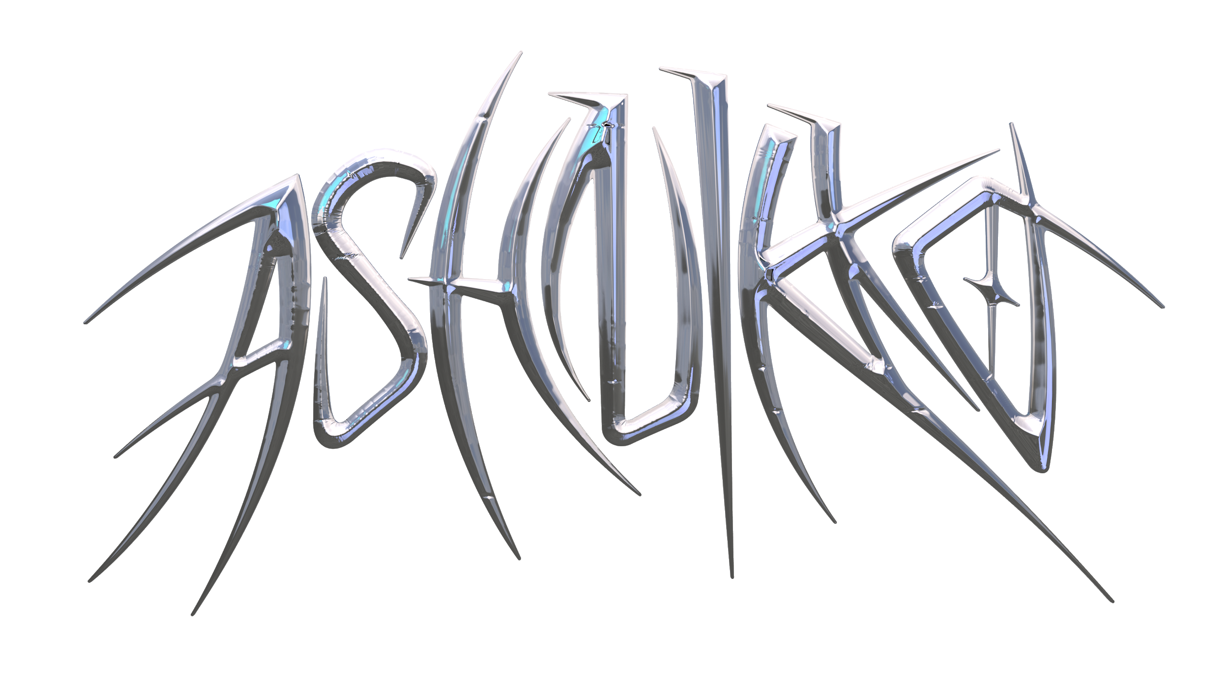

"I just like being a little demon – a little devil hellraiser," Ashnikko giggles, her voice both razor-sharp and feather-light. The London-based American artist is describing the concept behind her new mixtape DEMIDEVIL, the cover art of which shows her as a dragon being ridden by a demidevil version of herself. It's just like everything Ashnikko does: as real as it is surreal, and as terrifying as it is hilarious. "It sheds light on the polarity of my songs – some are tender and sweet, and some are more intense. The songs are very different, and DEMIDEVIL brings them together."

The mixtape is Ashnikko's first release since 2019's Hi, It's Me, the EP that introduced the world to "STUPID": her scariest iteration yet. The homicidal rap song propelled Ash to viral fame, spawning millions of TikToks. After a US tour with rapper Danny Brown, a headline-stealing femdom appearance flanked by male servants on the red carpet at the BRITs 2020, a Doja Cat support tour and string of sold-out headline shows of her own on the horizon, the coronavirus lockdown hit. That's when she threw her energy into compiling her best project yet: a collection of songs that celebrate female sexuality and noughties pop, featuring Grimes, Princess Nokia, Kelis, a musical theater number about the clitoris, and countless vicious one-liners.

Ashton Casey was born and raised in North Carolina, and later Eastern Europe – but in truth, she says "the internet raised me". As well as Tumblr, her most consistent influence was music made by empowered, misfit women: M.I.A., Nicki Minaj, Bjork, Kelis and Janis Joplin to name a few. After honing her singing skills in her bedroom, she took a fearless leap of faith at the age of 18 by moving to London, completely alone, to make it as a musician. "I wanted to make it big in the big city," she says wryly. "But I was slapped in the face by reality."

Over the following years, Ash took numerous "gruelling" nocturnal jobs selling shots in nightclubs, and waiting tables as a champagne bottle girl. Being groped by men on the job only cemented her early feminist leanings, and she rose like a blue-haired phoenix from the ashes by channelling her anger into her music. "I tapped into some really good rage," she reflects, noting that it was this inner demon that helped her to find her sound which she unleashed with Unlikeable in 2019. "I was just really mad at the way women and LGBTQ people were being treated. I was on a musical warpath, intent on dragging the patriarchy, dragging cisgender heterosexual men."

Hi, It's Me propelled Ashnikko to new heights. "As I've gotten older, my songwriting is still angry, but it's become more focused on self-empowerment, self-love, and body positivity," she says. "The best stuff I've ever written was written to myself as a pep talk. Hi, It's Me started as love letters to myself." Peppered with maniacal laughter and blown-out basslines, the 2019 EP is a victory lap of Ashnikko declaring that everything she does is extraordinary, and that she listens to her own music in Ubers. On "STUPID", she's joined by Georgia rapper Yung Baby Tate to deliver a biting kiss-off to entitled exes.

Seeing the track go viral on TikTok – with the exquisite hook "stupid boy think that I need him" – was a trippy experience, and one that has led Ash to work closely with her label on developing mental health support networks for artists who are shot to sudden, overnight visibility. "If you can put a numerical value on yourself, that is a recipe for bad mental health," she says. "I am very passionate about implementing good coping mechanisms for dealing with social media in a healthy way – hearing that many opinions about yourself is not normal. It's not sustainable."

Even so, Ash was thrilled that the success of "STUPID" spilled over to her whole discography, with new fans geeking out over her fearsome and freaky back catalogue of rap and alt-pop. At the time, she was sitting on hundreds of unreleased songs, and so she began the process of compiling Demidevil: ten funny, brash, chameleonic songs that show the true breadth of what Ashnikko has to offer. "People might think these are break-up songs," says Ash, "But they're more about prioritising your own wants and needs and desires over toxic relationships – which can be in a professional setting, in a romantic setting, or in a friendship setting."

The mixtape was introduced to the world in the form of "Daisy" – a femdom hip-hop anthem that announces "being a bitch is my kink" over an elastic beat. "Daisy" began life as a character in Ashnikko's mind: "She's a vigilante dominatrix who fights crime in the dead of night, throat punching rapists and smashing the patriarchy under her New Rock Boots. She's a real badass. She drinks straight whiskey. She hangs out in the dimly lit part of the bar in a leather jacket, blue diamonds and platforms." The aesthetic is capped off with a latex-draped, sci-fi video from LA-based director Charlotte Rutherford.

Following "Daisy" is "Deal With It", a sharp-tongued banger with a carefree chorus that samples Kelis’ "Caught Out There" "I stan her so hard," Ash sighs, noting how stoked she was to have the 1999 classic featured in her own song. "'Deal With It' is like the hero break-up song. It's about wanting a puppy and a vibrator rather than a man." The mixtape on the whole is infused with late 90s/early 00s nostalgia: on "L8er Boi", Ash interpolates Avril Lavigne's 2002 single, updating the lyrics for a 2020 audience. "The original lyrics were a bit 'pick me'," she notes. "I feel like we all have a history of our own internalised misogyny, growing up in this society. It's about addressing that and moving on and learning." On "L8er Boi", Ash tells her skater crush to grow up: "I'm not a therapist, and I don't have time to be your mom. I'm living my life and blossoming, and don't have time to be weighed down by a sk8r boi."

As well as sampling her childhood heroes, Ashnikko called up two contemporary legends to appear on DEMIDEVIL: Grimes and Princess Nokia. The "magical" Grimes features on "Cry", an Evanescence-channelling emo-rap song about the volatile emotions that come with the breakdown of a female friendship. Meanwhile, Princess Nokia lends a verse to the ultra-horny "Slumber Party"; “a sexy song I wrote about a girl I had a crush on," Ash explains, lamenting: "It seems to be a reoccurring theme that I always fall for girls who are dating someone else”.

"Drunk With My Friends" is a grunge-y party track sat alongside the sinister lullaby "Little Boy", and "Toxic", a vengeful alt-pop song about a music industry suit who dared try to take the credit for Ashnikko's talent. Capping it all off is the echoing, guitar-based ballad "Good While It Lasted", a rare moment of vulnerability in which Ash reflects on the embers of a former relationship. But true to form, she follows this gentle moment with a belly laugh: an excerpt from Clitoris, the Musical! "Yeah, me and some friends are working on a musical about the clitoris," she chuckles, "and how it seems to be such a difficult place for men to find. Like a mythical land, shrouded in mystery. It's a quest-based musical, set in medieval times."

It's that multiplicity that sits at the heart of DEMIDEVIL, the biggest and boldest Ashnikko release yet, defying any attempts to pigeonhole the blue-haired maverick. Ash is more than the blood-soaked character who cackled with laughter on "STUPID", or the fetish queen that stomps through "Daisy". The demidevil, she says, is "two people – and I can be five different people. I can be very multi-faceted." Throughout the mixtape, she's bratty, sexy, angry, and heartbroken, over everything from trap beats to rock choruses. Most importantly, she's a songwriter with talents that will carry her far beyond a viral moment of fame. Her personal idea of success isn't about online likes and comments – it's about the people who will fill the room once music venues are up and running again. "As long as they know all the lyrics by heart," she says, "then I'll know I've succeeded."

