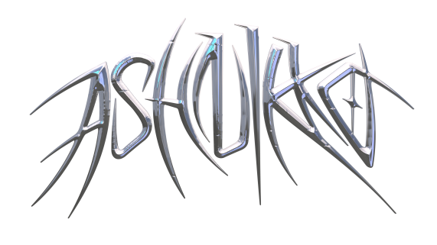

**ASHNIKKO UNLEASHES NEW TRACK “CRY” FEATURING GRIMES**

**WATCH THE ACTION-PACKED ANIME VIDEO** [**HERE**](https://Ashnikko.lnk.to/CryVid)



*“Her music proves she’s more than just a meme-y blip in the online soundscape.”* ***– NYLON***

*“She's entered the market to dominate”* ***– PAPER***

*“Ashnikko is bigger than tiktok...aggressive, campy, and demonic all at once”* ***– The Fader***

*“If smashing the patriarchy had a sound, we're pretty sure it would sound like Ashnikko.”* ***– Time Out London***

*“Ashnikko takes charge with a burst of playful energy.”* ***– Complex***

**June 17, 2020 (Los Angeles, CA)** – Today, London-based rapper Ashnikko unleashes an action-packed anime style video for brand new track “Cry” featuring ethereal pop artist, Grimes. The photo-real CGI video directed by Mike Anderson depicts Ashnikko and Grimes mutating and metamorphosing into a demon alter ego of Ashnikko stalking her prey as the two sing *“this could get gruesome*” – the aftermath of a brutal betrayal. “Cry” follows Ashnikko’s latest angst-charged *Hi, It’s Me* EP, giving listeners a new glimpse into Ashnikko’s sensitive side, while never straying too far from her boss bitch nature.

**Watch/Share “Cry” (feat. Grimes) Video** [**HERE**](https://Ashnikko.lnk.to/CryVid)

**Listen/Share “Cry” (feat. Grimes) Audio** [**HERE**](https://ashnikko.lnk.to/CryFtGrimes)

“Cry” continues Ashnikko’s meteoric rise, catapulted by her breakout TikTok-fueled hit [“Stupid,”](https://www.youtube.com/watch?v=VbQrhOWkonk) which has now reached 300 million streams worldwide and earned acclaim from the likes of *The Fader*, *PAPER*, *Rolling Stone*, *NYLON*, *Genius*, *Pitchfork*, and more. Pre-COVID lockdown, Ashnikko supported Danny Brown on his *U Know What I’m Saying?* tour across North America and announced a US tour with Doja Cat before everything came to a halt. Even with the world slowing down, Ashnikko has been virtually busy eating chilies with YungBlud, doing yoga with Charli XCX, playing DJ sets for PAPER x Club Quarantine, and she just co-wrote Doja Cat's Gold-certified banger “Boss Bitch.” Stay tuned for more music and mayhem from everyone’s favorite blue-haired maven.

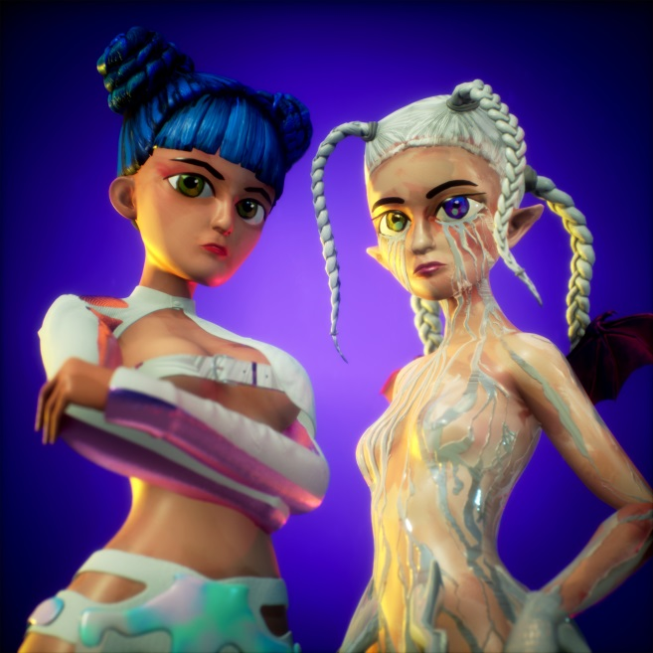

**More about Ashnikko:**

Art, music and sexual liberation are the three most potent ingredients in Ashnikko’s rebellion. Born and raised in suburban Greensboro, North Carolina, her parents raised her on a musical diet comprised exclusively of country music and Slipknot. But just as she was settling into life as an American teenager, they carted her off to Estonia, then Latvia, where she was the only American student in the public-school system, taking courses entirely in Latvian. Isolated, it catalyzed an identity crisis she’s still reckoning with to this day. She buried herself in music, listening exclusively to female artists until she was 17 – specifically proudly feminist and sex positive female artists – all of whom shaped her early sound. She used to receive death threats as a woman trying to make music in the “very patriarchal” Baltics. As soon as she turned 18, she moved to London and spent her nights wandering nightclubs and open mics, eventually establishing a home for herself in the community.

# # #

**For further information contact Warner Records Publicity:**

National: [Jaime.Rosenberg@warnerrecords.com](mailto:Jaime.Rosenberg@warnerrecords.com)

Tour/Regional: [Patrice.Compere@warnerrecords.com](mailto:Patrice.Compere@warnerrecords.com)

**Follow Ashnikko:**

[**Spotify**](https://open.spotify.com/artist/3PyJHH2wyfQK3WZrk9rpmP) **|** [**Instagram**](https://www.instagram.com/ashnikko/) **|** [**Twitter**](https://twitter.com/ashnikko) **|** [**Facebook**](https://www.facebook.com/ashnikkomusic/)

**Follow Grimes**

[**Spotify**](https://nam04.safelinks.protection.outlook.com/?url=https%3A%2F%2Fopen.spotify.com%2Fartist%2F053q0ukIDRgzwTr4vNSwab%3Fsi%3Dew1WyR59QZmjxRibhceBLg&data=02%7C01%7CPatrice.Compere%40warnerrecords.com%7C016a45ec4d50433f120708d8032d2d94%7C8367939002ec4ba1ad3d69da3fdd637e%7C0%7C0%7C637262839851577725&sdata=cI%2F7Ybk8O86cywKgbLpnsO%2BYpkJnm5ojObypa%2F4bTGE%3D&reserved=0) **|** [**Instagram**](https://nam04.safelinks.protection.outlook.com/?url=https%3A%2F%2Fwww.instagram.com%2Fgrimes%2F&data=02%7C01%7CPatrice.Compere%40warnerrecords.com%7C016a45ec4d50433f120708d8032d2d94%7C8367939002ec4ba1ad3d69da3fdd637e%7C0%7C0%7C637262839851587723&sdata=aMLNV5nLRn4SkkSKK67vgaPozJkA6B%2B9CpfnKN17Fj0%3D&reserved=0) **|** [**Twitter**](https://nam04.safelinks.protection.outlook.com/?url=https%3A%2F%2Ftwitter.com%2FGrimezsz&data=02%7C01%7CPatrice.Compere%40warnerrecords.com%7C016a45ec4d50433f120708d8032d2d94%7C8367939002ec4ba1ad3d69da3fdd637e%7C0%7C0%7C637262839851587723&sdata=loBXg9lkRktp3BqU%2FCSP08JjwO7Zz4%2Ficsf17lHs9SY%3D&reserved=0) **|** [**Facebook**](https://nam04.safelinks.protection.outlook.com/?url=https%3A%2F%2Fwww.facebook.com%2Factuallygrimes&data=02%7C01%7CPatrice.Compere%40warnerrecords.com%7C016a45ec4d50433f120708d8032d2d94%7C8367939002ec4ba1ad3d69da3fdd637e%7C0%7C0%7C637262839851597715&sdata=BRfbkaoHObSm%2BW6Bsxg0c5ygmzQX1V2X6Qqyv%2BYU3p0%3D&reserved=0)

**cid:image001.png@01D5204D.CFB194F0**