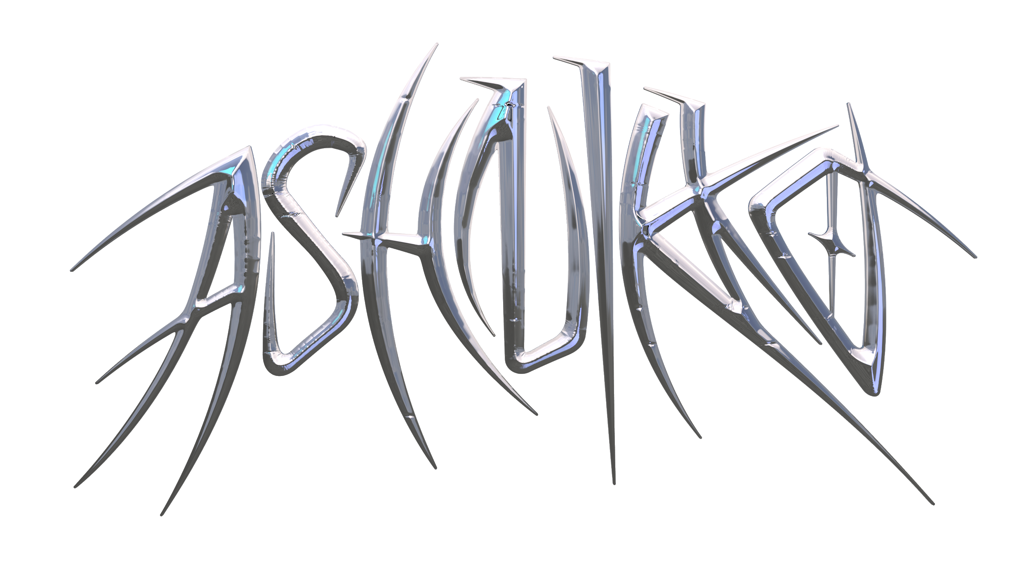

**ASHNIKKO DROPS NEW SINGLE “DAISY”**

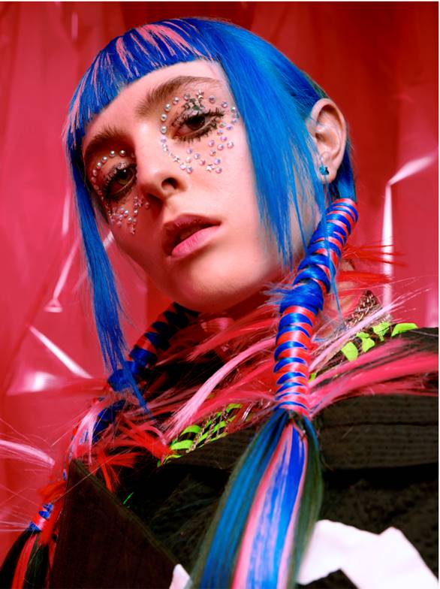

*Photo Credit: Micaela McLucas. Hi-res photos/assets available* [*here*](https://press.warnerrecords.com/ashnikko/)

“*[Ashnikko](https://hypebeast.com/tags/ashnikko) continues her ascent to world takeover” –* ***Hypebeast***

*“literally out of this world” –* ***PAPER***

*“Ashnikko is bigger than TikTok...aggressive, campy, and demonic all at once”* ***– The Fader***

*“Bold, ground-breaking future pop... a future pop wonder, working with full embrace of technology and a dismissal of the rules.” -* ***CLASH***

**July 9, 2020 (Los Angeles, CA)** – Today, London-based alt-pop rapper Ashnikko releases her summer anthem “Daisy.” On the track, the blue-haired maven merges her unique hyper-energized rapping with melodic vocals, delivering her signature messages of empowerment through a bubblegum blue hue to inspire young womxn. “Daisy” follows Ashnikko’s recent track “Cry” featuring Grimes, which has gained widespread acclaim from the likes of *Pitchfork*, *PAPER*, *Hypebeast*, *NME*, *Consequence of Sound*, *Stereogum*, to name a few.

**Listen/Share “Daisy”** [**HERE**](http://ashnikko.lnk.to/Daisy)

Ashnikko explains, *“This song is for the brats (brattiness being a recurring theme in my music). It’s about this absolute boss dominatrix vigilante character of mine. She rids the world of rapists and throat punches the patriarchy, leaving daisies behind as a calling card of sorts. She's sexy as fuck, wears only platforms, latex, and blue diamonds.”*

Ashnikko has teamed up with Beats by Dr. Dre (Beats) to collaborate on the creation of the forthcoming “Daisy” music video. Over the next four weeks, Ashnikko and Beats will ask TikTok users to join in the #BEATSDAISYCHALLENGE, bursting with vibrant colored themes – Glacier Blue, Spring Yellow, Cloud Pink and Lava Red – where the most creative entrees will be featured in a UGC music video directed by Charlotte Rutherford at the end of the month.

Ashnikko’s meteoric rise began after the release of her breakout *Hi It’s Me* EP with meme-able anthems like “Stupid” taking off on TikTok for the #stupidchallenge. Pre-COVID lockdown, Ashnikko supported Danny Brown on his *U Know What I’m Saying?* tour across North America and announced a US tour with Doja Cat before everything came to a halt. Even with the world slowing down, Ashnikko has been virtually busy eating chilies with YungBlud, doing yoga with Charli XCX, playing DJ sets for *PAPER* x Club Quarantine, and she just co-wrote Doja Cat's Gold-certified banger “Boss Bitch.” Now with more music on the horizon, Ashnikko is set to take 2020 by storm.

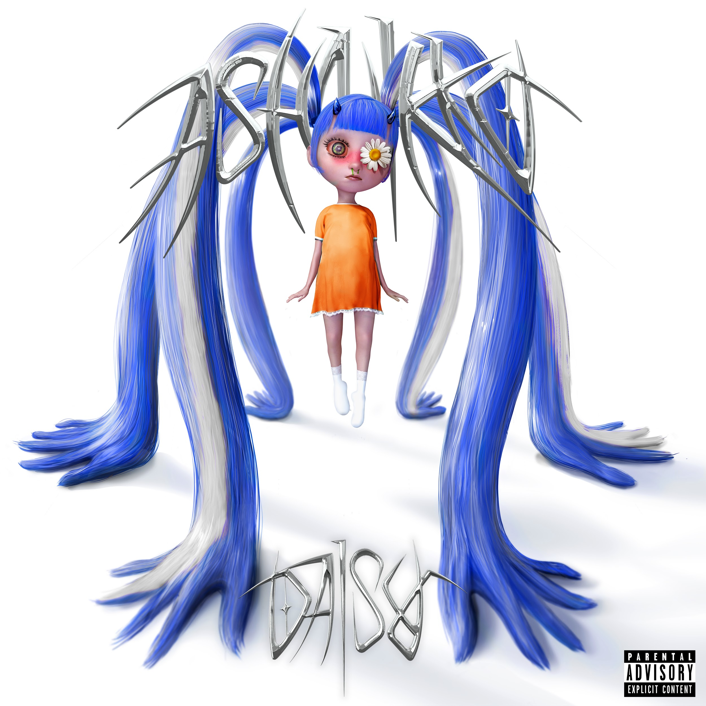

**More about Ashnikko:**

Art, music and sexual liberation are the three most potent ingredients in Ashnikko’s rebellion. Born and raised in suburban Greensboro, North Carolina, her parents raised her on a musical diet comprised exclusively of country music and Slipknot. Spending her teenage years in Eastern Europe, Ashnikko buried herself in music, listening exclusively to female artists until she was 17 – specifically proudly feminist and sex positive female artists – all of whom shaped her early sound. As soon as she turned 18, she moved to London and spent her nights wandering nightclubs and open mics, eventually establishing a home for herself in the community.

# # #

**For further information contact Warner Records Publicity:**

National: [Jaime.Rosenberg@warnerrecords.com](mailto:Jaime.Rosenberg@warnerrecords.com)

Tour/Regional: [Patrice.Compere@warnerrecords.com](mailto:Patrice.Compere@warnerrecords.com)

**Follow Ashnikko:**

[**Spotify**](https://open.spotify.com/artist/3PyJHH2wyfQK3WZrk9rpmP) **|** [**Instagram**](https://www.instagram.com/ashnikko/) **|** [**Twitter**](https://twitter.com/ashnikko) **|** [**Facebook**](https://www.facebook.com/ashnikkomusic/)

**cid:image001.png@01D5204D.CFB194F0**