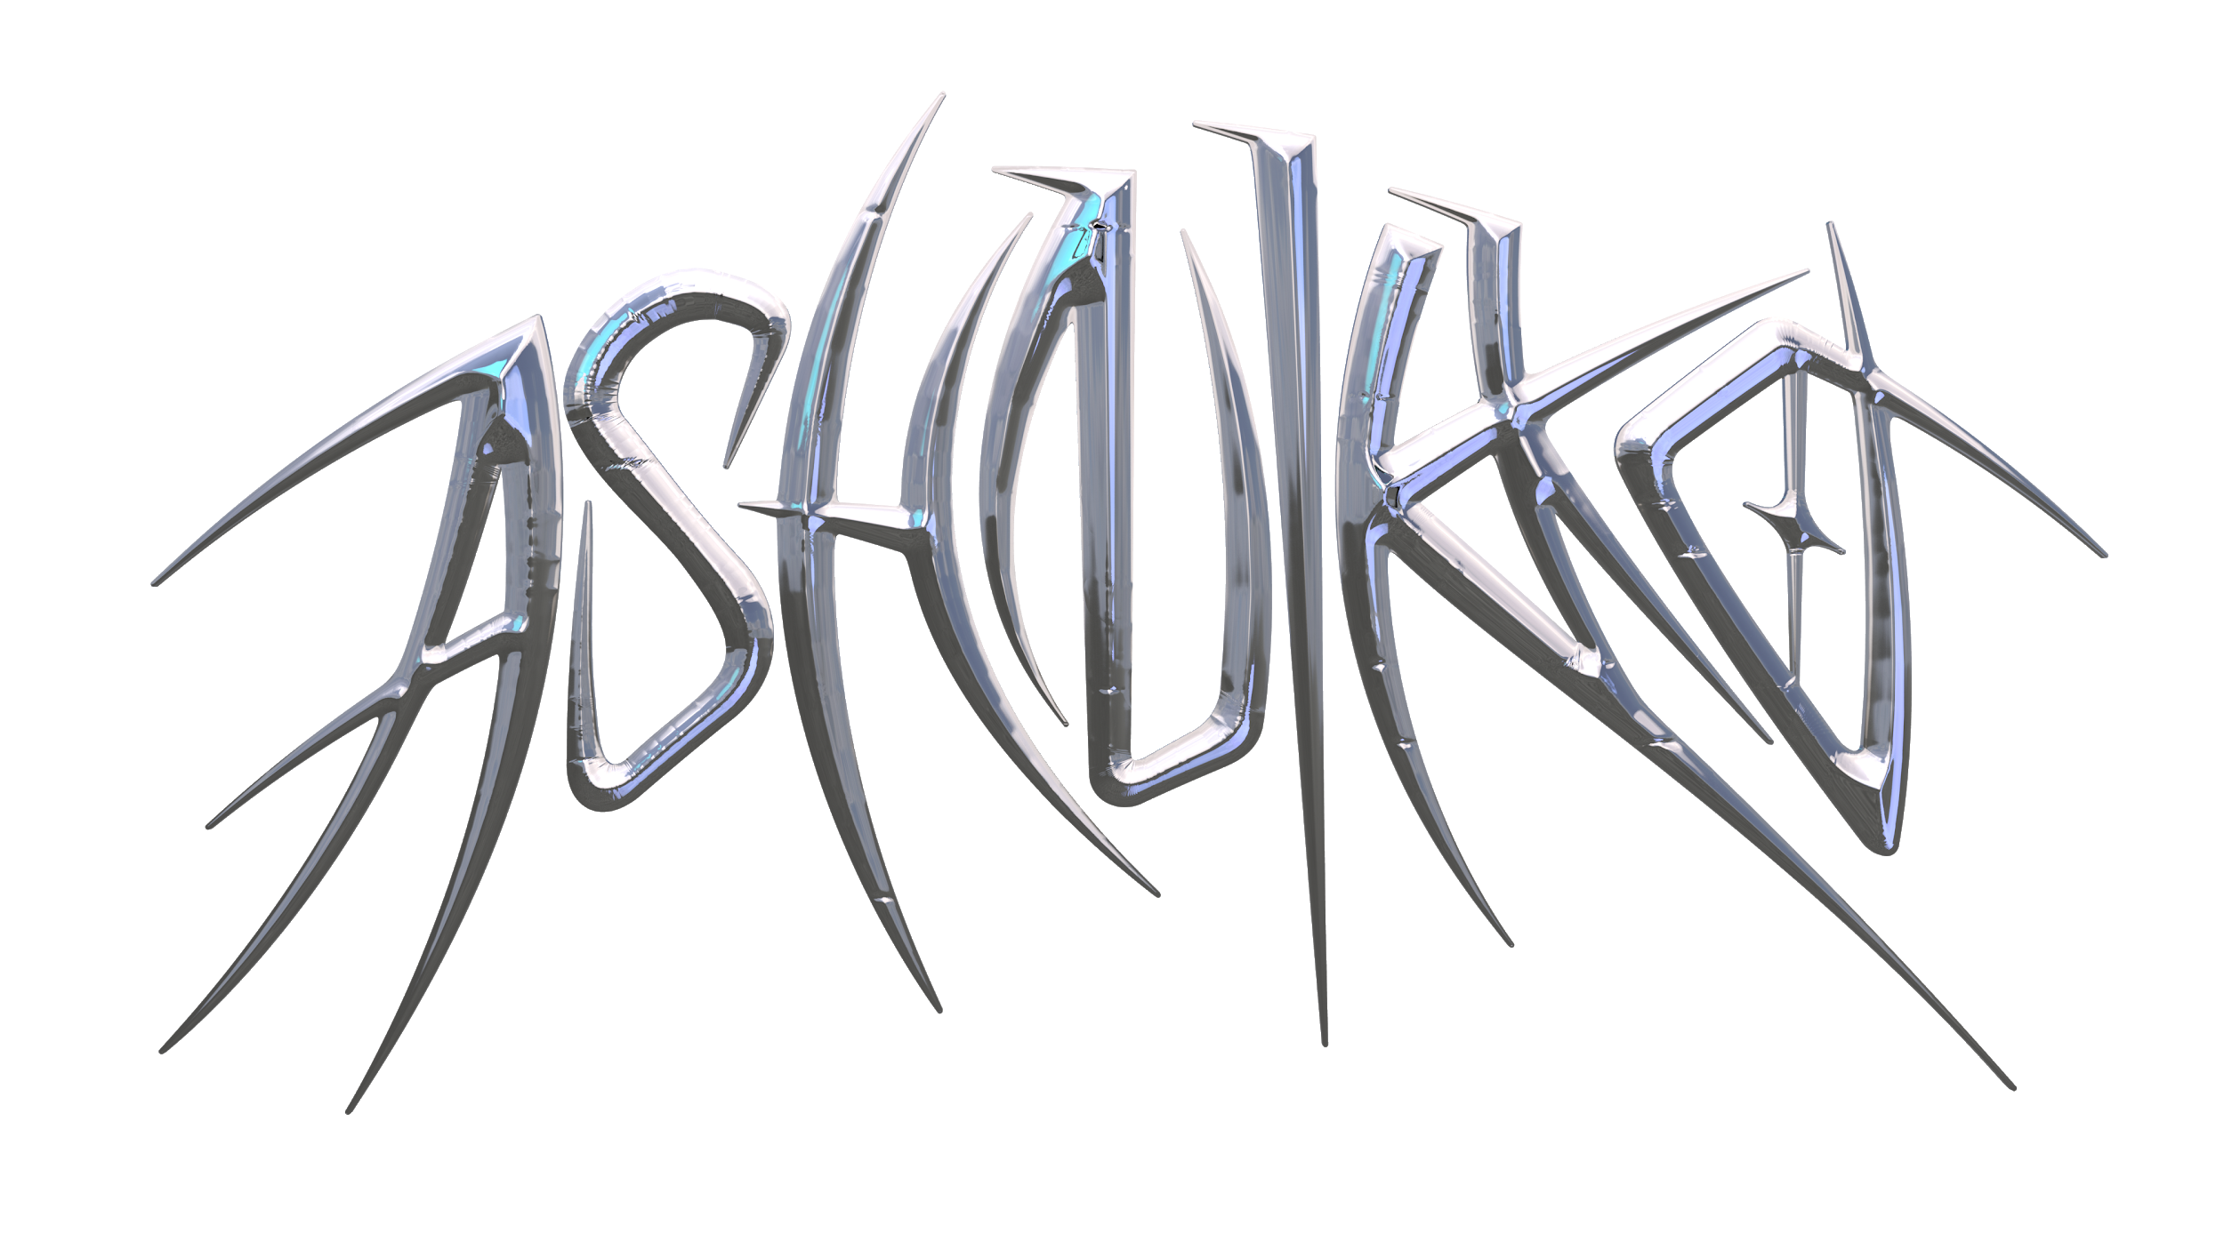

**ASHNIKKO TEAMS UP WITH BEATS BY DR. DRE AND TIKTOK**

**FOR OUTRAGEOUS NEW “DAISY” VIDEO**

[**WATCH HERE**](http://ashnikko.lnk.to/DaisyVideo)

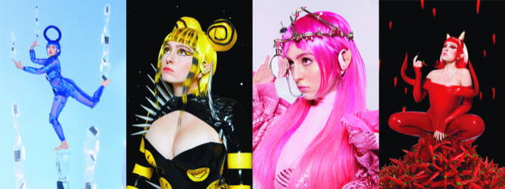

“*[Ashnikko](https://hypebeast.com/tags/ashnikko) continues her ascent to world takeover” –* ***Hypebeast***

*“literally out of this world” –* ***PAPER***

*“Ashnikko is bigger than TikTok...aggressive, campy, and demonic all at once”* ***– The Fader***

*“Bold, ground-breaking future pop... a future pop wonder, working with full embrace of technology and a dismissal of the rules.” -* ***CLASH***

**August 7, 2020 (Los Angeles, CA)** – Today, London-based alt-pop rapper Ashnikko unleashes the outrageous new video for [“Daisy,”](http://ashnikko.lnk.to/DaisyVideo) created in collaboration with Beats by Dr. Dre (Beats). To craft the over-the-top UGC video, Ashnikko called upon TikTok users to join in the #BEATSDAISYCHALLENGE, which has amassed more than 7.7 billion views and 2.4 million submissions. The most creative entries were selected to be featured in the final product directed by Charlotte Rutherford, bursting with vibrant colored themes – Glacier Blue, Spring Yellow, Cloud Pink and Lava Red. To top it all off, the blue-haired maven also just released a hilarious ball-busting breakdown of “Daisy” for an episode of *Genius* “Verified” – watch [here](https://youtu.be/F3p8Appnu_g).

“Daisy” has now accumulated 6.3M global streams to date, following recent track [“Cry”](https://youtu.be/pssWSj42t8M) featuring Grimes, which has gained widespread acclaim from the likes of *Pitchfork*, *PAPER*, *Hypebeast*, *NME*, *Consequence of Sound*, *Stereogum*, to name a few. The tracks are just the latest in Ashnikko’s meteoric rise, which began after the release of her breakout *Hi It’s Me* EP featuring meme-able anthems like TikTok-fueled hit “Stupid.” Pre-COVID lockdown, Ashnikko supported Danny Brown on his *U Know What I’m Saying?* tour across North America and announced a US tour with Doja Cat before everything came to a halt. Even with the world slowing down, Ashnikko has been virtually busy eating chilies with YungBlud, doing yoga with Charli XCX, playing DJ sets for *PAPER* x Club Quarantine, and she just co-wrote Doja Cat's Gold-certified banger “Boss Bitch.” Now with more music on the horizon, Ashnikko is set to take 2020 by storm.

**More about Ashnikko:**

Art, music and sexual liberation are the three most potent ingredients in Ashnikko’s rebellion. Born and raised in suburban Greensboro, North Carolina, her parents raised her on a musical diet comprised exclusively of country music and Slipknot. Spending her teenage years in Eastern Europe, Ashnikko buried herself in music, listening exclusively to female artists until she was 17 – specifically proudly feminist and sex positive female artists – all of whom shaped her early sound. As soon as she turned 18, she moved to London and spent her nights wandering nightclubs and open mics, eventually establishing a home for herself in the community.

# # #

**For further information contact Warner Records Publicity:**

National: [Jaime.Rosenberg@warnerrecords.com](mailto:Jaime.Rosenberg@warnerrecords.com)

Tour/Regional: [Patrice.Compere@warnerrecords.com](mailto:Patrice.Compere@warnerrecords.com)

**Follow Ashnikko:**

[**Spotify**](https://open.spotify.com/artist/3PyJHH2wyfQK3WZrk9rpmP) **|** [**Instagram**](https://www.instagram.com/ashnikko/) **|** [**Twitter**](https://twitter.com/ashnikko) **|** [**Facebook**](https://www.facebook.com/ashnikkomusic/)

**cid:image001.png@01D5204D.CFB194F0**