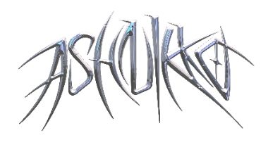

**ASHNIKKO UNLEASHES HIGHLY-ANTICIPATED *DEMIDEVIL* MIXTAPE**

**TO WIDESPREAD ACCLAIM FROM *THE NEW YORK TIMES*, *NPR*, *NME* & MANY MORE**

[**LISTEN HERE**](https://ashnikko.lnk.to/DEMIDEVIL)

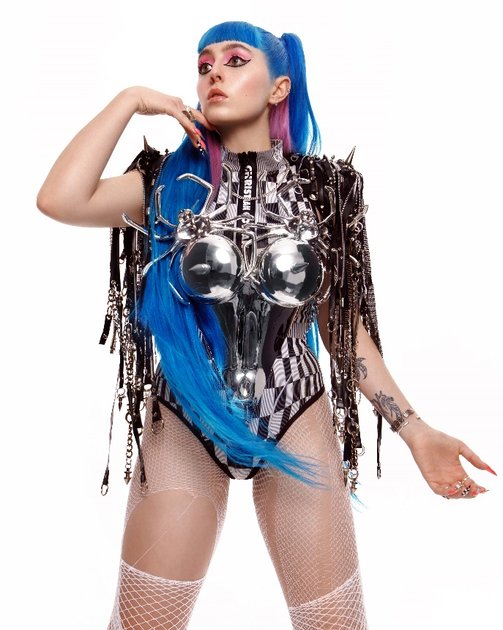

*Named in* ***NPR’s*** *Best Music of 2020 + 2021 Music Recommendations*

*“‘Demidevil’: lewd antics, bravado, misandry and zippy one-liners engineered for social media” –* ***The New York Times***

*“‘Demidevil’ shows that Ashnikko’s far more than a two-trend wonder”* ***– NME***

*Named as a 2021 Artist To Watch by* ***Spotify****,* ***FORTUNE*** *&* ***Vogue UK***

*“One of the most provocative voices in pop right now, helping young women feel unbreakable"* ***– The Telegraph***

*“Ashnikko is bigger than TikTok...aggressive, campy, and demonic all at once”* ***– The Fader***

*“She's entered the market to dominate”* ***– PAPER***

*“Ashnikko is the real deal.”* ***– V Magazine***

*“Bold, ground-breaking future pop”* ***– CLASH***

**January 15, 2021 (Los Angeles, CA)** – London-based alt-pop rapper Ashnikko unleashes her highly-anticipated mixtape *DEMIDEVIL* today on Warner Records to widespread critical acclaim from the likes of *NPR*, *The New York Times*, *NME*, *The FADER*, *PAPER*, *Vogue UK*, and *The Telegraph* to name a few. Listen to it [HERE](https://ashnikko.lnk.to/DEMIDEVIL)

On the 10-track romp, Ashnikko’s furious feminist energy is palpable, flaunting her multi-hyphenate genre-spanning style as she ricochets between themes of empowerment, vengeance to full-blown side-splitting humor. Throughout, Ashnikko calls on other fiercely independent womxn, including ethereal pop star Grimes on emo banger [“Cry,”](https://www.youtube.com/watch?v=pssWSj42t8M) Kelis on the brand new single [“Deal With It,”](https://ashnikko.lnk.to/dwivideo) and Princess Nokia on the sapphic soaked dreamer “Slumber Party,” not to mention a Gen-Z update on an Avril Lavigne classic (“L8r Boi”).

About the record, Ashinnko proudly states, *“The fruit of my loins, the apple of my eye, the product of my blood, sweat, snot, and tears, my mixtape DEMIDEVIL!!!!! I worked so hard on this music I don’t know how to even deal with it being released into the wild. Might have to hibernate for a week or two while everyone listens to it.”*

*DEMIDEVIL* follows Ashnikko’s 2019 *Hi, Its Me* EP, which introduced the world to her atmospheric smash hit “STUPID.” Since then, the blue-haired maven has firmly solidified herself as a top artist to watch in the new year, reigning as a Spotify “Artist to Watch in 2021” with nearly 2 million TikTok followers and earning global acclaim from the likes of *NPR*, *PAPER*, *V Magazine*, *ELLE UK*, *Rolling Stone*, *Pitchfork*, *The Fader*, *Nylon*, *Complex*, and many more, including a recent 3-page feature in [*New York Magazine*](https://warnerrecords.app.box.com/s/8tyhccvhd7ojtqrwhgzo67tj5rp2d4vt)*.*

***DEMIDEVIL* Tracklist:**

1. Daisy
2. Toxic
3. Deal With It (feat. Kelis)
4. Slumber Party (feat. Princess Nokia)
5. Drunk With My Friends
6. Little Boy
7. L8r Boi
8. Cry (feat. Grimes)
9. Good While It Lasted
10. Clitoris! The Musical

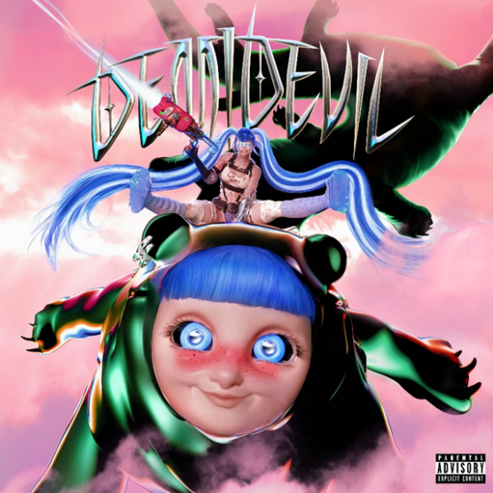

*High-res artwork available* [*here*](https://press.warnerrecords.com/ashnikko/)

# # #

**For further information contact Warner Records Publicity:**

National: [Jaime.Rosenberg@warnerrecords.com](mailto:Jaime.Rosenberg@warnerrecords.com)

Regional: [Patrice.Compere@warnerrecords.com](mailto:Patrice.Compere@warnerrecords.com)

**Follow Ashnikko:**

[**Spotify**](https://open.spotify.com/artist/3PyJHH2wyfQK3WZrk9rpmP) **|** [**Instagram**](https://www.instagram.com/ashnikko/) **|** [**Twitter**](https://twitter.com/ashnikko) **|** [**Facebook**](https://www.facebook.com/ashnikkomusic/)

