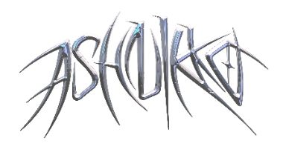

**ASHNIKKO UNVEILS LATEST SINGLE + VIDEO “DEAL WITH IT” (FEAT. KELIS)**

**NEW RELEASE DATE ANNOUNCED FOR HIGHLY-ANTICIPATED *DEMIDEVIL* MIXTAPE**

**OUT THIS FRIDAY, JANUARY 15TH**

**PRE-SAVE IT** [**HERE**](Https://ashnikko.lnk.to/DEMIDEVIL)

*Named in* ***NPR’s*** *Best Music of 2020 + 2021 Music Recommendations*

*Named as a 2021 Artist To Watch by* ***Spotify****,* ***FORTUNE*** *&* ***Vogue UK***

*“She's entered the market to dominate”* ***– PAPER***

*“Ashnikko is the real deal.”* ***– V Magazine***

*“Ashnikko is bigger than TikTok...aggressive, campy, and demonic all at once”* ***– The Fader***

*“Bold, ground-breaking future pop”* ***– CLASH***

**January 12, 2021 (Los Angeles, CA)** – Already taking 2021 by storm, London-based alt-pop rapper Ashnikko is bringing forward the release date of her highly-anticipated mixtape *DEMIDEVIL* to this Friday, January 15th on Warner Records. Read Ashnikko’s statement [here](https://nam04.safelinks.protection.outlook.com/?url=https%3A%2F%2Fwww.instagram.com%2Fp%2FCJwUmhLpahk%2F&data=04%7C01%7CPatrice.Compere%40warnerrecords.com%7C405d8e6602754fffc07f08d8b3fb5dec%7C8367939002ec4ba1ad3d69da3fdd637e%7C0%7C0%7C637457239478191883%7CUnknown%7CTWFpbGZsb3d8eyJWIjoiMC4wLjAwMDAiLCJQIjoiV2luMzIiLCJBTiI6Ik1haWwiLCJXVCI6Mn0%3D%7C1000&sdata=ALr0awqG8Kmf01gTd757S1haMePKs6iWhcqZNrW7ibo%3D&reserved=0).

Alongside the news comes her latest single “Deal With It” – featuring Kelis’ iconic “Caught Out There” – an empowering anthem song of sexual liberation and sweet freedom that comes from getting over an ex. Self-described as “my tentacle break-up fantasy brought to life,” Ashnikko transforms into a tentacle clad monster in the accompanying pirate-themed video directed by Charlotte Rutherford, who previous collaborated with Ashnikko on ["Daisy"](https://nam04.safelinks.protection.outlook.com/?url=https%3A%2F%2Fyoutu.be%2F6i01tOMgBDU&data=04%7C01%7CPatrice.Compere%40warnerrecords.com%7C405d8e6602754fffc07f08d8b3fb5dec%7C8367939002ec4ba1ad3d69da3fdd637e%7C0%7C0%7C637457239478191883%7CUnknown%7CTWFpbGZsb3d8eyJWIjoiMC4wLjAwMDAiLCJQIjoiV2luMzIiLCJBTiI6Ik1haWwiLCJXVCI6Mn0%3D%7C1000&sdata=MLtBAimWebdpLUeqR3iambY2NotJ4BNQnIrTtzd8Q5g%3D&reserved=0) as well as the ‘["Daisy 2.0" (feat. Hatsune Miku)](https://nam04.safelinks.protection.outlook.com/?url=https%3A%2F%2Fyoutu.be%2FeVOWYeZm9v8&data=04%7C01%7CPatrice.Compere%40warnerrecords.com%7C405d8e6602754fffc07f08d8b3fb5dec%7C8367939002ec4ba1ad3d69da3fdd637e%7C0%7C0%7C637457239478201877%7CUnknown%7CTWFpbGZsb3d8eyJWIjoiMC4wLjAwMDAiLCJQIjoiV2luMzIiLCJBTiI6Ik1haWwiLCJXVCI6Mn0%3D%7C1000&sdata=yomQeu5ZY2rnpfYxB7ZKaArI3Lcw6HfhtI2el7DKYIk%3D&reserved=0). Listen to “Deal With It” [HERE](https://ashnikko.lnk.to/DealWithIt) and watch the “Deal With It” video [HERE](https://ashnikko.lnk.to/dwivideo).

On *DEMIDEVIL*, the London-based North Carolina-born artist flaunts her multi-hyphenate genre-spanning style as she ricochets between themes of empowerment [(“Daisy”](https://www.youtube.com/watch?v=6i01tOMgBDU)), vengeance ([“Cry”](https://www.youtube.com/watch?v=pssWSj42t8M)) to side-splitting humor (“Clitoris! The Musical”). Throughout, Ashnikko calls on other fiercely inspiring artists like New York rapper Princess Nokia for a collaboration on the Sapphic-soaked dream sequence “Slumber Party” as well as ethereal pop star Grimes on emo banger “Cry.” Always paying her dues to the feminist artists of the early naughties and late 90’s paving the way for outspoken Gen Z artists like herself, she pays homage to Avril Lavigne with “L8r Boi.” upgrading the lyrics through her ‘no-fucks-given’ prism. Ashnikko stays true to herself as she excavates her emotions and experiences with friendships, relationships and even with the music industry, from the very literal “Toxic” to the shot pouring and dance floor ready “Drunk With My Friends.” Channeling her grungier side on “Little Boy” and “Good While It Lasted” we get a taste of Ashnikko’s acerbic tongue and to finish: the ‘funny ‘cause it’s true’ “Clitoris! The Musical,” a hilarious take down of the hetrosexual males' arguable inability to find the sweet spot.

*DEMIDEVIL* follows Ashnikko’s 2019 *Hi, Its Me* EP, which introduced the world to her atmospheric smash hit “STUPID.” Since then, the blue-haired maven has firmly solidified herself as a top artist to watch in the new year, reigning as a Spotify “Artist to Watch in 2021” with nearly 2 million TikTok followers and earning global acclaim from the likes of *NPR*, *PAPER*, *V Magazine*, *ELLE UK*, *Rolling Stone*, *Pitchfork*, *The Fader*, *Nylon*, *Complex*, and many more, including a recent 3-page feature in [*New York Magazine*](https://warnerrecords.app.box.com/s/8tyhccvhd7ojtqrwhgzo67tj5rp2d4vt)*.*

The 24-year old’s furious feminist energy is palpable, turning the male gaze on itself again and again on her new mixtape. As Ash puts herself: “I just like being a little demon – a little devil hellraiser".

In conjunction with today’s video release, [Paige Piskin](https://nam04.safelinks.protection.outlook.com/?url=https%3A%2F%2Fwww.instagram.com%2Fpaigepiskin%2F&data=04%7C01%7CPatrice.Compere%40warnerrecords.com%7Cde20343132724e32048e08d8b6657d13%7C8367939002ec4ba1ad3d69da3fdd637e%7C0%7C0%7C637459894288048210%7CUnknown%7CTWFpbGZsb3d8eyJWIjoiMC4wLjAwMDAiLCJQIjoiV2luMzIiLCJBTiI6Ik1haWwiLCJXVCI6Mn0%3D%7C1000&sdata=kEkwJqgFwZXmilEVsF24mT5dqHcB04c5XjIkX3pbgNA%3D&reserved=0) has recreated the Ashnikko Sea Monster as an Instagram filter. Follow Ashnikko on [Instagram](https://nam04.safelinks.protection.outlook.com/?url=https%3A%2F%2Fwww.instagram.com%2Fashnikko%2F%3Fhl%3Den&data=04%7C01%7CPatrice.Compere%40warnerrecords.com%7Cde20343132724e32048e08d8b6657d13%7C8367939002ec4ba1ad3d69da3fdd637e%7C0%7C0%7C637459894288058208%7CUnknown%7CTWFpbGZsb3d8eyJWIjoiMC4wLjAwMDAiLCJQIjoiV2luMzIiLCJBTiI6Ik1haWwiLCJXVCI6Mn0%3D%7C1000&sdata=Ia08FYEEqNTkYCc2UkAx5QyagRj9v0RmEwlQmzHwfis%3D&reserved=0) to use the filter and follow her there as well as [Twitter](https://nam04.safelinks.protection.outlook.com/?url=https%3A%2F%2Ftwitter.com%2Fashnikko%3Fref_src%3Dtwsrc%25255Egoogle%25257Ctwcamp%25255Eserp%25257Ctwgr%25255Eauthor&data=04%7C01%7CPatrice.Compere%40warnerrecords.com%7Cde20343132724e32048e08d8b6657d13%7C8367939002ec4ba1ad3d69da3fdd637e%7C0%7C0%7C637459894288058208%7CUnknown%7CTWFpbGZsb3d8eyJWIjoiMC4wLjAwMDAiLCJQIjoiV2luMzIiLCJBTiI6Ik1haWwiLCJXVCI6Mn0%3D%7C1000&sdata=dP7y27RuqJtRLqmeMHrxvpb5ABhyGU5GKV6awsSEP38%3D&reserved=0), [Facebook](https://nam04.safelinks.protection.outlook.com/?url=https%3A%2F%2Fwww.facebook.com%2Fashnikkomusic%2F&data=04%7C01%7CPatrice.Compere%40warnerrecords.com%7Cde20343132724e32048e08d8b6657d13%7C8367939002ec4ba1ad3d69da3fdd637e%7C0%7C0%7C637459894288068199%7CUnknown%7CTWFpbGZsb3d8eyJWIjoiMC4wLjAwMDAiLCJQIjoiV2luMzIiLCJBTiI6Ik1haWwiLCJXVCI6Mn0%3D%7C1000&sdata=LnDpaY8zmUC0NntELes9ACITJpYzc8kKPadI3e3Xps0%3D&reserved=0), and [TikTok](https://nam04.safelinks.protection.outlook.com/?url=https%3A%2F%2Fwww.tiktok.com%2F%40ashnikko%3Flang%3Den&data=04%7C01%7CPatrice.Compere%40warnerrecords.com%7Cde20343132724e32048e08d8b6657d13%7C8367939002ec4ba1ad3d69da3fdd637e%7C0%7C0%7C637459894288068199%7CUnknown%7CTWFpbGZsb3d8eyJWIjoiMC4wLjAwMDAiLCJQIjoiV2luMzIiLCJBTiI6Ik1haWwiLCJXVCI6Mn0%3D%7C1000&sdata=qoVW%2FoAbQtwwSuWxG%2Fwm%2Ba%2FK5BOaldMgUsvm2ny8xHE%3D&reserved=0) to stay up to date on everything in her blue tinged world.

***DEMIDEVIL* Tracklist:**

1. Daisy
2. Toxic
3. Deal With It (feat. Kelis)
4. Slumber Party (feat. Princess Nokia)
5. Drunk With My Friends
6. Little Boy
7. L8r Boi
8. Cry (feat. Grimes)
9. Good While It Lasted
10. Clitoris! The Musical

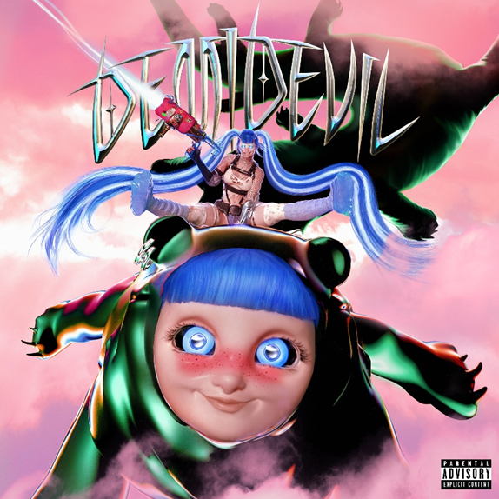

*High-res artwork available* [*here*](https://press.warnerrecords.com/ashnikko/)

# # #

**For further information contact Warner Records Publicity:**

National: [Jaime.Rosenberg@warnerrecords.com](mailto:Jaime.Rosenberg@warnerrecords.com)

Tour/Regional: [Patrice.Compere@warnerrecords.com](mailto:Patrice.Compere@warnerrecords.com)

**Follow Ashnikko:**

[**Spotify**](https://open.spotify.com/artist/3PyJHH2wyfQK3WZrk9rpmP) **|** [**Instagram**](https://www.instagram.com/ashnikko/) **|** [**Twitter**](https://twitter.com/ashnikko) **|** [**Facebook**](https://www.facebook.com/ashnikkomusic/)

