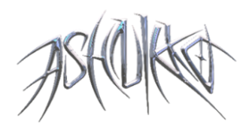

**ASHNIKKO CONTINUES ANNUAL HALLOWEEN TRADITION WITH**

**“HALLOWEENIE IV: INNARDS”**

[**LISTEN HERE**](https://ashnikko.lnk.to/HalloweenieIVInardsOutNow)

**SOLD-OUT *DEMIDEVIL* WORLD TOUR KICKS OFF NEXT WEEK**

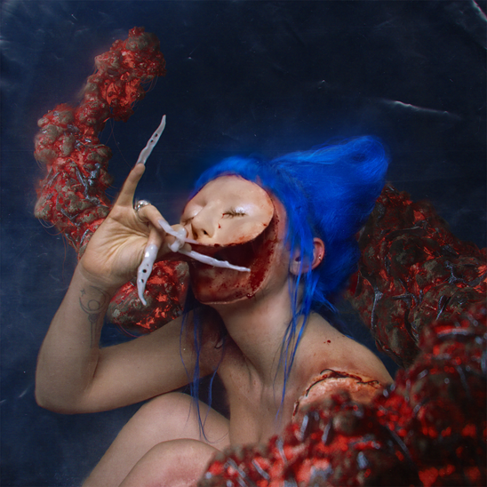

*Named in* ***NPR’s*** *Best Music of 2020 + 2021 Music Recommendations*

*“lewd antics, bravado, misandry and zippy one-liners engineered for social media”*

***– The New York Times***

*“‘Ashnikko’s far more than a two-trend wonder”*

***– NME***

*“Ashnikko is one of the most provocative voices in pop right now"*

***– Telegraph***

**October 22, 2021 (Los Angeles, CA)** – Just in time for spooky season, blue-haired alt-pop superstar Ashnikko (she/they) unveils “Halloweenie IV: Innards,” featuring a haunting interpolation of classical song “In The Hall Of The Mountain King” by Edvard Grieg. Over the past 4 years, Ashnikko has made it an annual tradition to release a Halloween track in celebration of their favorite holiday, including [“Halloweenie,”](https://nam04.safelinks.protection.outlook.com/?url=https%3A%2F%2Fyoutu.be%2FiqSt1ZS_Znw&data=04%7C01%7CPatrice.Compere%40warnerrecords.com%7C03b0c57074a34845fa4908d993275961%7C8367939002ec4ba1ad3d69da3fdd637e%7C0%7C0%7C637702619469414125%7CUnknown%7CTWFpbGZsb3d8eyJWIjoiMC4wLjAwMDAiLCJQIjoiV2luMzIiLCJBTiI6Ik1haWwiLCJXVCI6Mn0%3D%7C1000&sdata=hm9lNFc741fVSkZD%2FLHshwqBeod0sMPsG%2Fj%2BjJ2rOH4%3D&reserved=0) [“Halloweenie II: Pumpkin Spice,”](https://nam04.safelinks.protection.outlook.com/?url=https%3A%2F%2Fyoutu.be%2F2sZIaNwFzRc&data=04%7C01%7CPatrice.Compere%40warnerrecords.com%7C03b0c57074a34845fa4908d993275961%7C8367939002ec4ba1ad3d69da3fdd637e%7C0%7C0%7C637702619469414125%7CUnknown%7CTWFpbGZsb3d8eyJWIjoiMC4wLjAwMDAiLCJQIjoiV2luMzIiLCJBTiI6Ik1haWwiLCJXVCI6Mn0%3D%7C1000&sdata=ywCbYuDan52nt4zuulBzfLRFaEk3iExAWj8wColq7dM%3D&reserved=0) and [“Halloweenie III: Seven Days.”](https://nam04.safelinks.protection.outlook.com/?url=https%3A%2F%2Fwww.youtube.com%2Fwatch%3Fv%3D2qJa_5hp06g&data=04%7C01%7CPatrice.Compere%40warnerrecords.com%7C03b0c57074a34845fa4908d993275961%7C8367939002ec4ba1ad3d69da3fdd637e%7C0%7C0%7C637702619469414125%7CUnknown%7CTWFpbGZsb3d8eyJWIjoiMC4wLjAwMDAiLCJQIjoiV2luMzIiLCJBTiI6Ik1haWwiLCJXVCI6Mn0%3D%7C1000&sdata=NkOnchEt7HaxjAVzmEc58Wb%2B5Rtxb9hpMlpdJEVCRLc%3D&reserved=0)

“Halloweenie IV: Innards” follows Ashnikko’s two arresting new singles, [“Panic Attacks In Paradise”](https://youtu.be/-VNFkMZPn88) and [“Maggots,”](https://youtu.be/qiyP7kjasQs) as well as recent collaboration with Lady Gaga on her record-breaking remix album *Dawn of Chromatica*, which saw Ashnikko reimagine [“Plastic Doll,”](https://www.youtube.com/watch?v=S-DixhC22GA) giving new life to the empowering bop.

With widespread critical acclaim from the likes of *NPR*, *The New York Times*, *NME*, *Pitchfork*, *The FADER*, *PAPER*, V Magazine, *New York Magazine*, *The Telegraph,* and many more,Ashnikko has gathered north of 1.7 billion total career streams to date, with no signs of slowing down anytime soon. Alongside the release of their explosive mixtape *DEMIDEVIL*, they most recently performed to packed crowds at this year’s top summer festivals, including Reading and Leeds and Life is Beautiful, before embarking on a completely sold-out U.S. run this fall – their first-ever North American headline tour – finally bringing their wild, weird, and wonderful world to life in cities across the U.S. Check out the full itinerary below.

**Upcoming U.S. Tour Dates:**

Oct. 26 Silver Spring, MD The Fillmore ***(SOLD OUT!)***

Oct. 27 Philadelphia, PA The Fillmore ***(SOLD OUT!)***

Oct. 31 New York, NY Terminal 5 ***(SOLD OUT!)***

Nov. 1 Boston, MA Paradise Rock Club ***(SOLD OUT!)***

Nov. 2 Boston, MA Paradise Rock Club ***(SOLD OUT!)***

Nov. 4 Detroit, MI The Fillmore Detroit [***(JUST ADDED)***](https://concerts.livenation.com/event/08005B47F4644564)

Nov. 5 Chicago, IL Concord Music Hall ***(SOLD OUT!)***

Nov. 6 Chicago, IL Concord Music Hall ***(SOLD OUT!)***

Nov. 9 San Francisco, CA The Warfield ***(SOLD OUT!)***

Nov. 10 Los Angeles, CA The Novo ***(SOLD OUT!)***

**For further information, contact:**

National: [Jaime.Rosenberg@warnerrecords.com](mailto:Jaime.Rosenberg@warnerrecords.com)

Tour Press: [Patrice.Compere@warnerrecords.com](mailto:Patrice.Compere@warnerrecords.com)

**Follow Ashnikko:**

[**Spotify**](https://nam04.safelinks.protection.outlook.com/?url=https%3A%2F%2Fopen.spotify.com%2Fartist%2F3PyJHH2wyfQK3WZrk9rpmP&data=04%7C01%7CPatrice.Compere%40warnerrecords.com%7C6ac80cca8ecf474281c908d8ed9680d6%7C8367939002ec4ba1ad3d69da3fdd637e%7C0%7C0%7C637520577965528245%7CUnknown%7CTWFpbGZsb3d8eyJWIjoiMC4wLjAwMDAiLCJQIjoiV2luMzIiLCJBTiI6Ik1haWwiLCJXVCI6Mn0%3D%7C1000&sdata=OWsOygIeMgKzfbjZmfBRV1Qw94WzCRNDEAPwjSSxN1k%3D&reserved=0) **|** [**Instagram**](https://nam04.safelinks.protection.outlook.com/?url=https%3A%2F%2Fwww.instagram.com%2Fashnikko%2F&data=04%7C01%7CPatrice.Compere%40warnerrecords.com%7C6ac80cca8ecf474281c908d8ed9680d6%7C8367939002ec4ba1ad3d69da3fdd637e%7C0%7C0%7C637520577965538236%7CUnknown%7CTWFpbGZsb3d8eyJWIjoiMC4wLjAwMDAiLCJQIjoiV2luMzIiLCJBTiI6Ik1haWwiLCJXVCI6Mn0%3D%7C1000&sdata=LmC%2F3GJOKFS3URd8oFaXpnqWIRSeJT9JJuPT27k5q8Y%3D&reserved=0) **|** [**Twitter**](https://nam04.safelinks.protection.outlook.com/?url=https%3A%2F%2Ftwitter.com%2Fashnikko&data=04%7C01%7CPatrice.Compere%40warnerrecords.com%7C6ac80cca8ecf474281c908d8ed9680d6%7C8367939002ec4ba1ad3d69da3fdd637e%7C0%7C0%7C637520577965538236%7CUnknown%7CTWFpbGZsb3d8eyJWIjoiMC4wLjAwMDAiLCJQIjoiV2luMzIiLCJBTiI6Ik1haWwiLCJXVCI6Mn0%3D%7C1000&sdata=URMF%2BgT75GUTJu2BMxIMX2Qt5oqVkhOx7u8eJOcdzZ8%3D&reserved=0) **|** [**Facebook**](https://nam04.safelinks.protection.outlook.com/?url=https%3A%2F%2Fwww.facebook.com%2Fashnikkomusic%2F&data=04%7C01%7CPatrice.Compere%40warnerrecords.com%7C6ac80cca8ecf474281c908d8ed9680d6%7C8367939002ec4ba1ad3d69da3fdd637e%7C0%7C0%7C637520577965548230%7CUnknown%7CTWFpbGZsb3d8eyJWIjoiMC4wLjAwMDAiLCJQIjoiV2luMzIiLCJBTiI6Ik1haWwiLCJXVCI6Mn0%3D%7C1000&sdata=l5QMa0SIOuUm1zLAE%2BYcofazLyG4MT2MxBzF%2F6wji6o%3D&reserved=0)

