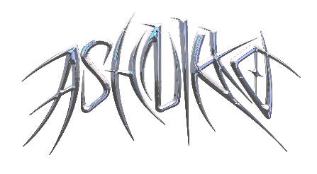

**ASHNIKKO UNVEILS DEVILISH NEW VIDEO FOR**

**“HALLOWEENIE III: SEVEN DAYS” –** [**WATCH HERE**](https://ashnikko.lnk.to/HalloweenieIIIVideo)

**HIGHLY-ANTICIPATED *DEMIDEVIL* MIXTAPE PUSHED TO FEB. 19, 2021**

*“She's entered the market to dominate”* ***– PAPER***

*“Ashnikko is the real deal.”* ***– V Magazine***

*“Ashnikko is bigger than TikTok...aggressive, campy, and demonic all at once”* ***– The Fader***

*“Ashnikko takes charge with a burst of playful energy.”* ***– Complex***

**October 30, 2020 (Los Angeles, CA)** – This Hallow’s Eve, London-based alt-pop rapper Ashnikko unveils a devilish new video for her Halloween-themed track “Halloweenie III: Seven Days.” The video features five outrageous costume changes, ranging from a creepy clown to a blinded nun, culminating in a haunting blood-spattered finale. The spooky new take on “The Twelve Days” of Christmas” is the third iteration of Ashnikko’s annual tradition for her favorite holiday, spawning [“Halloweenie II: Pumpkin Spice”](https://nam04.safelinks.protection.outlook.com/?url=https%3A%2F%2Fyoutu.be%2F2sZIaNwFzRc&data=04%7C01%7CPatrice.Compere%40warnerrecords.com%7Ced6b9962c0934b18801208d876adf3a9%7C8367939002ec4ba1ad3d69da3fdd637e%7C0%7C0%7C637389836771862913%7CUnknown%7CTWFpbGZsb3d8eyJWIjoiMC4wLjAwMDAiLCJQIjoiV2luMzIiLCJBTiI6Ik1haWwiLCJXVCI6Mn0%3D%7C1000&sdata=NKQdGpeZzI%2BIfuBkkb4aOuXqg8Kcos%2F0V0eVCmPfajE%3D&reserved=0) and the original [“Halloweenie,”](https://nam04.safelinks.protection.outlook.com/?url=https%3A%2F%2Fyoutu.be%2FiqSt1ZS_Znw&data=04%7C01%7CPatrice.Compere%40warnerrecords.com%7Ced6b9962c0934b18801208d876adf3a9%7C8367939002ec4ba1ad3d69da3fdd637e%7C0%7C0%7C637389836771872908%7CUnknown%7CTWFpbGZsb3d8eyJWIjoiMC4wLjAwMDAiLCJQIjoiV2luMzIiLCJBTiI6Ik1haWwiLCJXVCI6Mn0%3D%7C1000&sdata=sANLmHJ2%2B7EMT2fCwFr7asEF8VEKBYkzDVuJMp8cCts%3D&reserved=0) which *PAPER* called “a tight, catchy-as-hell bop.”

Meanwhile, Ashnikko’s current single [“Daisy”](https://youtu.be/6i01tOMgBDU) continues to climb the Spotify Global Top 50 charts and currently ranks at #21 on the Global Shazam Chart with more than 1.5 million streams per day and 100 million streams to date, plus upwards of 10 billion TikTok views thanks to the #BeatsDaisyChallenge and #MakeItRedChallenge. The track is the latest taste of the blue-haired maven’s forthcoming mixtape *DEMIDEVIL*, which has just been postponed to Ashnikko’s birthday, February, 19, 2021. In a [post](https://nam04.safelinks.protection.outlook.com/?url=https%3A%2F%2Fwww.instagram.com%2Fp%2FCGnfIj9pvnk%2F&data=04%7C01%7CPatrice.Compere%40warnerrecords.com%7Ced6b9962c0934b18801208d876adf3a9%7C8367939002ec4ba1ad3d69da3fdd637e%7C0%7C0%7C637389836771872908%7CUnknown%7CTWFpbGZsb3d8eyJWIjoiMC4wLjAwMDAiLCJQIjoiV2luMzIiLCJBTiI6Ik1haWwiLCJXVCI6Mn0%3D%7C1000&sdata=BX3CsrCMVZqgHP2kOENEeH%2F0NgTY%2Flp7WblIc4ddm4M%3D&reserved=0) to her followers, she explained:

*“Like most of you, I can’t wait for the year from the slimiest pits of hell to be over. For COVID’s bitch ass to be gone!! To be blunt, I’ve made the executive decision (cuz I’m an executive lol) to move the release of ‘DEMIDEVIL’ to my birthday, February 19th, 2021. I just don’t want to put it out this year. I want to vote the orange fascist piece of shit out of office, spend time with my family, and throw my phone into the fucking ocean.”*

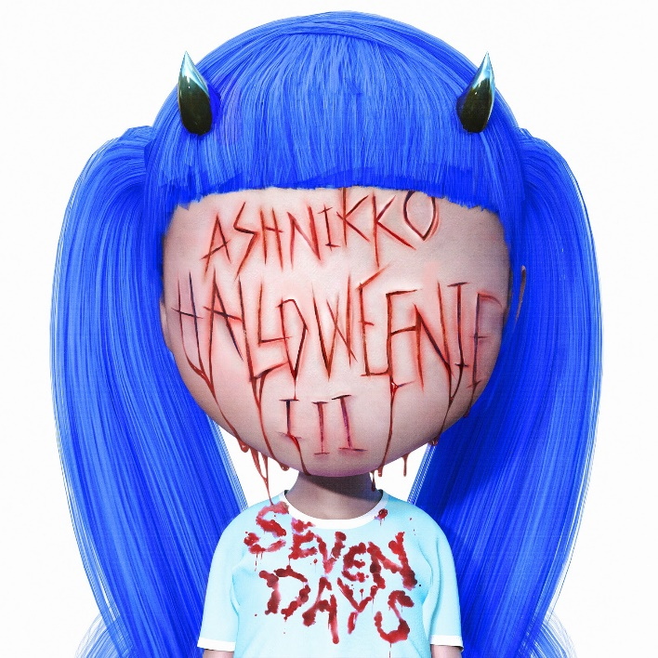

*Artwork + Photos available* [*here*](https://press.warnerrecords.com/ashnikko/)

**More about Ashnikko:**

Art, music and sexual liberation are the three most potent ingredients in Ashnikko’s rebellion. Born and raised in suburban Greensboro, North Carolina, her parents raised her on a musical diet comprised exclusively of country music and Slipknot. Spending her teenage years in Eastern Europe, Ashnikko buried herself in music, listening exclusively to female artists until she was 17 – specifically proudly feminist and sex positive female artists – all of whom shaped her early sound. As soon as she turned 18, she moved to London and spent her nights wandering nightclubs and open mics, eventually establishing a home for herself in the community. *Demidevil* is just the latest in Ashnikko’s meteoric rise, which began after the release of her breakout *Hi It’s Me* EP featuring meme-able anthems like TikTok-fueled hit “Stupid.” Pre-COVID lockdown, Ashnikko toured the US with Danny Brown, made a headline-stealing femdom appearance at the Brits (with her signature blue pigtails flanked by male servants), and announced a US tour with Doja Cat before everything came to a halt. Even with the world slowing down, Ashnikko has been virtually busy eating chilies with YungBlud, doing yoga with Charli XCX, playing DJ sets for *PAPER* x Club Quarantine, and she co-wrote Doja Cat's Gold-certified banger “Boss Bitch.”

# # #

**For further information contact Warner Records Publicity:**

National: [Jaime.Rosenberg@warnerrecords.com](mailto:Jaime.Rosenberg@warnerrecords.com)

Tour/Regional: [Patrice.Compere@warnerrecords.com](mailto:Patrice.Compere@warnerrecords.com)

**Follow Ashnikko:**

[**Spotify**](https://open.spotify.com/artist/3PyJHH2wyfQK3WZrk9rpmP) **|** [**Instagram**](https://www.instagram.com/ashnikko/) **|** [**Twitter**](https://twitter.com/ashnikko) **|** [**Facebook**](https://www.facebook.com/ashnikkomusic/)

