**cid:image001.png@01D5204D.CFB194F0**

**LONDON-BASED RAPPER ASHNIKKO RELEASES   
*HI, IT’S ME* EP ON WARNER RECORDS**

[**WATCH THE VIDEO FOR TITLE TRACK AND SINGLE**](https://warnerr.ec/hiitsmevideo)

“If smashing the patriarchy had a sound, we're pretty sure it would sound like Ashnikko.” – ***Time Out***

“The unapologetic rapper-singer makes angsty tracks for her teenage self.” – ***Wonderland***

“A hot stack of sass pancakes drizzled in dark and playful wordplay.” –[***i-D***](https://i-d.vice.com/en_gb/article/the-soundtrack-to-your-weekend-ft-charli-xcx-steps-and-dream-wife)

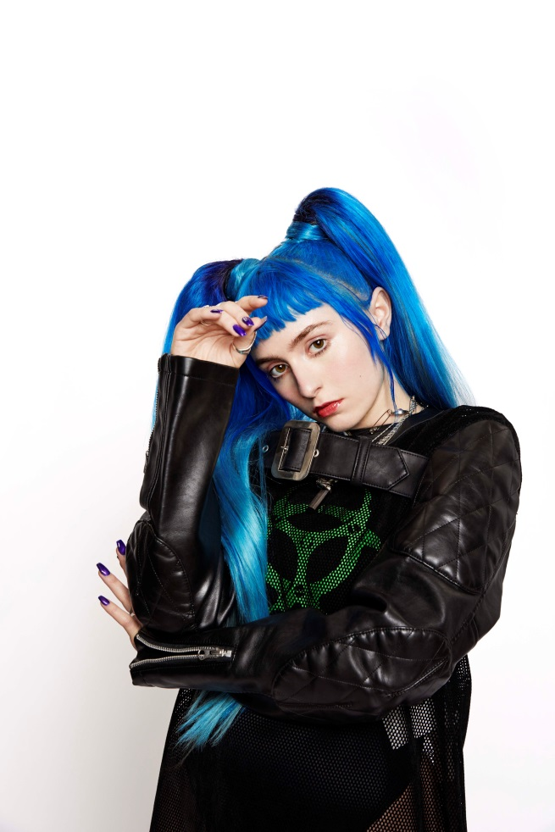

**July 12, 2019 (Los Angeles, CA)** - The perfect antidote for coy pop sexuality in 2019, London-based rapper Ashnikko winds the sonic spirits of punk and hip-hop around each other until the finished product is almost indefinable. From the frenetic trap beats and salacious rhymes of her debut EP *Sass Pancakes* to her recent floor-filler “[Special](https://www.youtube.com/watch?v=LBfuM27T1eM),” a host of influential names have supported your favorite new anarchic pop artist, including Zane Lowe, Annie Mac, *Clash Magazine*, *I-D*, and more. Now, Ashnikko again levels up for her next chapter by dropping a brand new EP *Hi, It’s Me* along with the video for its title track and lead single, out today on Warner Records.

**Watch/Share “Hi, It’s Me” (Official Video)**

[**https://warnerr.ec/hiitsmevideo**](https://warnerr.ec/hiitsmevideo)

**Listen/Share *Hi, It’s Me* (EP)**

[**https://warnerr.ec/hiitsme**](https://warnerr.ec/hiitsme)

“Hi, It’s Me” is a break-up anthem that Ashnikko wrote for herself – a message from her stronger, more decisive self, begging the real Ashnikko to see that she has to get over her ex. “Repeat after me: I’m over it! We’re so over over!” she hollers during the track’s attention-grabbing hook. It’s a serious message about having the confidence to go it alone, delivered in a way that’s mischievous and immediately captivating. The accompanying video was directed by [Lucrecia Taormina](https://www.lucreciataormina.com/). Like the song, the video reflects the struggle of being at odds with one’s self in the middle of a break-up, with Ashnikko effectively kidnapping herself – a symbolical split personality that reminds us that in an ideal world, the reaction to heartbreak would be focused on logic rather than emotion.

The EP is packed with “f*&! you” anthems, each track designed to embolden autonomous women. Ashnikko speaks frankly about things that matter to her, prioritizing her career over bad sex in the country R&B mashup of “Working Bitch,” and bluntly defying stereotypical expectations of female behavior in “Manners.” And on “Stupid,” she teams up with Atlanta’s [Yung Baby Tate](https://open.spotify.com/artist/3IJ21966TwNZI24MwZHMu4?si=MZ0fSfB-TBabnt0jCR4Sag) as the two next wave artists deliver their sexually liberated message. Whether the songs are imbued with a genuine and necessary anger or a sense of playfulness, we can all sing along. *Hi, It’s Me* features production from N8tive, Tylr Rydr, Firzt World Problemz, CallMeTheKidd (Hardy Caprio, Etta Bond), Oscar Scheller (Lily Allen, Mabel) and Jason Julian (Ms Banks, Avelino).

Art, music and sexual liberation are the three most potent ingredients in Ashnikko’s rebellion. Born and raised in suburban Greensboro, North Carolina, her parents raised her on a musical diet comprised exclusively of country music and Slipknot. But just as she was settling into life as an American teenager, they carted her off to Estonia, then Latvia, where she was the only American student in the public school system, taking courses entirely in Latvian. Isolated, it catalyzed an identity crisis she’s still reckoning with to this day. Desperate to escape, she began flying to London on the weekends to pursue music, eventually moving there permanently when she turned 18. Away from the strict confines set for her back home, she arrived in the capital naïve yet hungry to make it in music. Her nights were spent wandering in and out of nightclubs and gigs, befriending creative people who were cool enough to let her crash on their couch. It was a hustle in the beginning, but it’s now paying off.

***Hi, It’s Me* Tracklisting**

1. “Hi, It’s Me”
2. “Special”
3. “STUPID (feat. Yung Baby Tate)”
4. “Working Bitch”
5. “Manners”

# # #

**For further information contact Warner Records Publicity**

National: [Jaime.Rosenberg@warnerrecords.com](mailto:Jaime.Rosenberg@warnerrecords.com)

Regional: [Patrice.Compere@warnerrecords.com](mailto:Patrice.Compere@warnerrecords.com)

**Follow ASHNIKKO:**

[Spotify](https://open.spotify.com/artist/3PyJHH2wyfQK3WZrk9rpmP)

[Instagram](https://www.instagram.com/ashnikko/)

[Twitter](https://twitter.com/ashnikko)

[Facebook](https://www.facebook.com/ashnikkomusic/)