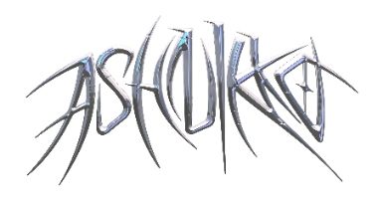

**ASHNIKKO MAKES GLOBAL TELEVISION DEBUT ON *JIMMY KIMMEL LIVE!* WITH PERFORMANCE OF SMASH HIT “DAISY”**

***DEMIDEVIL* OUT NOW TO OVERWHELMING ACCLAIM**

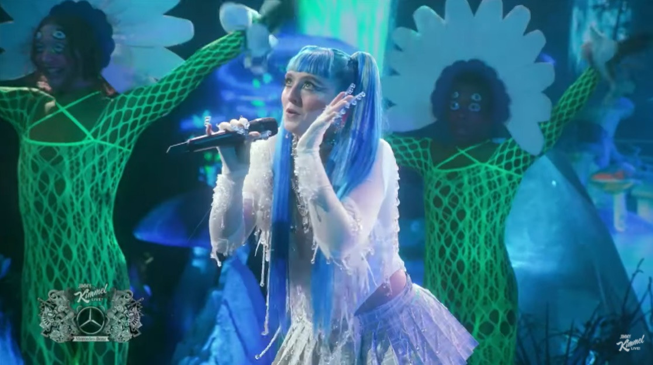

**February 4, 2021 (Los Angeles, CA)** – Fresh off the release of her globally acclaimed mixtape *DEMIDEVIL*, London alt-pop rapper Ashnikko continues on her path to domination, making her worldwide television debut on *Jimmy Kimmel Live!* last night with a performance of her smash hit “Daisy,” which just reached Gold-certified status. Watch the performance [HERE](https://youtu.be/ipTswxigRd4).



*“‘Demidevil’: lewd antics, bravado, misandry and zippy one-liners engineered for social media”*

*–* ***The New York Times***

**

*"… ridiculously catchy, debut mixtape Demidevil is as menacing as it is comically absurd.”*

***– NPR***

**

*“‘Demidevil’ shows that Ashnikko’s far more than a two-trend wonder”*

***– NME***



*“Ashnikko commands fantasy and chaos with ease… a showcase for her newly refined confidence, a step towards the pop powerhouse she’s capable of becoming.”*

***– Pitchfork***

**

*“her bravado, thirst for vengeance, IDGAF attitude, and penchant for hilarity … cements her as an artist above just the trends and the mainstream, making music for women and for herself.”*

***– V Magazine***



*“From front to back, Demidevil is definitive proof that Ashnikko is a musical force of nature, and she's here to stay.”*

***– Billboard***

**

*“She's entered the market to dominate”*

***– PAPER***

**

*“Ashnikko is bigger than TikTok...aggressive, campy, and demonic all at once”*

***– The FADER***



*“[DEMIDEVIL] … capable of propelling her outrageous persona the rest of the way to ubiquity.”*

***– Stereogum***



*“One of the most provocative voices in pop right now, helping young women feel unbreakable"*

***– The Telegraph***

# # #

**For further information contact Warner Records Publicity:**

National: [Jaime.Rosenberg@warnerrecords.com](mailto:Jaime.Rosenberg@warnerrecords.com)

Regional: [Patrice.Compere@warnerrecords.com](mailto:Patrice.Compere@warnerrecords.com)

**Follow Ashnikko:**

[**Spotify**](https://open.spotify.com/artist/3PyJHH2wyfQK3WZrk9rpmP) **|** [**Instagram**](https://www.instagram.com/ashnikko/) **|** [**Twitter**](https://twitter.com/ashnikko) **|** [**Facebook**](https://www.facebook.com/ashnikkomusic/)

