

**ASHNIKKO ANNOUNCES *DEMIDEVIL* – THE LIVESTREAM**

**PRESENTED BY SONGKICK**

**APRIL 30TH AT 6PM PST / 9PM EST IN NORTH AMERICA**

**TICKETS ON SALE** [**NOW**](http://www.ashnikko.world)

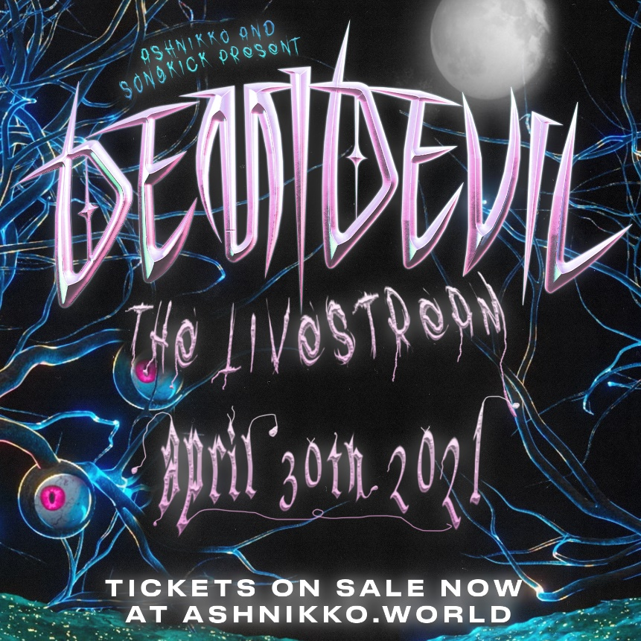

*“‘Demidevil’: lewd antics, bravado, misandry and zippy one-liners engineered for social media” –* ***The NY Times***

*"… ridiculously catchy, debut mixtape Demidevil is as menacing as it is comically absurd.”* ***– NPR***

*“‘Demidevil’ shows that Ashnikko’s far more than a two-trend wonder”* ***– NME***

*“Ashnikko commands fantasy and chaos with ease… a showcase for her newly refined confidence, a step towards the pop powerhouse she’s capable of becoming.”* ***– Pitchfork***

**March 23, 2021 (Los Angeles, CA)** – Following the release of her critically acclaimed [*DEMIDEVIL*](https://nam04.safelinks.protection.outlook.com/?url=https%3A%2F%2Fashnikko.lnk.to%2FDEMIDEVIL&data=04%7C01%7CPatrice.Compere%40warnerrecords.com%7C6ac80cca8ecf474281c908d8ed9680d6%7C8367939002ec4ba1ad3d69da3fdd637e%7C0%7C0%7C637520577965508254%7CUnknown%7CTWFpbGZsb3d8eyJWIjoiMC4wLjAwMDAiLCJQIjoiV2luMzIiLCJBTiI6Ik1haWwiLCJXVCI6Mn0%3D%7C1000&sdata=xnM95loNb4lJNgfosA43RBMQtnk2tHRAKTEpbTrfRKg%3D&reserved=0)mixtape, London alt-pop rapper Ashnikko announces “*DEMIDEVIL* – The Livestream,” a one-off virtual experience of the weird, wonderful, and wild world of Ashnikko that will mark the first-ever live performance of *DEMIDEVIL* in its entirety. The highly-anticipated livestream event will take place on April 30th as part of Songkick Presents – a series of easily accessible global livestream events – broadcasting for fans in North America at 6pm PST/9pm EST and the UK/Europe at 8pm BST. Tickets are available now at [www.ashnikko.world](http://www.ashnikko.world)

With widespread critical acclaim from the likes of *NPR*, *The New York Times*, *NME*, *Pitchfork*, *The FADER*, *PAPER*, V Magazine, *New York Magazine*, *The Telegraph,* and many more,Ashnikko has solidified her status as a 2021 artist to watch. On [*DEMIDEVIL*](https://nam04.safelinks.protection.outlook.com/?url=https%3A%2F%2Fashnikko.lnk.to%2FDEMIDEVIL&data=04%7C01%7CPatrice.Compere%40warnerrecords.com%7C6ac80cca8ecf474281c908d8ed9680d6%7C8367939002ec4ba1ad3d69da3fdd637e%7C0%7C0%7C637520577965508254%7CUnknown%7CTWFpbGZsb3d8eyJWIjoiMC4wLjAwMDAiLCJQIjoiV2luMzIiLCJBTiI6Ik1haWwiLCJXVCI6Mn0%3D%7C1000&sdata=xnM95loNb4lJNgfosA43RBMQtnk2tHRAKTEpbTrfRKg%3D&reserved=0), her furious feminist energy is palpable, flaunting her multi-hyphenate genre-spanning style as she ricochets between themes of empowerment, vengeance to full-blown side-splitting humor. Throughout, the blue-haired maven calls on other fiercely independent womxn, including [Grimes](https://nam04.safelinks.protection.outlook.com/?url=https%3A%2F%2Fwww.youtube.com%2Fwatch%3Fv%3DpssWSj42t8M&data=04%7C01%7CPatrice.Compere%40warnerrecords.com%7C6ac80cca8ecf474281c908d8ed9680d6%7C8367939002ec4ba1ad3d69da3fdd637e%7C0%7C0%7C637520577965518245%7CUnknown%7CTWFpbGZsb3d8eyJWIjoiMC4wLjAwMDAiLCJQIjoiV2luMzIiLCJBTiI6Ik1haWwiLCJXVCI6Mn0%3D%7C1000&sdata=6etA39sLbyMvN2OxDy8SdlzWnLk00HRLh4z8PHUBzww%3D&reserved=0), [Kelis](https://nam04.safelinks.protection.outlook.com/?url=https%3A%2F%2Fashnikko.lnk.to%2Fdwivideo&data=04%7C01%7CPatrice.Compere%40warnerrecords.com%7C6ac80cca8ecf474281c908d8ed9680d6%7C8367939002ec4ba1ad3d69da3fdd637e%7C0%7C0%7C637520577965518245%7CUnknown%7CTWFpbGZsb3d8eyJWIjoiMC4wLjAwMDAiLCJQIjoiV2luMzIiLCJBTiI6Ik1haWwiLCJXVCI6Mn0%3D%7C1000&sdata=LRXW%2FIm3Ytgi9fc2b4AeDCf9MnbjMVHYKlXlQ0c9xKY%3D&reserved=0), and of course, Princess Nokia on her latest viral smash [“Slumber Party,”](https://nam04.safelinks.protection.outlook.com/?url=https%3A%2F%2Fwww.youtube.com%2Fwatch%3Fv%3DUkYpdM3aup8&data=04%7C01%7CPatrice.Compere%40warnerrecords.com%7C6ac80cca8ecf474281c908d8ed9680d6%7C8367939002ec4ba1ad3d69da3fdd637e%7C0%7C0%7C637520577965528245%7CUnknown%7CTWFpbGZsb3d8eyJWIjoiMC4wLjAwMDAiLCJQIjoiV2luMzIiLCJBTiI6Ik1haWwiLCJXVCI6Mn0%3D%7C1000&sdata=1CktJE78VcO43NO4A9L1clJQZz1LYMSEwm5EH134xw8%3D&reserved=0) which is currently climbing the Viral Spotify Chart globally – including the Top 20 in the US – with 5 million global streams per week and counting.

**About Songkick:**

Songkick has been a trusted home for live music since 2007. They’ve set about making it as easy, fun and fair as possible for you to see your favorite artists live. Right now, more than 16 million music fans across the globe use Songkick to track their favorite artists, discover concerts and buy tickets with confidence.  While live music is on hiatus, they’re here powering livestreams to help continue to connect artists and fans.

# # #

**For further information contact Warner Records Publicity:**

National: [Jaime.Rosenberg@warnerrecords.com](mailto:Jaime.Rosenberg@warnerrecords.com)

Regional: [Patrice.Compere@warnerrecords.com](mailto:Patrice.Compere@warnerrecords.com)

**Follow Ashnikko:**

[**Spotify**](https://nam04.safelinks.protection.outlook.com/?url=https%3A%2F%2Fopen.spotify.com%2Fartist%2F3PyJHH2wyfQK3WZrk9rpmP&data=04%7C01%7CPatrice.Compere%40warnerrecords.com%7C6ac80cca8ecf474281c908d8ed9680d6%7C8367939002ec4ba1ad3d69da3fdd637e%7C0%7C0%7C637520577965528245%7CUnknown%7CTWFpbGZsb3d8eyJWIjoiMC4wLjAwMDAiLCJQIjoiV2luMzIiLCJBTiI6Ik1haWwiLCJXVCI6Mn0%3D%7C1000&sdata=OWsOygIeMgKzfbjZmfBRV1Qw94WzCRNDEAPwjSSxN1k%3D&reserved=0) **|** [**Instagram**](https://nam04.safelinks.protection.outlook.com/?url=https%3A%2F%2Fwww.instagram.com%2Fashnikko%2F&data=04%7C01%7CPatrice.Compere%40warnerrecords.com%7C6ac80cca8ecf474281c908d8ed9680d6%7C8367939002ec4ba1ad3d69da3fdd637e%7C0%7C0%7C637520577965538236%7CUnknown%7CTWFpbGZsb3d8eyJWIjoiMC4wLjAwMDAiLCJQIjoiV2luMzIiLCJBTiI6Ik1haWwiLCJXVCI6Mn0%3D%7C1000&sdata=LmC%2F3GJOKFS3URd8oFaXpnqWIRSeJT9JJuPT27k5q8Y%3D&reserved=0) **|** [**Twitter**](https://nam04.safelinks.protection.outlook.com/?url=https%3A%2F%2Ftwitter.com%2Fashnikko&data=04%7C01%7CPatrice.Compere%40warnerrecords.com%7C6ac80cca8ecf474281c908d8ed9680d6%7C8367939002ec4ba1ad3d69da3fdd637e%7C0%7C0%7C637520577965538236%7CUnknown%7CTWFpbGZsb3d8eyJWIjoiMC4wLjAwMDAiLCJQIjoiV2luMzIiLCJBTiI6Ik1haWwiLCJXVCI6Mn0%3D%7C1000&sdata=URMF%2BgT75GUTJu2BMxIMX2Qt5oqVkhOx7u8eJOcdzZ8%3D&reserved=0) **|** [**Facebook**](https://nam04.safelinks.protection.outlook.com/?url=https%3A%2F%2Fwww.facebook.com%2Fashnikkomusic%2F&data=04%7C01%7CPatrice.Compere%40warnerrecords.com%7C6ac80cca8ecf474281c908d8ed9680d6%7C8367939002ec4ba1ad3d69da3fdd637e%7C0%7C0%7C637520577965548230%7CUnknown%7CTWFpbGZsb3d8eyJWIjoiMC4wLjAwMDAiLCJQIjoiV2luMzIiLCJBTiI6Ik1haWwiLCJXVCI6Mn0%3D%7C1000&sdata=l5QMa0SIOuUm1zLAE%2BYcofazLyG4MT2MxBzF%2F6wji6o%3D&reserved=0)

