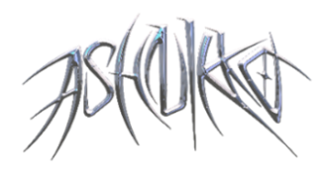

**ASHNIKKO & PRINCESS NOKIA GET STEAMY IN VICTORIAN-STYLE VIDEO**

**FOR VIRAL SMASH “SLUMBER PARTY”**

[**WATCH HERE**](https://ashnikko.lnk.to/vSlumberParty)

***DEMIDEVIL* FALL 2021 WORLD TOUR NEARLY SOLD-OUT**

**PERFORMED “SLUMBER PARTY” LIVE WITH PRINCESS NOKIA**

**ON *LATE NIGHT WITH SETH MEYERS* –** [**WATCH HERE**](https://nam04.safelinks.protection.outlook.com/?url=https%3A%2F%2Fyoutu.be%2FnuiZi3MOV9I&data=04%7C01%7CPatrice.Compere%40warnerrecords.com%7Cf52de62167624aca858408d90c0c090c%7C8367939002ec4ba1ad3d69da3fdd637e%7C0%7C0%7C637554068098993985%7CUnknown%7CTWFpbGZsb3d8eyJWIjoiMC4wLjAwMDAiLCJQIjoiV2luMzIiLCJBTiI6Ik1haWwiLCJXVCI6Mn0%3D%7C1000&sdata=4UslzPYiRnS1Dinf6BS3eijojnT5XQqtG3UyY%2B6rdOk%3D&reserved=0)

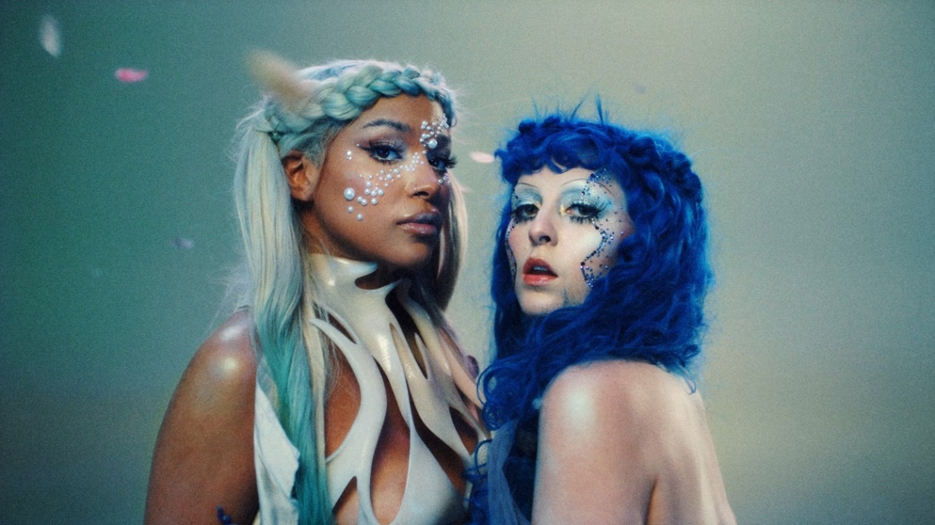

*“‘Demidevil’: lewd antics, bravado, misandry and zippy one-liners engineered for social media” –* ***The New York Times***

*“… ridiculously catchy, debut mixtape Demidevil is as menacing as it is comically absurd.”* ***– NPR***

*“‘Demidevil’ shows that Ashnikko’s far more than a two-trend wonder”* ***– NME***

*“Ashnikko commands fantasy and chaos with ease… a showcase for her newly refined confidence, a step towards the pop powerhouse she’s capable of becoming.”* ***– Pitchfork***

**May 13, 2021 (Los Angeles, CA)** – Today, blue-haired alt-pop superstar Ashnikko links up with Princess Nokia for the official video for their viral hit [“Slumber Party,”](https://ashnikko.lnk.to/vSlumberParty) which continues to scale the Top 100 Spotify Global Chart, generating more than 100 million streams and counting. The risqué Victorian-era style video – directed by longtime creative collaborator Charlotte Rutherford – comes of the heels of the pair’s performance of the rising track on *Late Night With Seth Meyers* – [watch it here](https://nam04.safelinks.protection.outlook.com/?url=https%3A%2F%2Fyoutu.be%2FnuiZi3MOV9I&data=04%7C01%7CPatrice.Compere%40warnerrecords.com%7Cf52de62167624aca858408d90c0c090c%7C8367939002ec4ba1ad3d69da3fdd637e%7C0%7C0%7C637554068098993985%7CUnknown%7CTWFpbGZsb3d8eyJWIjoiMC4wLjAwMDAiLCJQIjoiV2luMzIiLCJBTiI6Ik1haWwiLCJXVCI6Mn0%3D%7C1000&sdata=4UslzPYiRnS1Dinf6BS3eijojnT5XQqtG3UyY%2B6rdOk%3D&reserved=0).

At the conclusion her hotly anticipated livestream concert “*DEMIDEVIL* – The Livestream,” Ashnikko announced dates for her first-ever North American headline tour, finally bringing her wild, weird, and wonderful world to life in cities across the U.S. this fall. Kicking off on October 26th, the upcoming run will make stops in major markets across the country, including already sold-out shows in New York, Los Angeles, Boston, and Chicago, followed by another nearly sold-out run in UK and Ireland. Check out the full itinerary below. Tickets are now available [here](https://www.ashnikko.com/live/).

**About Ashnikko:**

With widespread critical acclaim from the likes of *NPR*, *The New York Times*, *NME*, *Pitchfork*, *The FADER*, *PAPER*, V Magazine, *New York Magazine*, *The Telegraph,* and many more,Ashnikko has solidified her status as a 2021 artist to watch. On [*DEMIDEVIL*](https://nam04.safelinks.protection.outlook.com/?url=https%3A%2F%2Fashnikko.lnk.to%2FDEMIDEVIL&data=04%7C01%7CPatrice.Compere%40warnerrecords.com%7Cf52de62167624aca858408d90c0c090c%7C8367939002ec4ba1ad3d69da3fdd637e%7C0%7C0%7C637554068099003980%7CUnknown%7CTWFpbGZsb3d8eyJWIjoiMC4wLjAwMDAiLCJQIjoiV2luMzIiLCJBTiI6Ik1haWwiLCJXVCI6Mn0%3D%7C1000&sdata=LjybC51F0ATor6e%2BvGxWP5gEUEjasiHmXMj65R%2FMBKA%3D&reserved=0), her furious feminist energy is palpable, flaunting her multi-hyphenate genre-spanning style as she ricochets between themes of empowerment, vengeance to full-blown side-splitting humor. Thus far, she has gathered north of 1.5 billion total career streams to date, thanks in part to gold-certified smash singles “Daisy” and “Stupid” [feat. Yung Baby Tate].

**About Princess Nokia:**

In March, Princess Nokia made her major label debut with new single ["It’s Not My Fault"](https://nam04.safelinks.protection.outlook.com/?url=https%3A%2F%2Fwww.youtube.com%2Fwatch%3Fv%3Die3IAoFM37Q%26feature%3Dyoutu.be&data=04%7C01%7CPatrice.Compere%40warnerrecords.com%7Cddb192c3f4b14953e6b008d915a6300f%7C8367939002ec4ba1ad3d69da3fdd637e%7C0%7C0%7C637564626876127744%7CUnknown%7CTWFpbGZsb3d8eyJWIjoiMC4wLjAwMDAiLCJQIjoiV2luMzIiLCJBTiI6Ik1haWwiLCJXVCI6Mn0%3D%7C1000&sdata=XV5BgOjYSYzr4GLfmr6oiNU4JMZxa3eNtPI0qhVjDsg%3D&reserved=0) via Arista Records. The song is directly influenced by the content subscription site OnlyFans where Princess Nokia is one of the top celebrities on the platform. Princess Nokia’s 2020 global smash hit ["I Like Him,”](https://nam04.safelinks.protection.outlook.com/?url=https%3A%2F%2Fyoutu.be%2Fj_rXSJm-7zg&data=04%7C01%7CPatrice.Compere%40warnerrecords.com%7Cddb192c3f4b14953e6b008d915a6300f%7C8367939002ec4ba1ad3d69da3fdd637e%7C0%7C0%7C637564626876127744%7CUnknown%7CTWFpbGZsb3d8eyJWIjoiMC4wLjAwMDAiLCJQIjoiV2luMzIiLCJBTiI6Ik1haWwiLCJXVCI6Mn0%3D%7C1000&sdata=buCJAZoObdYmx5Fkr7bmGdsi4cD%2BD6RabNo6gIID%2BoY%3D&reserved=0) which garnered over 2.1 BILLION views across 2.9 MILLION videos for the track on TikTok - including one by Congresswoman Alexandria Ocasio-Cortez - and it earned more than 150 MILLION streams across DSPs.

**2021 NORTH AMERICAN TOUR DATES**

Oct. 26 Silver Spring, MD The Fillmore

Oct. 27 Philadelphia, PA The Fillmore

Oct. 31 New York, NY Terminal 5 ***(SOLD OUT!)***

Nov. 1 Boston, MA Paradise Rock Club

Nov. 2 Boston, MA Paradise Rock Club ***(SOLD OUT!)***

Nov. 4 Toronto, ON Venue TBA

Nov. 5 Chicago, IL Concord Music Hall ***(SOLD OUT!)***

Nov. 6 Chicago, IL Concord Music Hall

Nov. 9 San Francisco, CA The Warfield

Nov. 10 Los Angeles, CA The Novo ***(SOLD OUT!)***

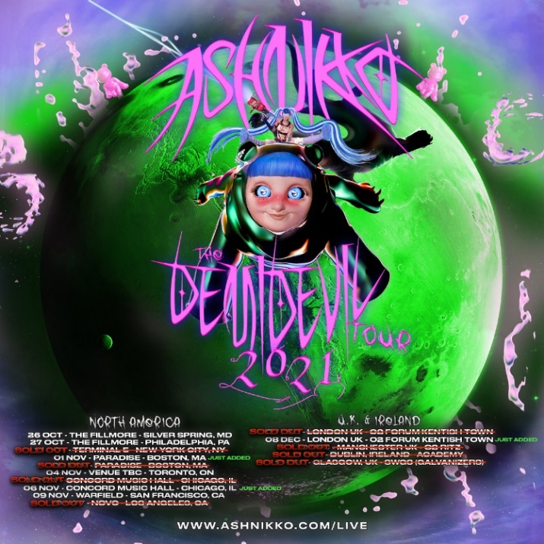

# # #

**For further information contact Warner Records Publicity:**

National: [Darren.Baber@warnerrecords.com](mailto:Darren.Baber@warnerrecords.com) + [Ceri.Roberts@warnerrecords.com](mailto:Ceri.Roberts@warnerrecords.com)

Tour Press: [Patrice.Compere@warnerrecords.com](mailto:Patrice.Compere@warnerrecords.com)

**Follow Ashnikko:**

[**Spotify**](https://nam04.safelinks.protection.outlook.com/?url=https%3A%2F%2Fopen.spotify.com%2Fartist%2F3PyJHH2wyfQK3WZrk9rpmP&data=04%7C01%7CPatrice.Compere%40warnerrecords.com%7C6ac80cca8ecf474281c908d8ed9680d6%7C8367939002ec4ba1ad3d69da3fdd637e%7C0%7C0%7C637520577965528245%7CUnknown%7CTWFpbGZsb3d8eyJWIjoiMC4wLjAwMDAiLCJQIjoiV2luMzIiLCJBTiI6Ik1haWwiLCJXVCI6Mn0%3D%7C1000&sdata=OWsOygIeMgKzfbjZmfBRV1Qw94WzCRNDEAPwjSSxN1k%3D&reserved=0) **|** [**Instagram**](https://nam04.safelinks.protection.outlook.com/?url=https%3A%2F%2Fwww.instagram.com%2Fashnikko%2F&data=04%7C01%7CPatrice.Compere%40warnerrecords.com%7C6ac80cca8ecf474281c908d8ed9680d6%7C8367939002ec4ba1ad3d69da3fdd637e%7C0%7C0%7C637520577965538236%7CUnknown%7CTWFpbGZsb3d8eyJWIjoiMC4wLjAwMDAiLCJQIjoiV2luMzIiLCJBTiI6Ik1haWwiLCJXVCI6Mn0%3D%7C1000&sdata=LmC%2F3GJOKFS3URd8oFaXpnqWIRSeJT9JJuPT27k5q8Y%3D&reserved=0) **|** [**Twitter**](https://nam04.safelinks.protection.outlook.com/?url=https%3A%2F%2Ftwitter.com%2Fashnikko&data=04%7C01%7CPatrice.Compere%40warnerrecords.com%7C6ac80cca8ecf474281c908d8ed9680d6%7C8367939002ec4ba1ad3d69da3fdd637e%7C0%7C0%7C637520577965538236%7CUnknown%7CTWFpbGZsb3d8eyJWIjoiMC4wLjAwMDAiLCJQIjoiV2luMzIiLCJBTiI6Ik1haWwiLCJXVCI6Mn0%3D%7C1000&sdata=URMF%2BgT75GUTJu2BMxIMX2Qt5oqVkhOx7u8eJOcdzZ8%3D&reserved=0) **|** [**Facebook**](https://nam04.safelinks.protection.outlook.com/?url=https%3A%2F%2Fwww.facebook.com%2Fashnikkomusic%2F&data=04%7C01%7CPatrice.Compere%40warnerrecords.com%7C6ac80cca8ecf474281c908d8ed9680d6%7C8367939002ec4ba1ad3d69da3fdd637e%7C0%7C0%7C637520577965548230%7CUnknown%7CTWFpbGZsb3d8eyJWIjoiMC4wLjAwMDAiLCJQIjoiV2luMzIiLCJBTiI6Ik1haWwiLCJXVCI6Mn0%3D%7C1000&sdata=l5QMa0SIOuUm1zLAE%2BYcofazLyG4MT2MxBzF%2F6wji6o%3D&reserved=0)

