**cid:image001.png@01D5204D.CFB194F0**

**ASHNIKKO UNLEASHES NEW VIDEO FOR “WORKING BITCH”**

**WATCH HERE**

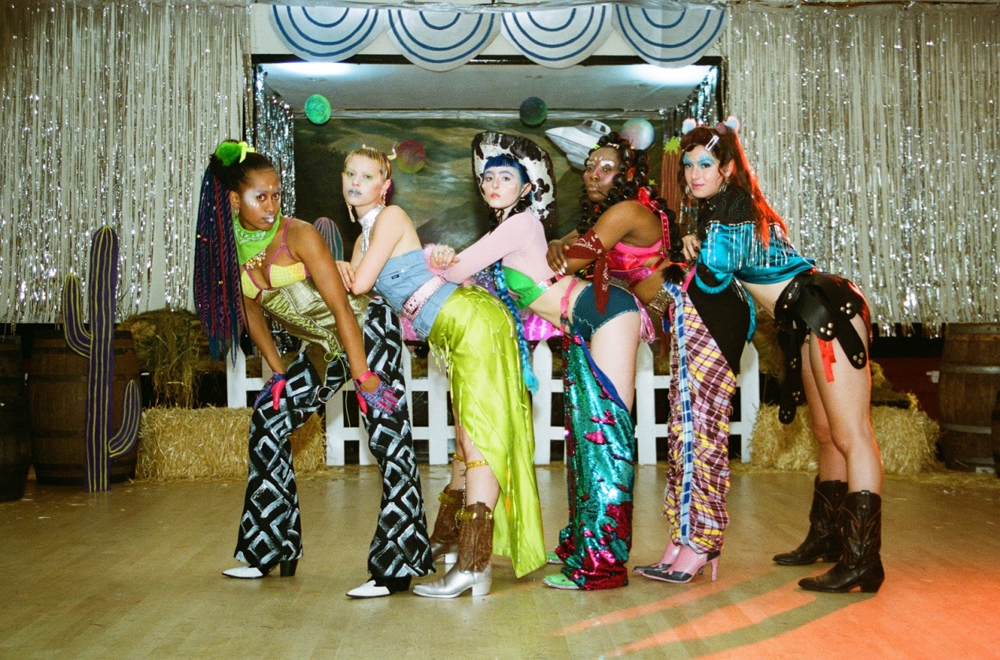

*“Ashnikko takes charge with a burst of playful energy.”* – **Complex**

*“A hot stack of sass pancakes drizzled in dark and playful wordplay.”* – **i-D**

*“The unapologetic rapper-singer makes angsty tracks for her teenage self.*” – **Wonderland**

*“Pinching from the latest Stateside rap and hyper-real pop.*” – **Clash**

“*Ashnikko is the artist providing an antidote to the glossy, hyper-sexualised imagery of*

*mainstream pop*.” – **Dummy**

**December 3, 2019 (Los Angeles, CA)** – London-based rapper Ashnikko unveils the new video for “Working Bitch” today, her latest since the metaphoric rise of her viral hit “Stupid” (feat. Yung Baby Tate). The quirky new video winds punk and hip hop with flashes of unabashed lyrics boasting sex positivity, complete with an accompanying alien-cowgirl themed hoedown.

Ashnikko says*, “I felt like an alien cowgirl writing this song so you bet your ass I’m gonna be an alien cowgirl in the music video! I grew up in the south so this video is a very strange ode to my childhood. Might incorporate more assless chaps into my wardrobe!”*

“Working Bitch” is taken from her *Hi, It’s Me. EP,* packed with ‘fuck you’ alternative pop: each track designed to embolden autonomous women. The EP also spawned “Stupid,” which has now reached more than 50 million streams worldwide, thanks to its explosive popularity on TikTok, including a recent entry from Miley Cyrus and Cody Simpson. Watch Ashnikko’s new *Genius* “Open Mic” for “Stupid” with Yung Baby Tate [here](https://www.youtube.com/watch?v=tyI4W7yoasM).

Ashnikko also just announced a special pop-up show in a secret Los Angeles location on December 6. Free tickets are available to win [here](https://dice.fm/partner/secret-location-la/event/n3g5l--ashnikko-presents-a-stupid-pop-up-show-6th-dec-secret-location-la-los-angeles-tickets?_branch_match_id=629713126354970277)**.**

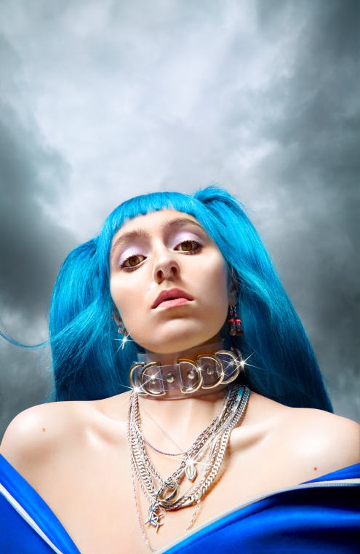

**About Ashnikko:**

Art, music and sexual liberation are the three most potent ingredients in Ashnikko’s rebellion. Born and raised in suburban Greensboro, North Carolina, her parents raised her on a musical diet comprised exclusively of country music and Slipknot. But just as she was settling into life as an American teenager, they carted her off to Estonia, then Latvia, where she was the only American student in the public-school system, taking courses entirely in Latvian. Isolated, it catalyzed an identity crisis she’s still reckoning with to this day. She buried herself in music, listening exclusively to female artists until she was 17 – specifically proudly feminist and sex positive female artists – all of whom shaped her early sound. She used to receive death threats as a woman trying to make music in the “very patriarchal” Baltics. As soon as she turned 18, she moved to London and spent her nights wandering nightclubs and open mics, eventually establishing a home for herself within the OddChild community.

# # #

**For further information contact Warner Records Publicity:**

National: [Jaime.Rosenberg@warnerrecords.com](mailto:Jaime.Rosenberg@warnerrecords.com)

Regional: [Patrice.Compere@warnerrecords.com](mailto:Patrice.Compere@warnerrecords.com)

**Follow Ashnikko:**

[Spotify](https://open.spotify.com/artist/3PyJHH2wyfQK3WZrk9rpmP)

[Instagram](https://www.instagram.com/ashnikko/)

[Twitter](https://twitter.com/ashnikko)

[Facebook](https://www.facebook.com/ashnikkomusic/)