

**SCOTTISH ALT-ROCK GIANTS BIFFY CLYRO ANNOUNCE NEW ALBUM**

***A CELEBRATION OF ENDINGS* – OUT MAY 15**

**FEATURES SINGLE “INSTANT HISTORY” + BRAND NEW TRACK “END OF”**

**“End Of” Premiered Today with Zane Lowe on Beats 1**



**March 5, 2020 (Los Angeles, CA) –** The U.K.’s alt-rock giants **Biffy Clyro** have announced their new album ***A Celebration of Endings*** for release **May 15** on Warner Records. The album is available now for pre-order and features the explosive new single “[**Instant History**](https://biffyclyro.co/instanthistory)” – impacting at Alternative and Rock radio in the U.S. next week – as well as brand new track “**End Of**,” which premiered today as a World Exclusive with **Zane Lowe** on **Apple Music Beats 1**. The aggression of the track is old-school Biffy, but the out-of-nowhere piano break and a final rally of rampaging riffs matches their current unpredictable flair. Listen to “**End Of**” [here](https://biffyclyro.co/endof).

**Pre-Order/Pre-Save *A Celebration of Endings* [HERE](biffyclyro.co/acelebrationofendings) – Listen to “Instant History”** [**HERE**](https://biffyclyro.co/instanthistory)

***A Celebration of Endings*** finds **Biffy Clyro** pushing everything they do to the next level, with the help of **GRAMMY**-winning producer **Rich Costey** (**Foo Fighters, Muse, The Killers**). Frontman **Simon Neil** explains, *“This is a very forward-looking album from a personal perspective and a societal perspective. The title is about seeing the joy in things changing, rather than the sadness. Change means progression and evolution. You can retain everything you loved before, but let’s lose the bad shit. It’s about trying to take back control.”*

Biffy Clyro have also announced their first full-scale UK tour since 2016, headlining arena shows this fall, with U.S. tour dates to be announced very soon!

**Biffy Clyro** have emerged from their independent beginnings to become **Britain’s** premier rock band. Their two most recent albums ***Ellipsis*** (2016) and ***Opposites*** (2013) both shot straight to **#1** in the U.K. charts with **2 million+** copies sold, and the band boasts more than **750 million streams** worldwide to date. The success of their huge-selling, critically-acclaimed albums is matched by the scale of their live show. In the U.S. they’ve toured arenas with the likes of **Foo Fighters** and **Muse**, in addition to sold-out headline runs, while overseas they’ve headlined leading festivals including **Reading and Leeds, Download** and **TRNSMT**, and this year will play **Radio 1’s Big Weekend** in **Dundee** in **May.** They’re part of an all-star bill that currently also features **Calvin** **Harris**, **Camilla** **Cabello**, **Dua** **Lipa** and **Harry** **Styles**. Continually supported by the press, Biffy Clyro have also won a wide range of major awards. These include four **NME Awards** (2 x **Best** **British** **Band**, **Best** **Live** **Band** and **Best** **Music** **Video**); four **Kerrang! Awards** (**Best British Band**, **Classic** **Songwriter**, **Best** **Album** and **Best** **Music** **Video**); and three **Q Awards** (**Best Live Band**, **Best** **Album** and the **Fender** **Play** **Award**). They’ve also been nominated for two **BRIT** **Awards** (both for **Best** **British** **Group**) and a **Mercury** **Prize**.

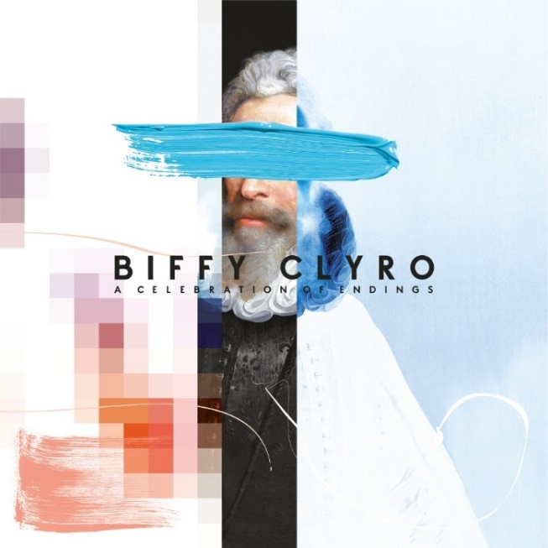

***A Celebration of Endings*** **tracklist:**

1. North Of No South
2. The Champ
3. Weird Leisure
4. Tiny Indoor Fireworks
5. Worst Type Of Best Possible
6. Space
7. End Of
8. Instant History
9. The Pink Limit
10. Opaque
11. Cop Syrup

***A Celebration of Endings*** will be released on vinyl, colored vinyl (exclusive to select indie stores), CD, and digital formats, with additional packages available at [**https://store.biffyclyro.com/**](https://nam04.safelinks.protection.outlook.com/?url=https%3A%2F%2Fstore.biffyclyro.com%2F&data=02%7C01%7CCeri.Roberts%40warnerrecords.com%7Cfbb185055e4241a51f5508d7c08697a9%7C8367939002ec4ba1ad3d69da3fdd637e%7C0%7C0%7C637189556604439559&sdata=1SP8CjSNH2sY81dw2%2BqRJcvigfmDbbLpN30fuFtODYQ%3D&reserved=0). Both **“End Of”** and **“Instant History”** will be provided as instant downloads for fans who pre-order the album.

###

**For further information please contact Warner Records Publicity:**

Ceri Roberts | (212) 707-2259

[Ceri.Roberts@warnerrecords.com](mailto:Ceri.Roberts@warnerrecords.com)

**Follow Biffy Clyro:**

[**Official website**](http://www.biffyclyro.com/)**|** [**Facebook**](https://www.facebook.com/biffyclyro) **|** [**Twitter**](https://twitter.com/biffyclyro) **|** [**Instagram**](https://www.instagram.com/biffy_clyro/) **|** [**YouTube**](https://www.youtube.com/user/biffyclyro)

**cid:image004.jpg@01D5E66A.9F2C7370**