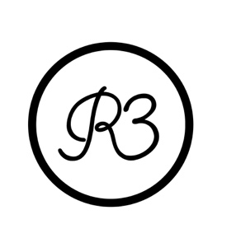
BIG HOMIE TY.NI has a sly warning for newcomers to her raw, risqué rhymes: “You shouldn’t listen to me around your kids.” The brow-raising bars on the 25-year-old rapper’s debut single, “Jelly,” drive home her assessment. (One memorable line: “P***y look like pie to ’em”). Her frankness is charming on its own but TY.NI complements it with sexy swagger and bold attitude, all of which have positioned her to become next up in Atlanta. She’s developed a large social presence over the last few years thanks to her wild (occasionally NSFW) posts, parlaying fame into modeling gigs and music video roles. Now, the self-described “gangster but nasty” artist creates lustful, hard-hitting anthems for folks in the club—or those at home wishing they were.

TY.NI and her music are Atlanta to the core. She had to grow up fast, raised in rough neighborhoods where illicit hustles were commonplace. After learning how to survive in the areas that birthed trap music, TY.NI lost her mother at 15. She decided to start dancing while attending school. By 17, she was dancing and performing acrobatics at strip clubs. “I went from being a basketball player to being a dancer,” TY.NI explains. “Coming to the strip club was easy once I got comfortable, but it was a transition.”

Throughout her journey, TY.NI listened to generations of Atlanta rappers, from OutKast to 21 Savage. Still, she found her greatest inspiration in trailblazing, unapologetically raw MCs like Lil Kim, Trina, and Cardi B—women whose lyrics and lifestyle spoke to her directly. Turning up to and studying her influences, TY.NI soon turned her local popularity into online fame, racking up hundreds of thousands of followers on Instagram. Eventually, she transitioned from stripping to modeling and began flexing her dancing abilities in videos like City Girls’ 2019 smash “Twerk.”

Encouraged by Grand Hustle producer Stroud, TY.NI stepped into the booth and began teaching herself to rap. It wasn’t her initial career plan, but she took to it fast. “Honestly, I didn’t want to be a rapper,” she says. “But I do know how to put on a show.” In 2020, not long after she picked up her first mic, she was discovered by Ray Daniels at Warner Records and Theron Thomas of R. City/3400. They knew that her charisma, voice, and point of view would make her a standout.

“A lot of these bitches be playing gangsta, but if they were put in the field, they wouldn't know what to do,” TY.NI says. “They talk and rap about it, but they not really ’bout it. I'm ’bout it.”

“Jelly,” an irresistible ode to her own body, realizes the potential TY.NI’s supporters saw. With one track, she affirmed her ability to captivate audiences all over again, but on record. TY.NI’s now locked in the studio fine-tuning her erotic and savage bangers. Like “Jelly,” they’ll surely resonate with those who can take some time to grind while they hustle to improve their lives.

