BRANDY CLARK’S “LIKE MINE” PRODUCED BY BRANDI CARLILE DEBUTS TODAY
ACCLAIMED NEW ALBUM YOUR LIFE IS A RECORD OUT NOW
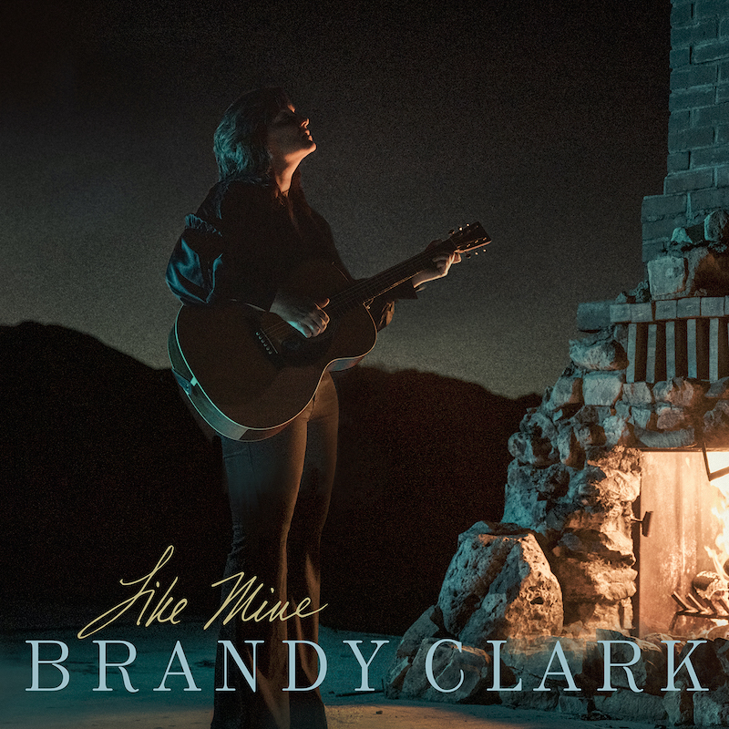
October 2, 2020 (Los Angeles, CA) — Grammy-nominated and CMA Award-winning singer, songwriter and musician Brandy Clark’s new song, “Like Mine,” produced by Brandi Carlile, is debuting today. Listen/share HERE.
Reflecting on the song, Clark shares, “‘Like Mine’ has multilayered meanings for me. It emanated from a conversation with my godson, that rolled into a conversation with co-writers about humanity and the world, that took shape as this song.”
Written by Clark, Luke Dick, Jessie Jo Dillon and Laura Veltz, “Like Mine” is the second song Clark and Carlile created amid the COVID-19 pandemic while working from their respective quarantines. Their first collaboration, “Same Devil,” performed by Clark and both featuring and produced by Carlile, premiered last week to critical acclaim—Entertainment Weekly declares, “this haunting, acoustic ballad that conjures both dark alleys and spectral hollers as it addresses the sins and salvations that unite us, more than honors the promise of the great Brandi/y summit of 2020,” while Variety praises, “a harmonic convergence of names and voices that features the billing we might have thought possible only in fiction.”
The two new songs follow Clark’s critically acclaimed new album, Your Life is a Record, which is out now on Warner Records (stream/purchase here). Produced by Jay Joyce, the album consists of eleven new songs including “Bigger Boat” featuring Randy Newman, of which Music Row declares, “It’s wry, jaunty and sideways philosophical. Newman’s drawl is as personality-packed as usual, and Clark’s laid-back, winking delivery is a sheer delight. It fills my heart with joy that this woman makes music. She’s a genius. That’s all.” Watch/share the official music video here.
Recent critical acclaim for Your Life is a Record…
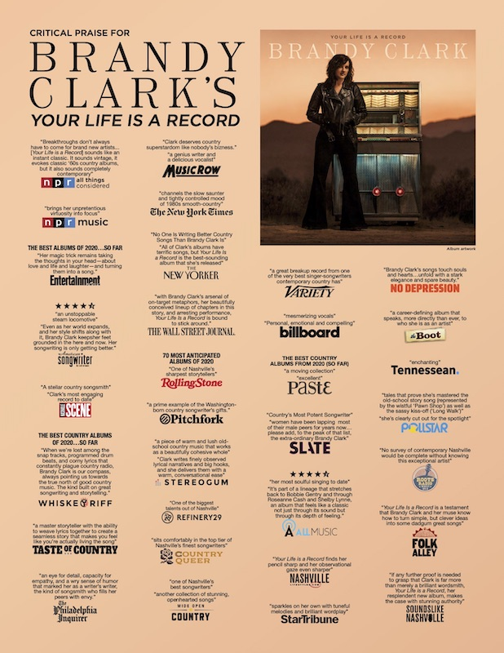
Created after the dissolution of a long-term relationship, the album features Clark’s most personal songwriting to date and was recorded largely as an intimate acoustic four-piece—featuring Clark, Joyce, Giles Reaves and Jedd Hughes—with subsequent Memphis strings and horns layered in with arrangements by Lester Snell.
In celebration of the release, Clark will embark on her extensive “Who You Thought I Was Tour” next year including stops at Nashville’s 3rd & Lindsley, Atlanta’s Smith’s Olde Bar, New York’s Bowery Ballroom, Boston’s Brighton Music Hall, Philadelphia’s Boot & Saddle, Denver’s Globe Hall, Seattle’s Neumos, Los Angeles’ Lodge Room and Austin’s The Parish among many others. See below for complete itinerary. Tickets for the tour can be purchased at www.brandyclarkmusic.com/tour.
Clark also recently launched a new online series, “You Can’t Come Over (But You Can Come In), as a way to stay connected throughout the COVID-19 pandemic. Premiering Wednesdays at 7:00pm ET/4:00pm PT on Clark’s YouTube page, the series has featured several special guests so far including Reba McEntire, Martina McBride, Ashley McBryde, Cam, Shane McAnally, Mary Chapin Carpenter, Tenille Townes, Lori McKenna, Maddie & Tae, Leslie Fram and more.
A six-time Grammy nominee and CMA Awards “Song of the Year” recipient, Clark is one of her generation’s most respected and celebrated songwriters and musicians. Her songs include Kacey Musgraves’ “Follow Your Arrow,” Miranda Lambert’s “Mama’s Broken Heart,” The Band Perry’s “Better Dig Two” and Hailey Whitter’s “Ten Year Town,” which was just named #2 on Rolling Stone’s “25 Best Country and Americana Songs of 2019” round up. Her two solo albums—2013’s 12 Stories and 2016’s Big Day in a Small Town—each garnered immense critical acclaim landing on “Best of the Year” lists at New York Magazine, Billboard, NPR Music Entertainment Weekly, Rolling Stone, Stereogum, etc. NPR Music’s Ann Powers calls her, “a storyteller of the highest caliber,” while Rolling Stone’s Will Hermes declares, “a country visionary…the consolation of a beautiful voice delivering a well-built song, cold truth rising from it like fog off dry ice.”

YOUR LIFE IS A RECORD TRACK LIST
1. I’ll Be the Sad Song
2. Long Walk
3. Love is a Fire
4. Pawn Shop
5. Who You Thought I Was
6. Apologies
7. Bigger Boat (feat. Randy Newman)
8. Bad Car
9. Who Broke Whose Heart
10. Can We Be Strangers
11. The Past is the Past
BRANDY CLARK CONFIRMED TOUR DATES
March 21, 2021—Nashville, TN—3rd & Lindsley
March 25, 2021—Birmingham, AL—Saturn
March 26, 2021—Atlanta, GA—Smith’s Olde Bar
March 27, 2021—Charlotte, NC—McGlohon
March 30, 2021—New York, NY—Bowery Ballroom
March 31, 2021—Boston, MA—Brighton Music Hall
April 2, 2021—Philadelphia, PA—Boot & Saddle
April 3, 2021—Alexandria, VA—Birchmere
April 5, 2021—Pittsburgh, PA—The Rex
April 6, 2021—Cleveland, OH—Beachland Ballroom
April 7, 2021—Ann Arbor, MI—The Ark
April 9, 2021—Louisville, KY—Headliners
April 10, 2021—Chicago, IL—The Space
April 12, 2021—Madison, WI—Majestic Theatre
April 13, 2021—Minneapolis, MN—Fine Line
April 15, 2021—Des Moines, IA—Wooly’s
April 16, 2021—Omaha, NE—The Waiting Room
April 17, 2021—Kansas City, MO—Saloon @ Knuckleheads
April 19, 2021—Denver, CO—Globe Hall
April 21, 2021—Salt Lake City, UT—The State Room
April 23, 2021—Seattle, WA—Neumos
April 24, 2021—Portland, OR—Alberta Rose Theatre
April 26, 2021—San Francisco, CA—Great American Music Hall
April 28, 2021—Los Angeles, CA—Lodge Room
April 29, 2021—Phoenix, AZ—Musical Instrument Museum
May 3, 2021—Houston, TX—White Oak Muisc Hall
May 4, 2021—Austin, TX—The Parish
May 6, 2021—Oklahoma City, OK—Tower Theatre
May 7, 2021—St. Louis, MO—Off Broadway

www.brandyclarkmusic.com
For more information, please contact Warner Records Publicity:
Rick Gershon | Rick.Gershon@warnerrecords.com

