BRANDY CLARK’S YOUR LIFE IS A RECORD OUT NOW
LISTEN HERE

PERFORMANCES CONFIRMED ON NBC’S TODAY AND CBS THIS MORNING
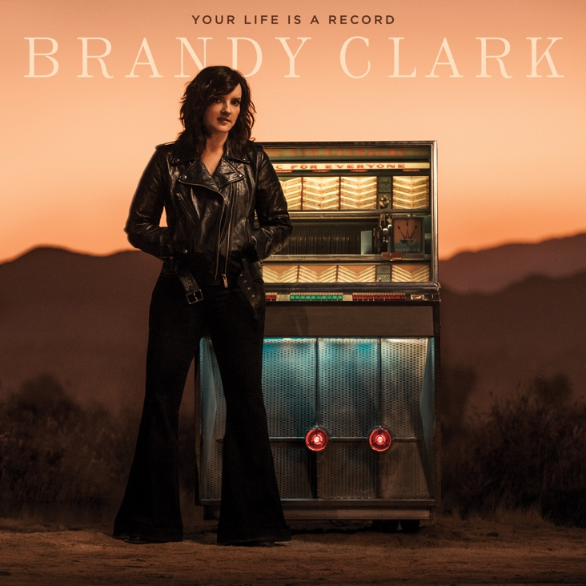
March 6, 2020 (Los Angeles, CA) - Grammy-nominated and CMA Award-winning singer, songwriter and musician Brandy Clark’s highly anticipated new album, Your Life is a Record, out now on Warner Records. Listen HERE. In celebration of the release, Clark will perform on NBC’s TODAY next Thursday, March 12th and on CBS This Morning as part of their “Saturday Sessions” series next Saturday, March 14th.
Produced by award winning producer Jay Joyce, the album features Clark’s most personal songwriting to date. Created after the dissolution of a long-term relationship, the 11-track album was recorded largely as an intimate acoustic four-piece—featuring Clark, Joyce, Giles Reaves and Jedd Hughes—with subsequent Memphis strings and horns layered in with arrangements by Lester Snell. It also features special guest appearances from Randy Newman (“Bigger Boat”) and guitarist John Osborne (“Bad Car”).
In support of the album, Clark will kick off her headlining Who You Thought I Was Tour later this month including special album release shows at Nashville’s 3rd & Lindsley on March 29th, Los Angeles’ Lodge Room on April 7th, New York’s Bowery Ballroom on April 28th and Chicago’s The Space on May 8th. See below for complete tour itinerary. Every ticket purchased for the headline tour includes a choice of a CD or digital download copy of Your Life is a Record. Available in most markets, check ticket details for confirmation.

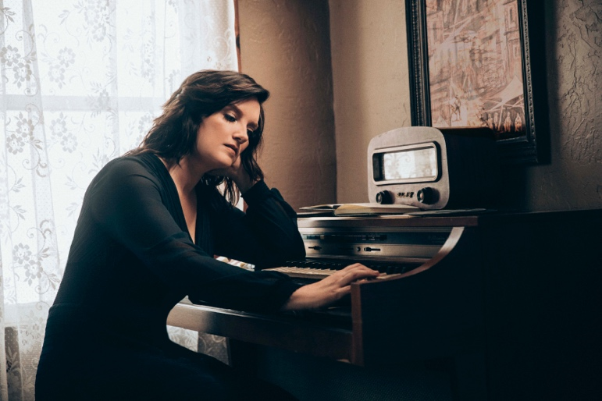
photo credit: Chris Phelps

A six-time Grammy nominee and CMA Awards “Song of the Year” recipient, Clark is one of her generation’s most respected and celebrated songwriters and musicians. Her songs include Kacey Musgraves’ “Follow Your Arrow,” Miranda Lambert’s “Mama’s Broken Heart,” The Band Perry’s “Better Dig Two” and Hailey Whitter’s “Ten Year Town,” which was just named #2 on Rolling Stone’s “25 Best Country and Americana Songs of 2019” round up. Her two solo albums—2013’s 12 Stories and 2016’s Big Day in a Small Town—each garnered immense critical acclaim landing on “Best of the Year” lists at New York Magazine, Billboard, NPR Music, Entertainment Weekly, Rolling Stone, Stereogum, etc. NPR Music’s Ann Powers calls her, “a storyteller of the highest caliber,” while Rolling Stone’s Will Hermes declares, “a country visionary…the consolation of a beautiful voice delivering a well-built song, cold truth rising from it like fog off dry ice.”

YOUR LIFE IS A RECORD TRACK LIST
1. I’ll Be the Sad Song
2. Long Walk
3. Love is a Fire
4. Pawn Shop
5. Who You Thought I Was
6. Apologies
7. Bigger Boat (feat. Randy Newman)
8. Bad Car
9. Who Broke Whose Heart
10. Can We Be Strangers
11. The Past is the Past

BRANDY CLARK CONFIRMED TOUR DATES
March 6—Nashville, TN—Grand Ole Opry
March 9—Nashville, TN—Grimey’s (in-store performance)
March 28—St. Louis, MO—Off Broadway*
March 29—Nashville, TN—3rd and Lindsley*
March 31—Houston, TX—White Oak†
April 1—Austin, TX—The Parish†
April 3—Phoenix, AZ—Musical Instrument Museum†
April 7—Los Angeles, CA—Lodge Room†
April 8—San Francisco, CA—Great American Music Hall†
April 10—Portland, OR—Alberta Rose Theatre‡
April 11—Seattle, WA—Showbox Theatre‡
April 13—Salt Lake City, UT—The State Room‡
April 14—Denver, CO—Globe Hall‡
April 16—Omaha, NE—The Waiting Room‡
April 17—Minneapolis, MN—Fineline‡
April 18—Des Moines, IA—Woolys‡
April 20—Ann Arbor, MI—The Ark#
April 21—Cleveland, OH—Beachland#
April 22—Pittsburgh, PA—The Rex#
April 24—Uncasville, CT—Wolf Den#
April 25—Philadelphia, PA—Boot & Saddle#
April 27—Boston, MA—Brighton Music Hall#
April 28—New York, NY—Bowery Ballroom#
May 1—Alexandria, VA—Birchmere#
May 2—Charlotte, NC—McGlohon#
May 4—Atlanta, GA—Terminal West#
May 5—Birmingham, AL—Saturn#
May 7—Louisville, KY—Headliners#
May 8—Chicago, IL—The Space#
May 9—Indianapolis, IN—Vogue#
May 11—Madison, WI—Majestic Theatre^
May 13—Kansas City, MO—Saloon @ Knuckleheads^
May 14—Oklahoma City, OK—Tower Theatre^
*with Cheley Tackett
†with Donovan Woods
‡with Alex Hall
#with Kelsey Waldon
^with Aubrie Sellers

Follow Brandy Clark
Official | Instagram | Twitter | Facebook | Press Materials

