

**INTRODUCING BUDJERAH  
 NEW SINGLE + VIDEO “TALK” FEAT. MAY-A OUT NOW**[**LISTEN HERE**](https://budjerah.lnk.to/Talk) **–** [**WATCH HERE**](https://budjerah.lnk.to/Talk-Video)

**AUSTRALIAN R&B ARTIST PARTNERS WITH WARNER RECORDS FOR U.S. DEBUT**



|  |  |
| --- | --- |
| |  | | --- | | *“Budjerah pieces together elements of traditional R&B, pop and gospel, all underpinned by a dreamy, soul-infused chord progression."* ***- NME****“...there was a powerful bond in the knowledge that an iconic musician was unfolding before our very eyes."* ***- BEST BEFORE*** *"...Budjerah’s ear for melody is so accomplished that you’ll be left awed and helplessly humbled.”* ***- HAPPY*** *"Shining voice of a star in waiting."* ***- SYDNEY MORNING HERALD*** | |

|  |  |
| --- | --- |
| |  | | --- | | **September 23, 2021 (Los Angeles, CA)** – Following a landmark 12 months in his native Australia, 19-year-old singer-songwriter **[Budjerah](https://www.instagram.com/budjerah/" \t "_blank)** unveils his gleaming, soulful new single[**“Talk” feat. MAY-A**](https://budjerah.lnk.to/Talk), alongside the track’s [**official video**](https://budjerah.lnk.to/Talk-Video)directed by [**Courtney Brookes**](https://www.instagram.com/bourtneycrookes/)*. “*Talk” marks his first official release in the U.S.   Taking a clear cue from his idols and antecedents Sam Cooke and The Clark Sisters — patron saints of clarity and honesty – “Talk” is an appeal to look up, take a beat, take a breath, and reconnect with your loved ones. A joyful, much-needed tonic for a world riddled with misunderstanding and miscommunication, it’s Budjerah’s brightest cut yet, a piece of modern R&B with all the warmth and wit of a classic.   “Talk” is a song that speaks to the woes of Gen Z while using a lingua franca that can be understood by all. “Talk” came about from a conversation with MAY-A “[where] we were just talking about how a lot of people would rather text than call,” Budjerah says of his inspiration behind the track. “It’s inspired by the fact that a lot of problems in our lives could be solved by talking openly and honestly, face-to-face, instead of hiding behind screens or lying.”  MAY-A adds, “In order for a relationship to thrive you need to be actively listening to each other and explaining how you feel, it doesn’t work if both people aren’t putting the effort in to both talk and listen. ‘You’re always speaking, but I never hear what you’re saying, can you replay it?’ - is when someone is avoiding the point and everyone is misunderstood. This song is about that moment where you cut all the bullshit and sit someone down, stare them in the face and say ‘let’s talk about this.’ It doesn’t always have to be a negative thing though. It's better to talk about the good things, like life, love, change, etc.”  Co-produced by **Chris Collins**and Budjerah’s collaborator and artistic confidante **Matt Corby**, “Talk” adds a lush, organic edge to Budjerah’s unique brand of pop. A vibrant, ebullient awakening, “Talk*”*also showcases the natural chemistry between Budjerah and MAY-A, the 20-year-old singer-songwriter whose genre-less brand of pop is making waves at home and overseas. “Talk” is a natural home for MAY-A’s warm, rough-hewn vocals, which have the inimitable rasp of so many soul divas past. “MAY-A’s just the coolest person, I was a little bit nervous to meet her,” Budjerah says. “She’s really down to earth, and an incredible singer and songwriter, and just so much fun to work with.”  Directed by [**Courtney Brookes**](https://www.instagram.com/bourtneycrookes/) and filmed at the majestic James Theatre in Dungog in NSW, Australia, the [**official video**](https://budjerah.lnk.to/Talk-Video) for “Talk”captures Budjerah and MAY-A united through the power of communication.    He might be young, but there’s always been something wise-beyond-his-years about Budjerah. The Coodjinburra musician’s **debut, self-titled EP**, released earlier in 2021, displayed an aptitude for the sheen and indelibility of old-school soul singers, a quality that spoke to the classic records he was raised on growing up in coastal New South Wales.   “Talk”is a celebration — of love and life, but also of Budjerah’s phenomenal past 12 months, a run from his debut single, October 2020’s “[**Missing You,**](https://www.youtube.com/watch?v=PFq9h4GYAd8)**”** to his runaway hit single “**Higher**,” which has seen him garner widespread support from Australian radio (**#1 most played on triple j, Top 30 national airplay**); be named an **Apple Music Up Next artist**; and most recently his collaboration with Australian dance music superstars **PNAU.** Budjerah’s personal highlights include supporting Aussie luminaries including **The Avalanches, Thelma Plum, Jack River** and**Lime Cordiale**, and performing to a sold out crowd in Sydney who sang along adoringly to all his songs. “It was always my dream come true to perform to hundreds of people, and now it’s right in front of me,” Budjerah says. It makes sense: Budjerah’s music makes dreams feel like shining, tactile reality. | |

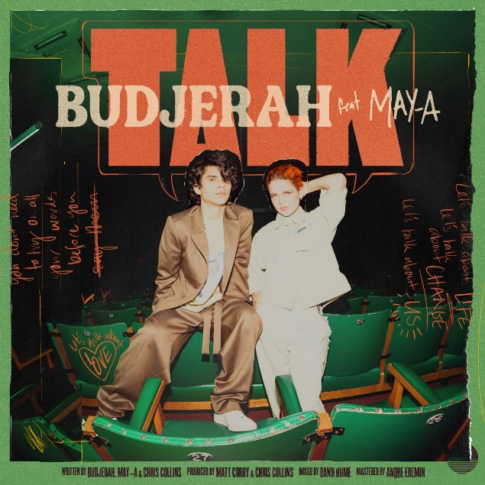

**MORE INFO:**  
[WEBSITE](http://www.budjerah.com/)  
[INSTAGRAM](https://www.instagram.com/budjerah/?hl=en)  
[FACEBOOK](https://www.facebook.com/Budjerah)  
[TWITTER](https://twitter.com/budjerahs?lang=en)  
[YOUTUBE](https://www.youtube.com/channel/UCFQXeU__ExeTFCFqeuiZXxA)  
[SPOTIFY](https://open.spotify.com/artist/4hOb2WdQMQWyG6RQAhR7iE?si=hxx3-KZhQP68iDCX-DN14Q)  
[APPLE MUSIC](https://music.apple.com/au/artist/budjerah/1535027426)

**CONTACT:**

[Jaime.Rosenberg@warnerrecords.com](mailto:Jaime.Rosenberg@warnerrecords.com)

