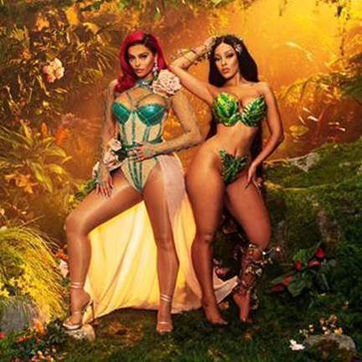

DIAMOND CERTIFIED, GRAMMY-NOMINATED
BEBE REXHA
UNVEILS “BABY, I’M JEALOUS” FEAT. DOJA CAT

Bebe’s #1 hit “Meant to Be” with Florida Georgia Line Earns RIAA 10x Platinum Diamond Certification

“Baby, I’m Jealous” video, shot by Hannah Lux Davis, features strong time traveling visuals – click here to watch

October 9, 2020 (Los Angeles, CA) — Diamond-certified, Grammy-nominated, Global Superstar Bebe Rexha teams up with Doja Cat for a stormy new single and video, “Baby, I’m Jealous,” that explores the insecurities of living in a digital age. Slinking synth work and a shivering bassline set the stage for an intoxicating pop bop about the perils of scrolling endlessly through social media.

Rexha wrote, and sings, about the negativity the modern era often imposes on people—envy, rage, self-doubt—but the single isn’t dark and brooding. “Baby, I’m Jealous” is funky, playful, and confident, even before Doja Cat sideswipes the song with a few gleeful bars aimed squarely at society’s expectations for women (“Waste trainer for a tinier waist / But I can’t help if I like the way food taste”). According to Rexha, it’s all about taking ownership of those complex emotions.

“‘Baby, I’m Jealous’ is a song I wrote about embracing my insecurities,” Rexha explains. “It’s about the way social media has heightened my jealousy which can affect how I feel about myself. We are constantly flooded with the highlights of other people’s lives, and at times I find myself comparing my worth and beauty to others. It’s part of the human process to experience jealousy—ultimately, this is an anthem to embrace those feelings as a form of empowerment.”

Today, Rexha also shares a stunning technicolor video for the single, directed by frequent award-winning collaborator Hannah Lux Davis, which features actors and influencers Charli D’Amelio, Nikita Dragun, and Avani Gregg. Rexha’s siren red hair bursts off the screen and the musical wonder woman’s playful lyrics come to life in the colorful fantastical clip.

“Baby, I’m Jealous” is Rexha’s first release of 2020, but it arrives hot on the heels of the news that her #1 hit “Meant to Be” with Florida Georgia Line, was certified Diamond (10x Platinum) by the RIAA. In 2018, Rexha released her debut album Expectations, which featured that hit alongside another Platinum single, “I’m a Mess.” Rexha had a busy 2019 as well, releasing a string of ecstatic cuts, including the simmering “Last Hurrah,” the swooning “Not 20 Anymore,” and her euphoric feature on the Chainsmokers’ “Call You Mine.” “Baby, I’mJealous” with Doja Cat is just the first taste of the thrilling new music Rexha has on the horizon. This comes off the news of Rexha newly signing with SAL&CO management. She’s set to release a new album in early 2021, so stay tuned.

ABOUT BEBE REXHA:
Diamond-selling and two-time Grammy®-nominated New York City native Bebe Rexha is a musical force to be reckoned with. She has accumulated over 12 million overall single sales, over 6 billion total global streams, and a radio audience over 10 billion. Her RIAA Gold-certified debut album Expectations (released June 2018 on Warner Records) contained the Platinum single “I’m a Mess” and global chart-topping smash “Meant to Be” (featuring Florida Georgia Line), now RIAA Certified Diamond. #1 on the Billboard Hot Country Songs chart for a record-setting 50 straight weeks, the longest reign ever by a female lead artist, “Meant to Be” won Top Country Song at the 2019 Billboard Music Awards and Best Collaboration at the 2018 iHeart Radio Music Awards. It was subsequently nominated for Best Country Duo/Group Performance at the 61st annual Grammy Awards® in February 2019, where Bebe was also nominated for Best New Artist. Early in her career, Bebe won the National Academy of Recording Arts and Sciences’ Best Teen Songwriter Award, and then formally burst onto the scene when she wrote “Monster,” a worldwide hit for Eminem and Rihanna that was certified 6x Platinum by the RIAA. Bebe went on to co-write and carry the instantly recognizable hook for the 3x Platinum “Hey Mama,” by David Guetta, Nicki Minaj, and Afrojack, nominated for a Billboard Music Award for Top Dance/Electronic Song. Bebe also hit #1 on the Billboard Pop and Rap charts with her RIAA Platinum “Me, Myself & I” with G-Eazy. In 2017, Bebe released the critically acclaimed EPs, All Your Fault: Part 1 (with “I Got You”), and All Your Fault: Part 2 (with “Meant to Be”). Now in 2019, Bebe has amassed over 2.7 billion YouTube views and counting. In conjunction with Grammy® Week 2019, Bebe launched the Grammy® Music Education Coalition’s (GMEC) national campaign on behalf of its new All-Star Ambassador program, whose members also include Luis Fonsi, Rita Ora, Kristin Chenoweth, Regina Spektor and others.





