DIAMOND-CERTIFIED, GRAMMY®-NOMINATED
BEBE REXHA
RELEASES “SACRIFICE” GORGON CITY REMIX TODAY
LISTEN HERE

“SACRIFICE” CROSSES 35 MILLION STREAMS
AND ENTERS TOP 20 AT POP RADIO

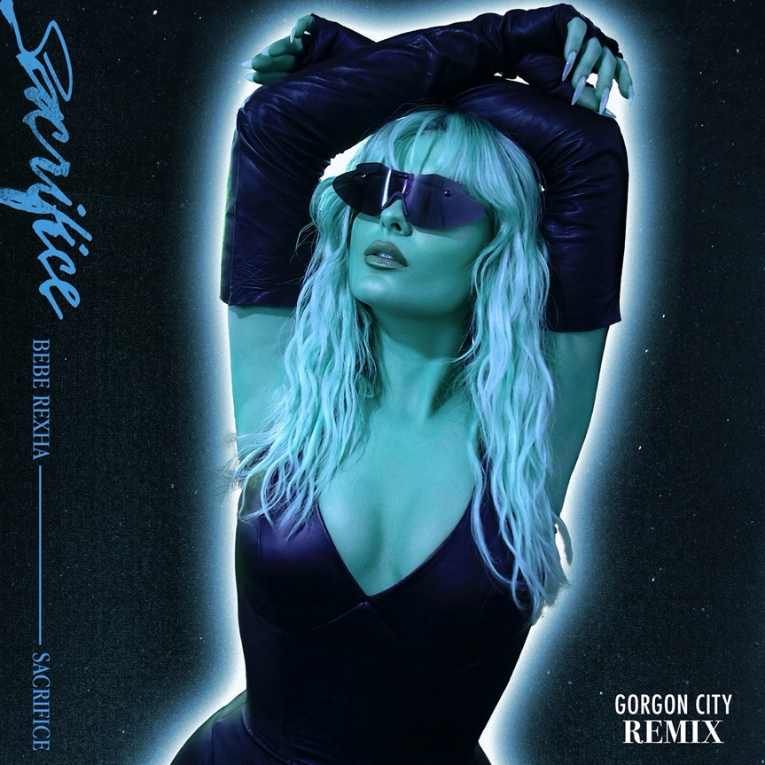
Click here for hi-res image

“She’s known for delivering stuck-in-your-head hits... the type of song you don’t realize you’ve memorized every word to until it comes on the radio mid-road trip.” – ELLE

ABOUT BEBE REXHA:
Diamond-selling and two-time Grammy®-nominated New York City native Bebe Rexha is a musical force to be reckoned with. Her RIAA Platinum-certified debut album Expectations (released June 2018 on Warner Records) contained the Platinum single “I’m a Mess” and global chart-topping smash “Meant to Be” (featuring Florida Georgia Line), now RIAA Certified Diamond. “Meant to Be” held the #1 spot on the Billboard Hot Country Songs chart for a record-setting 50 straight weeks, the longest reign ever by a female lead artist, and won Top Country Song at the 2019 Billboard Music Awards and Best Collaboration at the 2018 iHeart Radio Music Awards. It was subsequently nominated for Best Country Duo/Group Performance at the 61st annual Grammy Awards® in February 2019, where Bebe was also nominated for Best New Artist.

Early in her career, Bebe won the National Academy of Recording Arts and Sciences’ Best Teen Songwriter Award, and then formally burst onto the scene when she wrote “The Monster,” a worldwide hit for Eminem and Rihanna that was certified 6x Platinum by the RIAA. Bebe went on to co-write and carry the instantly recognizable hook for the 3x Platinum “Hey Mama,” by David Guetta, which was nominated for a Billboard Music Award for Top Dance/Electronic Song. Bebe also hit #1 on the Billboard Pop and Rap charts with her 5x Platinum “Me, Myself & I” with G-Eazy. In 2017, Bebe released the critically acclaimed EPs, All Your Fault: Part 1 (with the Platinum single “I Got You”), and All Your Fault: Part 2 (with “Meant to Be”). In conjunction with Grammy® Week 2019, Bebe launched the Grammy® Music Education Coalition’s (GMEC) national campaign on behalf of its new All-Star Ambassador program, whose members also include Luis Fonsi, Rita Ora, Kristin Chenoweth, Regina Spektor and others. In October 2020, Bebe released her lead single, “Baby, I’m Jealous” feat. Doja Cat, which was followed in March 2021 with “Sacrifice,” her second single from her forthcoming Spring 2021 new album. To date, Bebe has amassed over 4 billion YouTube views and over 12 billion total global streams and counting.

###

FOLLOW BEBE REXHA:
Facebook | Twitter | Instagram | TikTok | Spotify | YouTube

